GRO:NT

Grön Rutt Optimering och Navigering
för Tunga fordon

Green Route Optimisation and Navigation
for Heavy Trucks

Final Report

Vinnova diarienummer: 2010-01340
Projekttitel: Energieffektiv Navigation för tung trafik
Bidragsmottagarens namn: 556084-0976 Scania CV Aktiebolag
Projektets startdatum – slutdatum: 2010-12-01 – 2011-09-30
Report Authors
Executive Summary | Project Team
Introduction | Michael L . Sena
User and Usage Requirements | Magnus Hjälmdahl
Data | Per-Olof Svensk
Route Calculation and Optimization | Kees Wevers
System Architecture | Anders Johansson
Business Models | Michael L. Sena
Fuel Optimization | Per-Olof Svensk
Conclusions and Recommendations | Project Team
Editor | Michael L. Sena

Table of Contents
Table of Contents 3
Distribution 7
Document History 7
Definitions 7
1 Executive Summary 8
1.1 Objective of Analysis 8
1.2 Methodology and Structure 8
1.3 Background 9
1.4 Future Work 10
1.5 Acknowledgements 11
2 Introduction 12
2.1 Purpose of Project 12
2.2 Participants 12
2.2.1 Project Team Members 12
2.2.2 Project Team Member Tasks 12
2.3 Funding and Timetable 13
2.3.1 Budget 13
2.3.2 Project Schedule 13
2.4 The Nature and Operations of the Large Vehicles 14
2.5 Heavy Vehicle Navigation 19
2.5.1 Trucking Logistics Terminology 19
2.5.2 Security 22
2.5.3 Logistics 24
2.5.4 Operations 25
2.5.5 Compliance 25
3 User and Usage Requirements 28
3.1 Introduction 28
3.1.1 Objectives 28
3.1.2 Scope and delimitations 28
3.2 Method 29
3.2.1 Databases used 29
3.2.2 Keywords 30
3.3 Users and stakeholders of a navigation system for heavy vehicles 31
3.4 Identification of User Requirements 32
3.4.1 Drivers 33
3.4.2 Fleet owners 34
3.4.3 Authorities 37
3.4.4 Data providers, Truck manufacturers, System providers 37
3.4.5 Discussion 37
4 Data 39
4.1 Introduction 39
4.1.1 Data as part of the state-of-the-art study 39
4.1.2 Prerequisite and background 39
4.1.3 Objectives 39
4.1.4 Scope and delimitations 40
4.2 Useful data 40
4.2.1 Overview 40
4.2.2 Data for transport planning 41
4.2.3 Data for determining allowable routes for LGV 41
4.2.4 Data for route optimization 42
4.2.5 Data for navigation instructions 46
4.2.6 Needed quality on data 46
4.2.7 Comments on useful data 47
4.3 Available data 47
4.3.1 NAVTEQ 47
4.3.2 Trafikverket, Sweden 48
4.3.3 RDT 50
4.3.4 Other sources for static data 53
4.3.5 Other sources for dynamic data including real time probe data 55
4.3.6 Historical probe data 56
4.3.7 Summary of available data 57
4.4 Currently used data 58
4.4.1 Navigation system suppliers 58
4.4.2 Summary of currently used data 62
4.5 Usability of data 63
4.5.1 Mapping useful data towards available data and currently used data 63
4.5.2 Available but not used data 68
4.5.3 Missing data 68
4.5.4 Creation of new attributes and possible enhancements 68
4.6 Data provision chain 69
4.6.1 Overview 69
4.6.2 Services, Interfaces and Standards 69
4.7 Conclusions regarding data 73
4.7.1 Data for route optimization 73
4.7.2 Data describing transfer terminals 74
4.7.3 Data for logistics – planning and operating a fleet 74
4.7.4 What could be achieved with data available today 74
4.7.5 Expected development next 5-10 years 74
4.7.6 Expected development in the next 5-10 years 75
4.7.7 Possible action items 76
5 Route Calculation and Optimization 78
5.1 Introduction 78
5.1.1 State of the art study 78
5.1.2 Topics of study of the subgroup 78
5.1.3 Scope of the document 79
5.2 Vehicle navigation 79
5.2.1 History 79
5.2.2 Functionality 79
5.2.3 Components 80
5.2.4 Digital map 80
5.2.5 Exchange format and physical storage format 81
5.3 Route calculation 81
5.3.1 Route calculation: a single-source shortest path problem 82
5.3.2 Dijksta's algorithm 83
5.3.3 A* algorithm 84
5.3.4 Example of a simple A* implementation 86
5.3.5 Cost function 86
5.3.6 Bidirectional search 89
5.3.7 Restrictions 89
5.3.8 Dynamic information: traffic 90
5.3.9 Historic traffic information 91
5.3.10 NAVTEQ Traffic Patterns 92
5.3.11 Predictive traffic 92
5.3.12 Link transition cost 93
5.4 Vehicle fuel consumption 93
5.5 Energy-efficient routing 97
5.5.1 Eco-driving and eco-routing 97
5.5.2 Minimal fuel routing 98
5.5.3 Base fuel cost component 99
5.5.4 Gradient fuel cost component 100
5.5.5 Fuel cost component related to variations in speed (braking fuel cost) 102
5.5.6 Discussion 103
5.6 The EcoMove project 103
5.6.1 Description and goals of the EcoMove project 103
5.6.2 EcoMove components 105
5.6.3 Ecomove research questions 106
5.6.4 Discussion on the 20 % reduction goal 106
5.6.5 Elements of EcoMove particularly relevant for GRO:NT 107
5.7 System Availability 110
5.7.1 Introduction 110
5.7.2 Truck routing applications 110
5.7.3 Eco-routing applications 111
5.7.4 Eco-predictive cruise control for trucks 111
5.7.5 Conclusion 112
5.8 Evaluation, discussion and general conclusion 112
5.8.1 Topics of study revisited 112
5.8.2 General conclusion and further work 114
5.9 References 114
6 System Architecture 116
6.1 Objectives 116
6.2 Surrounding systems and current initiatives 116
6.2.1 Systems optimizing transport operations 116
6.2.2 Communication channels 122
6.2.3 Communication and computing platforms 125
6.3 Recommendation/Comments 127
6.3.1 On-board vs off-board route calculation 128
6.3.2 Important aspects to consider 130
6.3.3 Relation to Transport Management Systems 133
6.3.4 Interaction with vehicle systems (ADAS etc.) 133
6.3.5 Communication channels 134
6.3.6 Wireless communications and computing platforms 134
6.4 References 134
7 Business Models 135
7.1 The Nature of Business Models 135
7.2 Roles 137
7.2.1 Navigation Systems and Services Eco-System 137
7.2.2 Data Providers 141
7.2.3 Navigation Map Engine Suppliers 144
7.2.4 End Users 147
7.2.5 User generated content 148
7.2.6 Demand for information 149
7.3 Updates 149
7.4 Payment Models 150
7.4.1 Who Pays Whom 150
7.4.2 Original Equipment – Embedded Navigation 150
7.5 Market Size 158
7.5.1 Vehicle Sales 158
7.5.2 Navigation System Sales 160
7.5.3 Truck Navigation 163
7.5.4 Fleet Management 164
8 Results from fuel optimization compared with usual fastest route optimization 167
8.1 Objective of the comparison 167
8.2 Description of the simulation 167
8.2.1 Test environment 167
8.2.2 Model for fuel optimization 167
8.2.3 Chosen routes 168
8.3 Results 168
8.3.1 Statistics 168
8.3.2 Examples 170
8.4 Conclusions 177
9 Conclusions and Recommendations 179
9.1 Requirements 179
9.2 Data 179
9.3 Route optimization 179
9.4 System Architecture 180
9.5 Business models 180
10 Appendices 181
10.1 Annex 1 - Truck routing applications on the market 181
10.1.1 ALK 181
10.1.2 BECKER 181
10.1.3 Falk 182
10.1.4 Garmin 183
10.1.5 Masternaut 183
10.1.6 NAVIGON 183
10.1.7 NavGear (distributed by Pearl) 184
10.1.8 PTV 185
10.1.9 Rand McNally (only US and Canada) 185
10.1.10 Snooper 186
10.1.11 TeleType 187
10.1.12 TomTom 188
10.2 Annex 2 - Eco-routing applications on the market 190
10.2.1 Bosch 190
10.2.2 Fiat 190
10.2.3 Garmin 191
10.2.4 Hyundai 192
10.2.5 TomTom 194
10.3 Annex 3 - Eco-predictive cruise control for trucks on the market 195
10.3.1 Freightliner Trucks 195

Distribution
Receiver | Date | Version
GRO:NT Project Team
FFI- Secretariat

Document History
Version | Date | Responsible | Comments
0.1 | 2011-08-01 | MLSena
0.2 | 2011-11-16 | MLSena | Integration of User Requirements and Route Optimisation
0.3 | 2011-12-11 | MLSena | Edits
0.4 | 2011-12-31 | MLSena | Inclusion of Fuel Optimization chapter and general edits

Definitions
Acronym | Description
IVSS | Intelligent Vehicle Safety Systems
ADAS | Advanced Driving Assistance System
ADAS rp | Advanced Driving Assistance System Research Platform
DMO | Digital Mapping Organization
GDF | Geographic Database Format
LAT | Look-a-side Attribute Table
DNDC | Internal NAVTEQ database format
CPM | Customer Program Management
PM | Product Management
IS | Information Systems
DDT | Digital Data Team
POI | Point Of Interest
TPD | Third Party Data
GWS | Geographic Work Station
DGPS | Differential Geographic Position System
QA | Quality assurance
SIF | Standard Information Format
P&RP | Product & Release Planning

Executive Summary

Objective of Analysis
The Swedish program for strategic automotive research (FFI) financed a one-year study of energy efficient navigation for heavy vehicles beginning October 2010. Scania is the leading party in the project with participation by Navteq, Triona AB, Michael L Sena Consulting AB, the Swedish Transport Administration and the Swedish National Road and Transport Research Institute (VTI).
The project has investigated the issues that can lead to the delivery of energy efficient navigation for heavy vehicles. A state-of-the-art study has been made analyzing data and usage issues, route optimization algorithms, the actors and business cases required for the accurate and timely data delivery to heavy vehicles. Concrete recommendations are presented concerning which are intended to serve as a foundation for an eventual full implementation of energy efficient navigation for heavy vehicles.
Goals of Project
- Increase road safety
  - Fewer truck-related accidents and deaths
- Stimulate economic growth
  - Reduced fuel usage
  - More effective routing
- Encourage technology development
  - Advanced systems for truck safety and performance improvements

Methodology and Structure
The objective of the project is to build a substantial base of knowledge regarding energy efficient navigation for heavy vehicles. This will pave the way for truck manufacturers to offer integrated navigation solutions and for fleet operators in include navigation and route optimization adequately suited for heavy vehicles in their offerings. To reach the overall objective, the project has addressed the following:
- Identify and clarify the requirements on the functionality and the interaction between different actors and roles in the data supply chain and the current payment flows.
- Analyze current navigation and route optimization algorithms, determine what is required for adapting these to heavy vehicle route planning, and provide suggestions for improved algorithms for navigation which are specifically designed for heavy vehicles.
- Make it possible to take advantage of data and platforms that are already available. Today this is done in a very limited way.
A new generation of navigation systems designed for heavy vehicles is expected to reduce the negative effects on the environment while improving the safety and economy for fleet owners and drivers. To ensure the commercial interest of large operators, a global perspective is set. At the same time, opportunities are identified where data and solutions from local actors can be utilized.

Background
The European transportation sector must improve the energy efficiency of its vehicles in order to achieve the EU Commission's goal of a 27% energy saving by the sector prior to 2020. There are a number of areas that need to be improved in order to provide owners and drivers of heavy trucks, buses and other equipment the best possible support for energy efficient navigation, including the provision of specific road data attributes that are necessary for route planning, the development of route optimization algorithms tailored to heavy vehicles, and the design of business models that offer measurable returns to all involved parties. Currently, drivers of heavy vehicles are often using navigation systems designed for private cars. These systems and the data they contain are not specifically designed for the weight, height, width or turning radii of heavy vehicles, and their use is leading to heavy vehicles following inappropriate, unsafe and inefficient routes.
To date, relatively few navigation systems have been developed for heavy vehicles, and those that are available do not incorporate all the data and functionality to minimize emissions, reduce fuel consumption and restrict effects of heavy vehicles on environmentally sensitive areas. In order to guide the eventual efforts of a full-scale implementation of route optimization and navigation for heavy vehicles, it is essential that the fundamental conditions are clarified and presented in an understandable manner.

Future Work
The results show that optimization for fuel definitely is possible. However, for a commercial product, a model is needed which combines optimization for:
- Lowest amount of fuel usage
- Fastest route
- The use of major roads
How to weight these factors against each other will be a task for each navigation provider. A suggested solution that would be more flexible would be to allow the user to do the weighting as shown in the HMI example below.

Acknowledgements
The FFI-Programme has provided an opportunity and a framework for Swedish companies and research institutions involved in the intelligent transport arena to cooperate on finding solutions to complex problems affecting their industry which will improve their own competitiveness and society in general. The requirement that participating private companies finance 50% of their costs has helped ensure that only those companies who are serious about collaboration and open to sharing their knowledge on common ground with both partners and competitors take part in the programme. The structure provided by the FFI-Programme and the assistance of the Secretariat have been invaluable throughout the entire project.

Introduction

Purpose of Project
The principal aim of the project is to analyse the preconditions for implementing solutions that optimise energy efficient route planning for heavy vehicles while at the same time accomplishing the following:
- Clarify the relationships between the different participants in the entire eco-system, including data assembly, data delivery and payment processes.
- Prepare recommendations on how Green Routing for heavy vehicles can be implemented in Sweden, Europe and globally.

Participants

Project Team Members
- Scania CV AB – Södertälje, Sweden
- Trafikverket – Borlänge, Sweden
- VTI – Linköping, Sweden
- Triona AB – Borlänge, Sweden
- Michael L. Sena Consulting AB – Åsa, Sweden
- Navigation Technologies Sweden AB – Stockholm, Sweden

Project Team Member Tasks
The project team is made up of members who were part of the IVSS-funded SOLVI Project with the addition of VTI. Each team member brings to the pre-study a specific set of knowledge in vehicle systems, navigation and routing, navigable databases and dynamic data. VTI adds the important component of user requirements and its experience from the HeavyRoute project.
Scania is the lead company in the project and has been responsible for the System Architecture state-of-the-art review.
Navteq has been responsible for leading the investigation of route optimization and routing algorithms as well as contributing its extensive knowledge in he area of navigable data bases.
Trafikverket has focused on the collection, processing and quality assurance of road information for safety and performance improvements in heavy truck operations.
Triona has served as the lead for data analysis.
Michael L. Sena Consulting AB has been responsible business model analysis and for project management.
VTI has been responsible for user and usage requirements, and brings extensive knowledge of evaluation criteria.

Funding and Timetable

Budget
4 674 750 MSEK (€4.5 million)
Project funding is provided through the Intelligent Vinnova FFI-Programme. Project team members receive 50% funding from Vinnova, and contribute the remaining 50% themselves. A partner agreement among all project team members defines the commercialisation and intellectual property rights of the participating parties.

Project Schedule
Work began on 1 October 2010 and was completed on 31 December 2011.
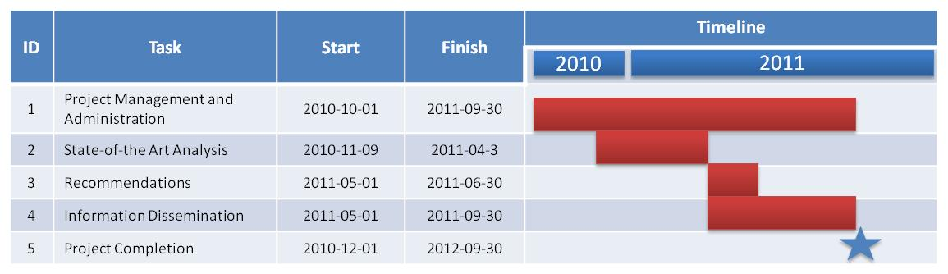
Figure 2.1:GRO:NT Project Timetable

The Nature and Operations of the Large Vehicles
A legitimate question that could be asked is why should time and resources be devoted to improving the performance of a road-based freight hauling alternative when carbon monoxide emissions for trucks (105 grams per ton of transport per kilometer) are three times greater than for rail (35 g/tkm), and over five times greater than for shipping (18 g/tkm). The answer lies in the current statistics of freight movement. Eurostat, in its Energy, transport and environment indicators, 2009 edition, quantifies the amount of freight shipped by road, rail and water, comparing figures for 2000 and 2008. In the EU27, the amount shipped by road during this eight-year period increased by 2.7% to 76.4%.
Table 2.1: Modal split of inland freight transport in percent of total inland tonne-kilometers (tkm)
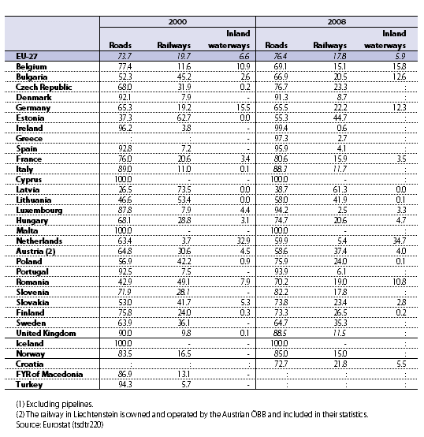
The heavy reliance of freight shipments on road transport occurred gradually over the period from 1950 to 1985, and then accelerated dramatically after that. Part of the reason for the increase was the completion of new motorways in many European countries allowing fast city-to-city travel. Another reason which has gained in importance during the past twenty years in Europe is a phenomenon that began in the US with the founding of Walmart (known as Wal-Mart until 2008 when the official name was changed to Walmart).
Sam Walton founded Wal-Mart in 1962 in Bentonville, Arkansas. Mr. Walton himself delivered all the goods to his first handful of stores in his station wagon. His warehouse was his garage. At the time of his death on April 5, 1992, he was the second richest person in the world, after Bill Gates. In 1997, Wal-Mart became the largest employer in the US with 680,000 “associates” (everyone in the company, up to and including the CEO, is referred to as an associate by the company, rather than an employee). In 2002, Wal-Mart topped the Fortune 500 List as the largest company in the world in terms of sales, $218 billion. In 2004, sales rose to $287 billion and the number of employees worldwide had grown to 1.5 million at more than 3,600 stores in the U.S., and more than 1,500 stores in Mexico, Puerto Rico, Canada, Argentina, Brazil, China, South Korea, Germany and Britain. By 2009-10, the number of employees had risen to 1.4 million in the U.S. with 4,300 stores.
Walmart’s success in attracting so many customers is based in large part on always delivering the lowest prices on all the goods it sells—not just on certain goods, or not just during special sales promotions, but always. They have perfected the art and science of penny-pinching, primarily by paying low wages to their staff, all of whom are non-unionized, and by squeezing their suppliers for lower prices and more donated labor. Because of their size, they can negotiate huge volume purchases, which drives down the prices they will accept from their suppliers to rock bottom. This, in turn, results in suppliers being forced to reduce their own costs of production. Fully 80% of the goods sold in Walmart stores now originate in low-cost countries, mostly China.
The company has its own private fleet of 7,100 trucks and employs 8,000 of its own drivers. This puts Walmart Logistics in a league just below truckload carriers Swift, Schneider and J.B. Hunt. The Walmart fleet carries all goods to its Walmart and Sam’s Club stores, and, whenever possible, leverages its fleet by backhauling inventory from manufacturers’ locations. This reduces the amount of contract shipping that is required, saving shipping costs. In fact, the suppliers pay Walmart a fee for the service. The company reportedly saved close to $1 billion in freight costs in 2004 by backhauling inventory.
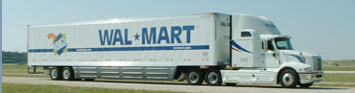
Source: Image downloaded from Walmart site describing energy-efficient trucks
Goods are moved first from ports or producers’ shipping points to one of Walmart’s 173 worldwide distribution centers. In the U.S, Walmart has around forty general merchandise distribution centers that support stores within a 130-mile radius. There are another forty-or-so distribution centers for groceries that are within a 156-mile radius of the stores they service. There are twenty more centers for Sam’s Clubs, seven for fashion, two for tires and one for e-retail fulfillment.
Rather than functioning primarily as storage facilities, as the traditional warehouse, there are cross-docking facilities at the distribution centers where goods are moved from supplier trucks to Walmart trucks in the shortest possible time. Fifty percent of goods are cross-docked from delivery truck to a waiting distribution truck in less than twenty-four hours. The goal is to make just-in-time deliveries of exactly the right combination of goods to each individual store. And when the goods get to the stores, they are placed on shelves, not in storage. The entire idea is to eliminate storage space, which is purely a cost for Walmart, and to get goods into shopping carts and out the doors as fast as possible. High volume stores can have multiple deliveries and many shelf re-stockings per day. Warehouse space has moved from a fixed facility to moving vehicles: large tractor trailers; shelf-stacking carts; customers’ shopping carts; and customers’ vehicles.
What is most interesting about the Walmart logistics solution is that it was the daughter of necessity. The key to the company’s original success was that it located its facilities in poor, rural areas, starting in Arkansas. Poor people shopped in their stores because they did not have much choice. Because Walmart’s facilities were not on high traffic routes, Walmart initially had trouble getting its suppliers to deliver to its stores. This was the principal reason for the distribution centers, to provide more convenient locations for suppliers to drop off their goods. To get the goods to the stores from the distribution center, Walmart was, in essence, forced to operate its own fleet of trucks. Once it owned the trucks, it could decide how to use them, and this is where the just-in-time delivery method and backhauling came into existence.
Walmart’s logistics ingenuity has been copied worldwide with the result that larger trucks and moving around in smaller spaces on our roads. Shipping by truck is preferred because it is, overall, the cheapest, most convenient, most flexible and most effective means for moving goods in a Walmarted world. Although environmentalists would prefer that a greater percentage of total freight could, and should, be moved on rails and water, it simply is not as practical as it was fifty years ago. There is nothing on the horizon that is going to change that fact, barring a catastrophic event of an unthinkable proportion, like the total and immediate lack of available fuel.
There are even serious calls for longer and heavier trucks on the basis that it is more energy-efficient for one tractor to pull two or more trailers than the same tractor to pull just one trailer. Volvo Trucks and Scania, two Swedish truck manufacturers and among largest in world-wide sales of large trucks, have proposed that all European countries adopt the 24 meter standard length of truck allowed in Sweden and Finland, and drop the 18 meter maximum length restriction in force today in the other European countries. Their reasoning is that it will reduce traffic, in spite of how counter-intuitive it sounds. They argue that it will reduce the total number of trucks by one-third, but it will also increase the total length of each truck by 25%. And road freight traffic will continue to grow, so that there will eventually be more and bigger trucks competing for space.

Heavy Vehicle Navigation

Trucking Logistics Terminology
Heavy Goods Vehicles (HGV, or now officially in the EU called LGV for Large Goods Vehicles) are classified by the European Union as motor vehicles (i.e. trucks/lorries) with a maximum allowed mass (MAM) or gross combination mass (GCM) of over 3,5 tonnes. There are two sub-categories:
- N2 – vehicles up to and including 12 tonnes
- N3 – vehicles over 12 tonnes
According to a report published by ANFAC (Asociación Española de Fabricantes de Automóviles y Camiones in 2008), European Motor Vehicle Parc 2003-2008, there were a total of 4.5 million vehicles corresponding to this categorization in use in 2008 in the EU 15 countries, a decrease of 0.4% from the 2003 number. However, the heaviest truck class, those over 16 tonnes, rose sharply from 2003 through 2007, tapering off in 2008 as the first signs of recession began to show. The total number of trucks over 16 tonnes rose by 13% between 2003 and 2008, from 49,733 to 56,329.
The physical characteristics of Heavy Vehicles compared to both light commercial vehicles and passenger cars (i.e., their sheer weight, length, height, noise generation, emissions, slowness of acceleration and length of stopping, and their difficulty to maneuver) generate distinct and complex challenges for providing suitable route planning. Larger and heavier vehicles tend to require more road space and are slower to accelerate, and so cause more traffic congestion than smaller, lighter vehicles. The relative congestion impact of different vehicles is measured in terms of “Passenger Car Equivalents” or PCEs. Large trucks and buses tend to have 1.5-4 PCEs, depending on roadway conditions, and even more through intersections or under stop-and-go driving conditions. A large SUV imposes 1.4 PCEs and a van 1.3 PCEs when traveling through an intersection. The end result is that as their numbers increase, they add disproportionately to the amount of congestion on the roads.
It is not only traffic that increases; safety is a major issue with large, heavy vehicles. Over 40,000 people are killed on European roads each year, and around 10% of those deaths involve heavy truck accidents. In Sweden, heavy truck traffic has increased by 60% during the past 20 years, and now consists of 8% of road traffic, but trucks are involved in 22% of traffic-related deaths.
There are other characteristics of large trucks which complicate route planning even further. These include the types of loads that the vehicle carries and, related to this, the distances that the vehicle is prepared to travel. Types of loads are:
- Truckload (TL) - Truckload freight moves from point A to point B without being transferred, and the shipper pays for the entire truck with its freight the only load on the truck. Full truckload carriers move freight that is loaded into a semi-trailer. Semi trailers are typically between 26 and 53 feet (7.92 and 16.15 m).
- Less-than-Truck-Load (LTL) - LTL shipping is the transportation of relatively small freight. This is anything too big to be shipped by a parcel carrier (e.g. FedEX or DHL) as a small package, but not a complete truckload. Parcel carriers usually handle small packages and freight that can be broken down in to units less than 150 pounds (68 kg). The LTL load is typically a product on skids that can be handled by a pallet jack or a forklift, but it can also be loose items. In this case the freight moves with other freight from origin to destination through a series of cross-dock terminals. The alternatives to LTL carriers are parcel carriers or full truckload carriers.
The principal distance categories for heavy trucks are:
- Long-haul - A truck designed to haul for long distances, equiped with an ample cab hosting from a simple bed to almost a full house amenities like toilet, tv, sound, air-conditioning, kitchen and so on. a long haul truck is a truck used for long distance.this usually means it has a sleeper cab and is gone from its home place more often than it is home.
- Short-haul or day cab – A truck that only runs locally, usually within 100 miles of its home base.
The process of moving goods involves many different actors who have an interest in the timely delivery of those goods. The shipper is the person or company who is usually the supplier or owner of commodities shipped. Another term for shipper is consignor (pronounced ‘cun-SIGN-or’). The freight forwarder is a person whose business is to act as an agent on behalf of the shipper. A freight forwarder frequently makes the booking reservation. The freight carrier is any person or entity who, in a contract of carriage, undertakes to perform or to procure the performance of carriage by rail, road, sea, air, inland waterway or by a combination of these modes. A freight carrier can be an individual who owns or leases one or more trucks, and who drives the truck him/herself or hires employs drivers. The consignee is a person or company to whom commodities are shipped. A shipment of goods is a consignment to a consignee. These are just the main actors.
There are four principal issues that Freight Carriers must address for their own business and on behalf of the Shipper and the Consignee:
- Security – Protecting the driver and the load from injury, damage and theft. The objective is to ensure that the load reaches its destination when it is expected.
- Logistics – Moving goods as quickly and economically as possible from shipping point to destination, minimizing waiting and loading times, providing information on the status of all stages of goods movement. The objective is to maximize profits while delivering the highest quality of service. Traffic congestion is a major problem.
- Operations – Operating the vehicle and all of the associated support activities necessary to keep the vehicle on the road, and to do this at the lowest possible costs. The objective is to keep the vehicle on the road for the maximum amount of time at the lowest possible cost. High and erratic fuel costs, the scaricity of skilled drivers are major problems.
- Compliance – Ensuring that all laws in all countries where goods are moved are compied with. The objective is to avoid paying more than the necessary amount of money in taxes and fees and to avoid non-compliant behavior that results in fines. Duty of care, work time directives, road charging and environmental regulations are major problems,

Security
The illustration below shows both the visible and hidden costs of a truck being stolen. Visible costs can be covered by insurance and tax reductions, but the hidden costs can have major, long-lasting cost costly effects on the consignee’s business.

Hidden

What is the real cost of a truck robbery?

Visible
- Cargo / vehicle losses
- Indemnities
- death
- handicaps
- Insurance policy cost growth
- Contract fines
- Freight cost increase (12-15%)

- Customer dissatisfaction
- “Empty shelves”
- Productivity losses
- Damages to the image
Hiden

Source: AB Volvo
The two main types of crimes are:
- Vehicle Robbery
  - Occurrence – low value cargo
  - Destination – dismantling for parts sales; exchange for other goods (e.g., drugs or weapons)
- Cargo Robbery
  - Occurrence – value cargo, easy to spread in the market
  - Destination – sales and distribution in the black market
In Brazil, the number of truck cargo robberies increased 300% from 1995 to 2003, and the value of losses increased by 500% during this same period.
In Europe, driver protection, load security and stolen vehicle tracking are important in all countries, but the problem is more acute in the eastern countries, especially Russia. Daimler-Benz has identified security telematics as a new field of positive growth. Securitas is aggressively pursuing security telematics for fleet applications as a major growth opportunity.

Logistics
Frost & Sullivan report that third-party logistics providers and the petrochemical industry are the highest adopters of telematics solutions. Daimler-Benz claim that the use of solutions like their FleetBoard offer savings potentials up to €9100 per year per vehicle, and that logistics management that increases transport efficiency generates the largest share, 43%. According to Daimler-Benz, efficient logistics management results from the following:
- Fewer empty trips
- Real time order processing, status and order updates
- Optimal integration of driver and shipments in the entire order/delivery chain
- Fuel costs savings of up to 4% through truck navigation with the company’s own points of interest.
- Easier integration of subcontractors.
Third-party logistics providers are demanding continuous improvements in their service level agreements while at the same time requiring better management of their costs. This is why this sector has the highest usage of telematics of all sectors, according to Frost & Sullivan.

Operations
The total energy consumption of heavy vehicles can be considered significant on a large, nation-wide scale. In the United Kingdom, for example, data in 2008 (National Statistics Publication 2008, Transport Statistics Publications 2008, National Statistics Publication 2009) indicates that the energy consumed by heavy goods vehicles annually account for about 6.1% of the total national energy consumption (approximately equal to 9.4 million tonnes of oil-equivalent). This amounts to about 22% of the energy used by all the road vehicles, despite the small number of all heavy vehicles of only 1.3% relative to all road vehicles (Transport Statistics Publications 2008). Cars, on the other hand, make up about 80% of the road vehicles, but consume slightly more than twice of that consumed by heavy vehicles, or 56% of the total road transport energy.
In a business where, on average, administrative costs account for 16.8%, personnel costs for 32.9% and fuel costs for 18.7% of total costs, freight carriers are constantly in search of even the slightest cost reduction potential. Economic survival in the field of transport logistics depends on the fast improvement of fleet performance in combination with a reduction of fixed and variable costs. Mobile solutions, such as telematics services, represent a highly promising approach in this context.

Compliance
In the European Union, drivers’ working hours are regulated by EU regulation (EC No 561/2006, which entered into force on April 11, 2007). The non-stop driving time may not exceed 4.5 hours. After 4.5 hours of driving the driver must take a break period of at least 45 minutes. This can be split into 2 breaks, the first being at least 15 minutes, and the second being at least 30 minutes in length. The daily driving time shall not exceed 9 hours. The daily driving time may be extended to at most 10 hours not more than twice during the week. The weekly driving time may not exceed 56 hours. In addition to this, a driver cannot exceed 90 hours driving in a fortnight. Within each period of 24 hours after the end of the previous daily rest period or weekly rest period a driver must take a new daily rest period.
Emissions compliance
European emission standards define the acceptable limits for exhaust emissions of new vehicles sold in EU member states. The emission standards are defined in a series of European Union directives which define the progressive introduction of increasingly stringent standards. Below is an example:
Currently, emissions of Nitrogen oxides (NOx), Total hydrocarbon (THC), Non-methane hydrocarbons (NMHC), Carbon monoxide (CO) and particulate matter (PM) are regulated for most vehicle types, including cars, trucks, trains, tractors and machinery and barges. These regulations exclude seagoing ships and airplanes. For each vehicle type, different standards apply. Compliance is determined by running the engine at a standardised test cycle. Non-compliant vehicles cannot be sold in the EU, but new standards do not apply to vehicles already on the roads. No use of specific technologies is mandated to meet the standards, though available technology is considered when setting the standards. New models introduced must meet current or planned standards, but minor lifecycle model revisions may continue to be offered with pre-compliant engines.
For passenger cars the standards are defined by vehicle driving distance, g/km. For trucks they are defined by engine energy output, g/kWh.

User and Usage Requirements

Introduction

Objectives
The objectives of User Requirements (UR) are in a first step to identify users and stakeholders of energy efficient navigation for heavy vehicles and in a second step identify their needs and requirements.

Scope and delimitations
As part of the GRO:NT project the research questions related to energy efficient navigation are formed. The process here was that each partner wrote down the research questions of interest for their company. The research questions where then sorted and collected in an Excel document and prioritised based on how important they were rated by the partners.
For UR there were 16 research questions identified that was considered important. These questions could be grouped into four categories described and colour coded below:
- What is the fleet owners’ opinion/acceptance on energy efficient navigation and what requirements do they have on it today with regard to functions, settings and route optimization?
- What is the truck drivers’ opinion/acceptance on energy efficient navigation and what requirements do they have on it today with regard to functions, settings and route optimization?
- What users are there are the market today and where does different requirements come from
- What could be the special requirements for navigation for heavy trucks within 10 years?
- This question is applicable to both yellow and green above

The color coding corresponds to the relevant research question in Table below.
Table 3.3: The research questions relevant for User requirements
ID | Question | Importance
S21 | What are the special requirements on navigation for heavy trucks today? | 9,0 | (x)
Tri22 | How do Fleet owners want to optimize their routes? What is their opinion on what is most important to optimize for? | 7,8 | x
S23 | From whom does the different requirement on navigation of heavy trucks come from (drivers, fleet owners, authorities, OEMs,..)? | 7,3 | (x)
Tri39 | What kinds of players are using which kinds of navigation systems? | 7,3 | (x)
V07 | What are the drivers' opinions about energy-efficient navigation systems? Do they want/need them? | 7,1 | x
V09 | What are the fleet owners' opinions about energy-efficient navigation systems? Do they want/need them? | 7,0 | x
Tri23 | How should you take into account different boundary conditions, such as rest periods? | 7,0 | (x)
S22 | What could be the special requirements for navigation for heavy trucks within 10 years? | 6,7 | (x)
S15 | What functions do fleet owner want today? / What are their requirements today? | 6,5 | x
V08 | What are drivers' requirements? (HMI, settings/options etc) | 6,4 | x
V10 | What are fleet owners' requirements? (HMI, settings/options etc) | 6,3 | x
S10 | What actors are interested in data/information today? | 6,0 | (x?)
S14 | What functions do heavy truck drivers want today? / What are their requirements today? | 6,0 | x
S11 | Which actors could be interested in data/information within 10 years? | 5,9 | (x?)
Tra07 | It is likely that the routing algorithms will point out a road network with a higher tax rate (motorways). How will the end users react to this? | 5,4 | x
Tri30 | How to get acceptance from the truck and bus drivers regarding system solutions? | 5,2 | x

Method
The main method of work in the User requirements subgroup has been literature studies and the search was based on the research questions above. The search was coordinated with the other subgroups.
The search was carried out by staff at the VTI library and databases used and search criteria are described below.

Databases used
The following databases was used
TRAX – the library database at VTI. TRAX was established 1976 and contains more than 130.000 references to publications, including about 13 000 documents freely availabe on internet. The database covers all modes and aspects of transport. TRAX is available at www.transguide.org
ITRD - International Transport Research Documentation. An international database produced jointly by institutes and organisations from more than 23 countries. Started 1972 and contains more than 400 000 references to publications on transport and transport research. More information at www.itrd.org. ITRD is available at http://trid.trb.org/ as one of the sources of TRID.
TRIS – Transportation Research Information Services, a database produced in USA containing more than 600 000 references to transport literature. TRIS is available at http://trid.trb.org/ as one of the sources of TRID.
Scopus – a reference database with more than 40 million records from the scientific, technical, medical and social sciences areas of research, and more lately also from arts and humanities. Scopus is produced by Elsevier. More information at http://info.scopus.com/.
CSA - CSA Engineering Research Database is an international database containing more than 8 000 000 million records covering international serial and non-serial literature pertaining to civil, earthquake, environmental, mechanical, and transportation engineering. More information at http://www.csa.com/factsheets/engineering-set-c.php.
Inspec - a database containing nearly 12 million records to literature in the fields of science and technology, the five main subjects being physics; electrical engineering and electronics; computers and control; information technology for business; and mechanical and production engineering. More information at http://www.theiet.org/publishing/inspec/.

Keywords
In general all words have been searched for different endings, like lorry/lorries, road haul?, navig? and different spellings, like routing/routeing.

In Swedish (searching Trax)
- Lastbil, tunga fordon, tung trafik, yrkestrafik, yrkesförare.
- Navigation, navigering, econavigation, econavigering, rutt, rutter, ruttval, ruttoptimering, ruttplanering.

In English
- Lorry, truck, motor carrier, heavy vehicle , heavy goods vehicle, goods vehicle, freight vehicle, hgv, commercial vehicle, trucking, road haul, road haulage, road haulier.
- Navigation, navigating, navigational, econavigation, ecoguidance, ecoroute, eco route, eco routing, route, route choice, route guidance, route optimisation, optimal,route, green route, green routing, dynamic routing, dynamic route guidance, shortest route, fastest route, routing algorithm, routeing, guidance system.

Selection of references
The search returned 350 references (roughly 300 unique references). To select the most relevant ones the abstracts were divided between all partners and scored from 1-10. The score 7-10 indicated that the reference was interesting enough to retrieve in full text. In total there were 67 references (61 unique) that were considered interesting enough for a second read. (See Appendix 1 for the full list of references.)

Users and stakeholders of a navigation system for heavy vehicles
When identifying users and stakeholders a first list was formed based on the users and stakeholders found among all the research questions. This resulted in a first version of users/stakeholders. When going through the literature searching for the information on what needs and requirements they had, it was also searched whether there were any users/stakeholders missing or if there were any that did not appear at all in the literature. Based on this the list was then modified.
The first set of users/stakeholders based on the research questions are:
- Drivers
  - Truck drivers
  - Bus drivers
- Fleet owners
- Authorities
  - Swedish Transport Administration
  - Local authorities in Sweden
  - Other European countries
- Data providers
  - Map providers
  - Suppliers of "free" data, such as OpenStreetMap and Google?
  - Data providers of both static and dynamic data
- Truck manufacturers
- System providers (only mentioned once)
  - Third party vendors providing "Apps"
When going through the references no new stakeholders appeared. A reflection however is that drivers, fleet owners and to some degree authorities are the most frequent mentioned in terms of requirements.

Identification of User Requirements
When searching the literature it was soon concluded that UR regarding energy efficient navigation is not a well-researched area. It was very hard to find any literature dealing directly with UR, instead requirements where hidden in the aims or identification of problems. An example could be a paper on route optimization arguing that this would lead to savings for the fleet owner or less congestion. This mean that the UR may reflect the view of the researcher rather than UR of the stakeholder.
When UR where identified it was primarily the fleet owners requirements that were found but drivers and authorities were also mentioned.
An attempt was made to categorize the UR into groups based on their character. There are of course more than one way to “cut the cake” and there are several UR that fit into more than one category. Each category also has subcategories and some subcategories would probably benefit by a second level of subcategories. This was however deemed to be too ambitious for the needs of this project.
The categories are:
- Navigation
  - Avoiding obstacles
  - Energy efficient routes
  - Comfortable route
  - Etc.
- Planning
  - Planning routes
  - Optimizing routes
  - Etc.
- Management
  - Operational control/support
  - Monitoring
  - Etc.
- Information
  - Parking along route
  - Restrictions along route
  - Etc.
- Miscellaneous
  - Reliability / system trust
  - Easy and safe UI
  - Etc.

Drivers
Drivers are, together with fleet owners, the categories most mentioned in the literature. The driver is sometimes described as the main user for which systems should be designed and in some cases he is described merely as a driver of the vehicle with little influence on where and how to drive.

Navigation
User Requirements identified for the drivers mainly deals with navigation in the sense of finding the “best” route, but also as important is to avoid routes which are unsuitable for trucks. ”Best” route depends on the scope of the paper identifying the UR and includes amongst others shortest, fastest, most fuel efficient, most comfortable and most optimal route depending on several factors.
Examples of unsuitable routes are routes consisting of obstacles such as:
- small roads
- restricted roads
- bridges and tunnels with weight/height restrictions
- roundabout with unsuitable dimensions
- etc.
If there is dynamic data available it is also of interest to get information on accidents, congestion, severe weather conditions, temporary lorry bans along the route.
Other requirements with regard to navigation are the possibility to choose streets with a preferred size, especially in urban areas as well as choosing routes with the fewest curves and slopes.
As a legal/safety feature speed-limit regulations are also mentioned. Drivers (and their employers) are interested in having the current speed limit presented to the drivers. Dynamic speed limits are also mentioned here, i.e. recommending an appropriate speed based on the current road and traffic conditions. Other UR concerning legal/safety issues is information on maximum axle loads and minimum inter-vehicle distances where applicable.

Planning
There are not many UR related to drivers and planning since this relates more to the fleet owners. The requirements that are mentioned that affects the drivers is planning for stop and rest times and often in combination with suitable LGV parking, restaurants, hotels and other amenities so the driver can stop at a suitable place. Information on delivery places and their opening hours is also mentioned as well as access periods into cities relevant for the LGV they are driving.

Management
When it comes to management and drivers there aren’t any specific UR related to energy efficient navigation. The UR found instead relates to secondary usage of the hardware such as the possibility to write time reports, confirm deliveries and communicate with the head office etc.
Another interesting use of the hardware that relates to navigation is the possibility to use the technology for a social network where drivers can warn each other of for instance vehicle hazards.

Miscellaneous
Other UR for drivers found in the literature relates mainly to the use of the system such that the user interface should be easy to use and safe to operate while driving. There are also UR that relates to reliability of the system, mainly concerning the information given. There is a requirement, and even skepticism towards current systems, that the information given should be trustworthy and up to date.

Fleet owners
There is a wide range of Fleet owners ranging from private companies with just a few trucks to global corporations with large truck fleets and even ships and planes. The UR will of course vary largely depending on the size of the companies but also depending on what type of transports the fleet is carrying out and what requirements their customers in turn have on them.
Instead of grouping fleet owners UR in one section like it is done in this report it may have been more appropriate to group them depending on size or type of business. On the other hand there is not enough information in the literature to make it meaningful to break down into further subcategories. As a general remark one can conclude that most UR refers to medium sized and large fleets rather than the smaller fleets.
Most UR also relates to planning and management but many of the drivers UR on navigation comes back to Fleet owners in the planning section.

Navigation
User Requirements for fleet owners related to navigation mainly concerns situations where the planned route needs to be changed for some reason, for instance when there is an extra pick up along the route. There are also some UR where fleet owners want to be able to send/upload destinations and even complete routes to the navigation system in the truck.

Planning
Planning is the area where the most UR for fleet owners can be found in the literature and there is a large overlap between the UR for navigation for drivers in terms of selecting the best routes and avoiding unsuitable routes (see 3.4.1.1 for examples). The difference between the two is that drivers want information to be dynamic, up to date and relevant for their specific route while planners will have to rely on historical data.
Apart from UR on choosing a route suitable for LGV, planners are interested in optimizing the routes. Optimization requires the information to be reliable, relevant and up to date. UR with regard to optimization are:
- To optimize with regard to the expected speed profile along the route, including stops at traffic lights etc.
- To decide departure and arrival time based on historical data on traffic flows
- To decide on departure time based on suitable platoons to join
- To consider access-periods into cities when recommending routes
- To contain information on delivery places and their arrival/opening hours
- To contain information regarding restrictions for certain goods or vehicle types, for example axle loads or environmental zones
- To contain information regarding available parking for LGV and space availability
One key issue that appeared in many of the papers was that the system and the information given had to be reliable, accurate and up-to date. This issue refers both to real time data but also the historical data. With more accurate estimates of travel times the truck companies would be able to better coordinate pick-up and delivery windows to minimize waiting times.

Management
For management the main UR deals with reliable real time data and communication with the drivers. As a general UR regarding management it is expected that a system would cut costs and ease the burden on management since this is under high pressure in many companies.
There is a great interest in accurate real time data since this would bring many benefits. It is of course a general interest to avoid congestion or places where there has been an incident but it would also allow for the trucking companies to warn customers about delayed transport, or even early if that was the case. It would further allow for them to better estimate whether additional pick-ups/stops were feasible.
For communication the UR refers to things that would make the administration/management easier such as notification of delivery completion and warning other drivers of hazards. But it also refers to monitoring of the drivers and mentioned in that respect are:
- Speed violations
- Resting time violation
- Load regulation violations
- Control if delays reportedly due to congestion are plausible

Miscellaneous
Other information found in the literature that is of interest is that there is a demand for data security so that strategically information about the trucking companies business is not spread.
It is also of interest to connect the navigation system to tracking and tracing of packages. This may interfere with the remark on data security above.

Authorities
User Requirements for authorities often refers to restrictions and traffic control. For instance authorities are interested in restricting LGV traffic in certain areas or at certain times during the day. This may be due to reducing noise or to enforce environmental zones. It may also be that some areas are restricted for certain type of goods, examples are water protection areas.
Another UR for authorities, or the public at large, is to minimize the sum of truck kilometers. This of course is in the interest of drivers and fleet owners as well.

Data providers, Truck manufacturers, System providers
For these three stakeholders no specific UR was found in the literature. This may of course be an effect of the search criteria rather than there not being any specific UR from these stakeholders. One could also argue that these three stakeholders represent system providers while the stakeholders above are end users and thereby potential customers. Thus, it is in the interest of the system providers to satisfy the UR from the customers and thereby their UR will overlap to some extent.

Discussion
When searching the literature for User Requirements a first step was to identify who the users were. A first set of users was identified by the project partners and this set was then to be verified by the literature. The main findings there were that it was primarily drivers and fleet owners that were mentioned as users, or at least users with specific requirements. Authorities were also mentioned but for the other users identified by the project partners (Data providers, Truck manufacturers and system providers) there was no information on requirements. This may be that they in a sense are more of providers than users and thereby follow the requirements of the user/customer.
Looking at the requirements of the identified users of energy efficient navigation it turned out to be a more difficult task than expected. There was very little research that had looked at this specifically; instead UR had to be extracted from the aims and problem identifications in papers. The requirements found was categorized into five categories; Navigation, Planning, Management, Information and Miscellaneous. Of these, navigation and planning were the most frequent.
It was early in the project decided to not perform surveys but to rely on existing knowledge. In retrospect it may have been more relevant to perform some kind of investigatory survey given the low number of relevant studies found.

Data

Introduction

Data as part of the state-of-the-art study
Data is a very essential part to analyze in the state-of-the-art study of GRO:NT. Needed data depends on used routing algorithms and with more data available more advanced routing algorithms can be used. Requirements on functionality for energy efficient navigation for Large Goods Vehicles will put requirements on routing algorithms that will put requirements on data. Suitable data provision chain (interfaces, standards, etc.) depends on the overall system architecture.

Prerequisite and background
Energy efficient navigation for Large Goods Vehicles is not common yet. This means that it is not obvious which kind of data to use. An investigation of useful data for the route optimization will hopefully lead to better use of already available data and it might also lead to demands for measuring and collecting missing data.
Navigation for a single truck is part of the whole logistics schema for a fleet operator. Therefore, this study, to a certain extent, also takes data useful for transport planning into account.

Objectives
The objective of Subgroup Data is to contribute to the state-of-the-art study and to the following recommendations. A summation of the questions defined in the initial phase of the project, conclude that the subgroup Data will investigate:
- Which data are used today
- Which data are needed and in which way
- Which data are available and what are the sources for the data
- How to enhance available data and calculate additional parameters from existing attributes
- The need for standards along the data provision chain
- Quality of the data
- How to retrieve the needed data

Scope and delimitations
Subgroup Data will focus on used data, needed data and available data, as well as providers of available data and how to retrieve the data. The study will not include:
- Suggestions on how to collect missing data
- Any exact quantification of needed quality of the data.

Useful data

Overview
Data are useful to find out:
- where it is allowable and where it is possible for the large goods vehicles to drive
- optimal route considering all rules anyone would like to include in the routing algorithms. Fastest route for a specific vehicle is usually the number one parameter to optimize for, but in this study energy efficiency is in focus. Constant and smooth speed is essential for energy efficiency, i.e. it is important to avoid road segments that increase the risk for decelerating and accelerating.
Vehicle parameters are needed to compare with road and traffic data in order to obtain possible and optimal routing for one specific vehicle.
Historical probe data and detector data can be used instead of some usual static data when finding the optimal route. Continuously improve the routing by using more and more historical data is also known as the learning map concept. Real time probe data and detector data can replace other kind of dynamic data.
At this stage the list of data below is not prioritized.
Needed data highly depend on the routing algorithms used by different navigation system suppliers.

Data for transport planning
For a transportation company, intelligent transport planning is the key for optimizing the use of their fleet. There might be a higher potential for saving fuel and reducing emissions, by optimizing the use of a fleet, than in route optimizing for a single vehicle. Data needed for transport planning includes:
- Address register including pick-up and delivery places for their customers.
- Available vehicles including their capacity
- Available drivers
- Type of goods and amount of goods to transport
- All static data for route optimization listed in 4.2.3.1 and 4.2.4.1 below.

Data for determining allowable routes for LGV

Static data
Attribute name | Type | Specific for LGV
Physical barrier | Physical restriction | No
One way road | Legal | No
Road forbidden for certain vehicles | Legal | Yes
Road forbidden for trailers | Legal | Yes
Physical turning restriction | Physical | Yes
Forbidden turn (left/right) | Legal | No
Forbidden turn for certain vehicles (left/right) | Legal | Yes
Forbidden turn for trailers | Legal | Yes
Height restriction | Physical restriction | Yes partly
Weight restriction | Legal | Yes
Weight per axle restriction | Legal | Yes
Length restriction | Legal | Yes
Width restriction | Legal or physical | Yes
Number of axles restriction | Legal | Yes
Environmental zoon | Legal | Yes
Restrictions for dangerous goods (what kind of goods that are forbidden can be specified) | Legal | Yes
Snow chains required | Legal | No
Restrictions as stated above can also apply only to through traffic.

Dynamic data
Attribute name | Type | Specific for LGV
Temporary closed road | Legal or Physical | No

Probe data
Temporary closures can be obtained by probe data. As most of the data for determining allowable routes are legal restrictions, they can’t be obtained by probe data.

Vehicle characteristics
Vehicle characteristics are important to be able to obtain allowable route for a specific vehicle. The following characteristics are valuable:
- Vehicle height
- Vehicle weight
- Weight per axle
- Vehicle width
- Vehicle length
- If cargo contains dangerous goods
- Emission (to compare with environmental zoon rules)

Data for route optimization

Static data
Attribute name | Type | Specific for LGV
Road geometry | Physical | No
LGV Speed limit (depending on vehicle-type, weight, type of goods, etc.) | Legal | Yes
Functional Road Class | MP defined | No
Height values included in road geometry | Physical | Extra valuable for LGV
Slope (angle or percentage) | Physical | Extra valuable for LGV
Slope index | Physical | Extra valuable for LGV
Steep slope (up/down) | Physical | Extra valuable for LGV
Recommended road for LGV | Authority | Yes
Preferred LGV routes defined by the authorities | Authority | Yes
Functional Road Class dedicated for LGV | MP defined | Yes
Recommended road for dangerous goods | Legal | Yes
Paved or unpaved road | Physical | No
Junction in a give way situation | Physical | Extra valuable for LGV
Road ferries | Physical | No
Road charging | Legal | No
Measured historical travel times | Physical | No
Urban area | Legal/Physical | Extra valuable for LGV
Stop sign | Legal | Extra valuable for LGV
Traffic light | Legal | Extra valuable for LGV
Roundabout
Speed bump | Physical | Extra valuable for LGV
Railway crossing | Physical | Extra valuable for LGV
Tunnel | Physical | Extra valuable for LGV
Bridge | Physical | Extra valuable for LGV
Type of road / FormOfWay | Physical | No
Road width | Physical | Yes
Curve index | Physical | Extra valuable for LGV
Sharp curve (left/right) | Physical | Extra valuable for LGV
Risk of grounding | Physical | Yes
Risk of lateral wind | Physical | Yes
Service area suited for LGV | Physical | Yes
Large vehicle parking place | Physical | Yes
Entry and exit to different kind of business related destinations, e.g. transition nodes, industries, etc. | Physical (legal) | Yes
Accident black spots | Statistics | No
Accident black spots for LGV | Statistics | Yes
Platooning sections | ? | Yes
Routing optimization for Hybrid Electric Vehicles (HEV:s) will be able to use the above attributes even though the optimization-algorithm is different from algorithms used for usual fuel vehicles.

Dynamic data
Attribute name | Type | Specific for LGV
Measured current travel times (cameras, loop data or probe data) | Physical | No
Traffic situation / congestions | Physical | No
Incidents | Physical | No
Road surface conditions | Physical | No
Weather conditions | Physical | No
Road works | Physical | No
Platooning | Physical | Yes

Probe data and detector data
Dynamic data can be replaced or supplemented by real time probe data or detector data in the form of measured current travel times and current speed.
Real time probe data
Attribute name | Comment
Current travel times per link* | Can replace many other attributes when calculating travel times
Current speed | An alternative to current travel time
Road surface conditions (friction) | Valuable information to take into account when calculating travel time (and for warnings).
* A link can be as long as appropriate.

Historical probe and detector data
Attribute name | Comment
Route preferred by drivers | By collecting GPS-tracks from thousands of trucks, routes preferred by drivers can be obtained
Average travel time per link | A fixed travel timer per link obtained from probe data
Travel time profiles per link | A profile means travel time divided into weekdays and timeframes per day.
Speed profiles per link | An alternative to travel time profiles.
Acceleration profiles per link | Shows historical acceleration & deceleration per link
Historical fuel consumption per link | Valuable information to be able to calculate energy efficient routes. Has to be combined with vehicle characteristics.
Historical emissions per link | The same comment as for fuel consumption
EcoIndex | Aggregated eco parameter based on historical fuel consumption, emissions, etc. Might be combined with other parameters as well.  A map providing an ecoIndex might also be called an eco-map,

Vehicle characteristics
Vehicle characteristics must be set by the user to adapt the navigation algorithm and optimize the route for a specific vehicle and a specific type of transport. The following characteristics are valuable:
- Vehicle weight
- Vehicle width
- Vehicle length
- Type of cargo (dangerous, flammable, explosive, sensitive, etc.)
The heavier a vehicle is the less slopes for an optimal route. A long and wide vehicle should use larger roads.
Fuel consumption and emissions depend to a large extent on type of engine and fuel. No further investigation regarding engines has been done.
Driver characteristics might also be something to take into consideration. Different drivers drive in different ways. As far as we know, there is no classification of drivers depending on driving behavior available.

Data for navigation instructions
Attribute name | Type | Specific for LGV
Road number | Authority defined | No
Road/Street name | Authority defined | No
Roundabouts | Physical | No
Junction number | Authority defined | No
Lane information | Physical | No
Speed cameras | Authority defined | No
Road sign text | Authority defined | No
Interchange number | Authority defined | No
Parking area forbidden for certain vehicles | Legal | Yes
Curves (left/right) | Physical | No
Steep slope (up/down) | Physical | No
Road narrows | Physical | No
No U-turn | Legal | No
No U-turn for LGV | Legal | Yes
No overtaking allowed for trucks | Legal | Yes
Lateral wind | Physical | Yes
Emergency exits | Physical | Yes

Needed quality on data
ISO 19115 is a standard regarding “Geographic information - Data quality measures” to be considered when creating and providing road data for routing purposes.
Quality requirements depend on the algorithms used for route optimization. The attributes used in the algorithms have to be complete on all major roads between cities.
Requirements on height values and positional accuracy for a number of other attributes are not the same for navigation purposes as it is for use in ADAS applications. The specification of NAVTEQ slope data in Western Europe state +-1 m and +-1% over 100 m for FC 1-2 and for FC 3-4 in some areas. Currently we can’t tell if that is good enough.

Comments on useful data

Time dependency
Values with a fixed start time and a fixed end time might be present for the attributes. Some attributes are valid certain timeframes every day or week, e.g. speed limit 30 km/h 7-9 and 15-17 every weekday, etc.

Need for road classification dedicated for LGV
Functional road class should reflect the capacity and status of each road and street. There might be a need for a functional road class dedicated for LGV. Road classification is done by the map providers, but they need best possible input to their classification. If authorities want to influence the classification they can either provide their own classification as an input or they can provide a list of preferred roads in certain areas.
The later solution was chosen by the Swedish Transport Administration and the forest industry when working with “Krönt vägval”. In order to improve the calculated routes two separate feature types were introduced. The purpose of the first one is to lower the resistance on high quality private roads and the second one steers timber lorries around sensitive regions like densely populated areas.

Attributes affecting energy efficiency and smooth speed
Although most of the attributes in 4.2.4 affect energy efficiency direct or indirect, some attributes are more important than other in that sense. Height values or slope index and are important as well as curvature and attributes like junction, railway crossing, traffic signal, stop sign, roundabout and speed bump that directly affect a smooth speed in a negative way.

Available data

NAVTEQ

Static road data
A lot of the attributes compiled for usual car navigation are of course also valid for truck navigation. In addition to that the product NAVTEQ Transport represents a set of attributes that enables routing and guidance specific to large vehicles (trucks).
The following attributes are examples from NAVTEQ Transport:
- Transport Access Restrictions depending on e.g. Vehicle Type, Hazardous Material Type, Trailer Type, Weight, Height, Length, Width
- Transport Restricted Driving Maneuver depending on the same factors
- Traffic Signs, for example:
  - Road narrows
  - Curve left/right
  - Winding road
  - No overtaking for trucks
  - Steep hill up/down
  - Lateral wind
- Transport Special Speed Limit depending on different factors
- Transport Preferred Route - identifies road elements as being part of a preferred truck route network.

NAVTEQ provide slope data of high quality in Western Europe, (+-1 m and +-1% over 100 m) for FC 1-2 and for FC 3-4 in some areas. Slope data of less quality are available on smaller roads.

NAVTEQ traffic
NAVTEQ bought German T-traffic in November 2008 and the T-traffic service is now marketed by NAVTEQ. NAVTEQ Traffic provides updated traffic information in the form of current traffic flow and traffic incidents to navigation systems of various kinds as well as to mobile phones.
NAVTEQ traffic covers the busiest roads in 11 European countries: Austria, Belgium, Denmark, Finland, France, Germany, Italy, Luxembourg, Norway, Sweden, Switzerland, Netherlands and Britain. In the UK, data from Trafficmaster is included.

Trafikverket, Sweden

NVDB
The Swedish Transport Administration is the national authority for state roads and with a sectorial responsibility for the road transport system. The responsibility for planning, construction, operation, and maintenance of the different parts of the road network is divided into
• State roads – The Transport Authority.
• Municipal roads – different municipalities
• Private roads – private road associations
• Forestry roads – forestry industry
• Bicycle paths – the authority and the different municipalities
In order to manage this road network a national road database was constructed. This database did not only cover the state roads but the entire road network. In other words, the Swedish national road database (NVDB) is a complete road database for Sweden. That means all roads, streets, ferry routes, and other routes or places used by motorized vehicles (snow mobiles excluded) are included. It is even possible to enter bicycle paths for those that so choose. Paths created for pedestrians are not yet included in the NVDB.
The responsibility to insert new or update present road features is divided among the Transport Administration, the municipalities, the forest industries and the National Land Survey.
There are varying requirements for the level of quality of a road’s attributes based on the road’s perceived level of importance from a general transportation perspective.
The NVDB was commissioned by the Swedish government and ought to be regarded as the general public’s fundamental database, which means the database contains a limited amount of basic information about Sweden’s roads. The data in the NVDB is stored according to a Swedish standard which makes it possible to combine the information in the NVDB with other road information. It also provides an effective channel for data exchange between different organizations. The NVDB is available to both commercial and public organizations.
The principle construction of the NVDB consists of two parts. The first part, the road network at a carriageway level, describes the geometry and topology of the network. The second part, the connected features, describes the road’s properties e.g. information on the road name, road’s width, speed limit among others. Each feature is stored in the database with geographic coordinates using the grid projection SWEREF 99 TM.
The forest industry is frequent user of NVDB data. They have developed a web-based mapping service that allows the user to make distance calculations, look at the roads with its features and also report deviations in the database. One important function in the system is called “Krönt vägval” (crowned choice of route) and it is a routing algorithm that produces a preferred route for the timber vehicles. The calculation is based on large number of the feature types in the NVDB and the result is used amongst other things for compensation to the transport companies. “Krönt vägval” will be referred to later on in this report.
There is an obvious disadvantage with NVDB and other road databases managed by road authorities when used for navigation and that is the fact that they only cover a specific country and very little has been done in order harmonize the data between the countries, except for Inspire ( see section x). The scope from the navigation industry is seldom less than harmonized data on a European level which rules out the national road data bases as the source for logistic planning and navigation. The exceptions are companies or industries with a fairly large vehicle fleet that only operates within a country, such as the forest industry in Sweden. But there are however vital information in the road databases managed by the authorities that could be used for navigation purposes. During the past three years an EU sponsored project called “ROSATTE” worked with technical solutions for distributing authority managed road safety attributes to the map providers in the navigation industry. It is of outmost importance that this work continues even if the first face of the project is finished.
The content of the NVDB is described in http://www22.vv.se/filer/68842/vagdata_produktkatalog_ENG_2akorr[1].pdf

RDT
By commission from the government, the Swedish Transport Agency has made available a specific website for traffic regulations. The system that supports and administrates the website includes a database called RDT, an acronym for “a nation-wide database for traffic regulations”. Government authorities and municipalities that decide certain traffic regulations shall publish them on the Swedish Transport Agency’s website.
At the publishing moment, the regulations are stored in the database. The website gives, first and foremost, the road-user access to traffic regulations via the Internet. It modernizes the handling of traffic regulations, makes it easier to find regulations and improves the rule of law. The Swedish Transport Agency’s leadership has additionally decided that the RDT must also be able to accept both process-able and road-network connected information about a traffic regulation. This happens through a coupling to the NVDB. That coupling makes it possible to process data in traffic regulations so that they can be used in IT-support traffic systems.
RDT is not operational at this moment and the timetable has drifted several times. The goal is to have the database operational Q1 2012. When this happens the feature types representing traffic regulations in NVDB today will be terminated and new feature types representing the same information will be provided by the Transport Agency. The great advantage with this process is that the actual traffic regulation will be represented in the road database, not the interpretations of the regulations, i.e. the traffic signs. This information could then be transferred to the map providers using the technology suggested in the “Rosatte” project.

Dynamic data (TRISS)
The Swedish Transport Administration supplies quality assured dynamic traffic information that can be used directly to inform private motorists and commercial drivers and can also contribute to increasing the value of different services and applications for road and traffic information. Traffic information from the Transport Administration shall be accessible and reliable, it is quality-assured and delivered in a standard format, Datex 2, which can be used and handled on a number of different platforms.
The Swedish Transport Administration’s traffic information is based on information that is collected from the national public road network together with different actors such as road maintenance contractors, public safety authorities, organized road reporters and the Swedish Meteorological and Hydrological Institute (SMHI) etc. Information is evaluated as a whole by traffic controllers and is to have an accessibility of 99.5 % per annum.
A subscription can be taken out on traffic information via a free of charge service agreement.
Feature types included are:
Feature type | Contents
Traffic emergency situations | Information on emergency situations  that have an impact on the traffic.  Emergency situations are extraordinary  events, such as the storm Gudrun, the landslide at Småröd in Bohuslän and the boat collision at Tranebergsbron in Stockholm.
Reduction in load bearing capacity | Information on a reduction in a  road’s load bearing capacity as a  result of, for example, ground frost  or damage to the road.
Events | Reports on special events that can  cause queues, parking problems etc.
Ferry timetable changes | Reports on timetable changes and  cancellations in the Swedish Transport  Administration’s ferry traffic.
Convoy driving | Information on convoy driving in  connection with heavy snowfall  on exposed road sections, where  convoy driving is necessary.
Unforeseen obstructions | Emergency information on traffic  accidents, fallen trees and other  obstructions that have an impact on  accessibility.
Road side service area | Information on roadside service areas  with details of locations and facilities  as well as service and information  functions.
Road works | information on on-going, planned  and terminated road works as well as  any lane closures, traffic diversions  and speed limit reductions.
Road surface condition | Regularly updated information on  road surfaces that is evaluated  by traffic control with the help of  camera images and SMHI.
Road weather | Information on the weather along  roads based on reports from automatic  measuring posts with details  of air and surface temperatures,  precipitation, wind direction and  wind speed.

Other sources for static data

TomTom
Former named Tele Atlas, TomTom CPU (Content Provider Unit) is the second largest supplier of navigational map data in the World.
The content of the TomTom products are similar to the content of the NAVTEQ products, i.e. the attributes fulfills most the need for usual car navigation. TomTom has one logistics product that includes attributes necessary for truck navigation like:
- Transport Access Restrictions depending on e.g. Vehicle Type, Hazardous Material Type, Trailer Type, Weight, Height, Length, Width
- Transport Restricted Driving Maneuver depending on the same factors
- Traffic Signs specific for trucks
TomTom supports a concept called TomTom map share, where users can update map data and share their updates with other TomTom users.
TomTom also rely on historical probe data as a complement to usual static map data, see more in 4.3.6.2 below.

Open Street Map
OpenStreetMap is a free editable map of the whole world. It is made by anyone who wants to contribute. The web interface allows a registered user to view, edit and use the data. The actual data is compiled in various ways. Some data is delivered by registered users from GPS points collected while driving, cycling or walking. However, the vast majority of the data in OpenStreetMap consists of data obtained from public agencies, like the US Census data, or data donated by private companies, such as AND. Two of its early sponsors were Google and Yahoo!
Taking current status into account Open Street Map is not a relevant source when it comes to navigation tools for professional drivers.
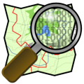
Figure 4.1: OpenStreetMap symbol

Google
Google claims to have collected its own data using its own sourcing methods developed as part of its StreetView product. Google records video images of many of the streets in the world in StreetView. Launched in May 2007, StreetView provides users with 360° horizontal and 290° vertical panoramic street level views within Google Maps. Google collects these images using special cameras and equipment that capture and match images to a specific location using GPS devices.
Besides collecting data by themselves, Google maps use several different sources of data in Europe. They are using Tele Atlas to a large extent plus smaller map providers like Geocentre Consulting, PPWK, Tracks4Africa, Transnavicom, Europa Technologies, etc.
Google Maps is used for real navigation only by Google themselves in Google Navigation. As far as we know, it is not possible to get any detailed information regarding available attributes from Google.
Google provide data to their own service Google Maps Navigation, but so far they do not provide data to other vendors like the OEM:s.

POI data from 3rd parties
A lot of static data are available from 3rd parties, although these data might not be the most important data for energy efficiency. POI data from 3rd parties include petrol stations, rest areas, truck stops, weight stations, speed cameras.

Lantmäteriet and other land surveyors
Depending on the algorithms for LGV navigation, detailed information on slope angles might be of great interest. In the project “Krönt vägval” from the Swedish forest industry, a slope and index is being evaluated. The index does not reveal the actual slope at a given position but instead index on the total amount of slopes on a road stretch.
Slope angles could be calculated from the Z-values of the vertices on the road geometry, but if data is only represented in 2D or the quality of the height representation is poor an external data source has to be used. One solution to this is to use laser scanning.
Laserscanning is a process where rotating lasers is used in order to create 3 dimensional 'point clouds' of thousands of data points. The sensor rig used could either be airborne or mounted on a vehicle depending.
Based on a recommendation made by the Climate and Vulnerability Commission in their report (SOU 2007:60), the Government has commissioned Lantmäteriet to produce a New National Elevation Model (In Swedish: Ny Nationell Höjdmodell) with high and known accuracy using laser scanning technique.
Since 2009, Lantmäteriet is carrying out airborne laser scanning (LiDAR) in accordance with a plan embracing the requirements connected to climate change and other environmental issues. The aim is to produce a new Digital Elevation Model (DEM) in which the standard error is better than 0,5 m for grid points in a 2 meter grid. This grid could then be used in order to improve the quality of the height representation of the geometry in the road database.
Among the map providers at least NAVTEQ is using vehicle borne laserscanning in order to improve the Z values.

Other sources for dynamic data including real time probe data

TomTom HD Traffic
TomTom HD Traffic is the service that provides traffic information to TomTom navigation devices. For TomTom HD traffic requires a subscription, which gives the user traffic information in all countries where this is available. A wireless data connection (3G/GPRS) and a SIM card are required.
The key features of TomTom HD Traffic are (according to themselves):
- Real-time traffic in Europe from the most updated sources
- Traffic information is updated via TomTom's traffic center that collects and processes traffic around the clock
- Detailed reports on the incident, expected delay, alternative routes and automatic re-planning of the route if it is enabled.
- Accurate real-time warnings about dangerous road conditions (fog, snow, ice, etc.)

ITIS
The UK company IT IS (acquired by Inrix in October 2011) provide traffic information via RDS-TMC to sixteen vehicle manufacturers and to all aftermarket suppliers. No 3G/GPRS-channel to navigation devices established so far. The majority of their affair operates in the UK, but a strong international expansion is underway.
ITIS provides quality assured traffic information for a variety of applications. This is done both in real time and forecasts as well as by historical data. ITIS has also developed its own technology to calculate current traffic flow out of probe data from vehicle fleets and from mobile phones.

Mediamobile
The French company Mediamobile recently bought Destia traffic and formed Mediamobile Nordic. Mediamobile collects traffic information by itself and contracts with external parties on the supply of traffic information. Governments at all levels as well as highway organizations are their providers. Sources are also cameras, GPS signals from cabs, etc. which means that they are using probe data quite extensively.
Mediamobile provides traffic information via both RDS-TMC and via 3G/GPRS to mobile phones and navigation systems that are connected via a SIM card.

Historical probe data

NAVTEQ Traffic Patterns
NAVTEQ Traffic Patterns is an enhanced service that makes use of data collected from GPS-equipped Nokia phones.
NAVTEQ Traffic Patterns include:
- Seven different traffic flow models, i.e. one for each day of the week.
- Speed ​​Statistics divided into 15-minute intervals that cover 24 hours a day.
- Coverage of major roads and street-road network in cities.

TomTom IQ routes
This new improved technology calculates routes based on the real average speeds measured on roads every day compared to speed limits. This uses historical data that TomTom users have been adding to over the years. It will always provide users with the smartest route hour-by-hour, day-by-day, saving them time, money and fuel.
As TomTom says: “This technology is part of the next generation of navigation delivering real smart routing for the 21st Century. IQ Routes™ is just one of many groundbreaking TomTom technologies that make your journey quicker, easier, safer, more predictable and less stressful.” By using IQ Routes you are supposed to get more realistic journey and arrival times.

Summary of available data
Looking into the attribute specifications from NAVTEQ and from NVDB, it is obvious that most of the attributes relevant for energy efficient navigation are specified and available or on the way to be provided. It looks promising, but some major obstacles still exist: Coverage, Up-to-date-ness and quality of data.
Physical conditions affecting smooth speed like junctions, traffic lights, stop signs, etc. are available as attributes in the specifications although the actual coverage might be limited to major roads and cities.
Absolute height (3-dimensional coordinates) or slope (angle or percentage) are of great importance for truck navigation. These attributes are included in data products from the map providers. NAVTEQ can provide slope with the quality of +-1 m and +-1% over 100 m for FC 1-2 and for FC 3-4 in some areas. Slope data of less quality are available on smaller roads. Whether this is sufficient for optimizing navigation for heavy vehicles, are still not verified.
Slope index as well as road classification dedicated for LGV are not explicitly available, but if needed, these two attributes might be possible to derive from other available attributes.
TomTom logistics product has about the same content as NAVTEQ Transport. TomTom collects probe data to a large extent which means that speed profiles (IQ routes) and travel time profiles are available in most of Europe. Also NAVTEQ collects probe data (Traffic patterns). Real time travel times are available in larger cities from both vendors. Google also provides real time travel times as well as historical travel times. These kinds of probe data are extremely interesting and will most probably make some traditional static data obsolete. Still a large amount of attributes, as legal restrictions etc. are not possible to collect from probes.
How to deal with up-to-date-ness and quality are discussed in chapter 4.7 below.

Currently used data

Navigation system suppliers

ALK CoPilot
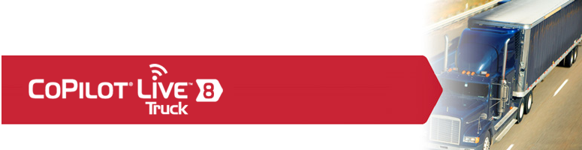
Figure 2 – Advertisement for CoPilot Truck from ALK
ALK CoPilot is a product profiled for use in trucks. ALK is using a large number of general and truck specific attributes available from NAVTEQ. Height, weight and other restrictions are taken into account and compared with truck-parameters, when deciding routes available for driving a specific truck. Large roads are prioritized before smaller roads to a larger extend than for usual car routing. ALK is tweaking the NAVTEQ functional road classes a bit before using them in their route optimization. In the US they also classify the roads according to GPS-traces from a large amount of trucks using their products.
ALK uses historical travel times when estimating current travel times, but so far no time dependent travel time profiles are used, only one fixed travel time per link.
ALK also uses what they call “Magnetic routes”. This is predefined routes obtained by collecting GPS-tracks from thousands of trucks. Magnetic routes are considered as routes preferred by the truck drivers. These routes can override the usual route optimization. The Magnetic route concept is a bit similar to the Swedish forest industry concept “Krönt vägval”
When calculating the best route for a truck, ALK consider to use:
- height and slope in combination with the truck profile for a specific vehicle
- a number of other attributes like traffic lights, stop signs, junctions, curves, but so far they don’t know a proper way to put cost on all these parameters.

Appello
Appello has based its off-board routing platform on a server platform provided by US-based deCarta. This is one of few companies that license a location-based server suite to third parties. Early 2010, deCarta was developing a large vehicle routing application and was preparing to process the special attributes required for this application. Currently deCarta has cancelled the project due to resource problems and reduced demand, which means that Appello also had to cancel its activities in this area. The conclusion is that currently Appello does not use any specific truck attributes in its navigation products, although it developed a demo application for truck navigation for SOLVI (see Figure .. below.)
Appello uses available static data from NAVTEQ for usual car navigation. Appello also uses dynamic traffic information from different providers in different countries as well as probe data in some countries where it is available.
Figure 3 – A screen shot from a demo application for truck navigation from Appello

Melco
Melco does not offer truck navigation at this stage. They have ambitions, but no actual progress towards truck navigation has been achieved so far.
Melco uses available static data from NAVTEQ for usual car navigation. Melco also uses dynamic traffic information from TMC-providers in different countries.

TomTom Work
TomTom Work is TomTom’s concept for truck navigation. TomTom CPU (former Tele Atlas) provides data to TomTom Work navigation products. In addition to usual car navigation data TomTom Work got truck related data, e.g.:
- the lower speeds of trucks on all roads
- sharp angles that trucks find difficult
- access restrictions for trucks based on weight and dimensions
Figure 4 – TomTom Work – navigation for trucks
Dimensional and weight restrictions are currently available on the major and interconnecting roads in Austria, Belgium, France, Germany, Luxemburg, the Netherlands, Spain, Switzerland and the Great Britain.
Depending on vehicle characteristics (put in by the driver) streets can be blocked because of restrictions related to:
- Height
- Length
- Width
- Weight
- Weight per axle
- Load
HD Traffic and LIVE services for real-time traffic information are available via TomTom WEBFLEET. Traffic information is provided from TomTom Traffic.
TomTom Work uses the TomTom so called IQ Routes technology for efficient route calculation. Travel time calculation is based on historical travel time information for every road, rather than the traditional static measure of maximum speed per road type.
TomTom’s Map Share technology is available, which means that the user can make his own map corrections and also benefit from the thousands of corrections made by TomTom users every day. With the TomTom Truck Map Share functionality, truck drivers can also make corrections to their map by adding or changing access restrictions for roads based on dimension and weight.
The algorithm for trucks in TomTom Work:
- favor major over small roads
- avoid small streets, sharp turns & U-turns as much a possible
- take into account that trucks prefer right turns (if right-hand traffic)

Google Navigation
In November, 2009, Google Maps Navigation was released in conjunction with Google Android OS 2.0. The initial release was limited to the United States. In 2010 it was launched in Canada, Australia and 11 countries in Europe. Sweden is not among these countries, although rumors say that the introduction in Sweden will come rather soon. It is still unknown when it will be released in the rest of the world.
No specific product for LGV is foreseen so far.
Google Navigation of course uses Google Maps as data source, see 4.3.4.3.

Summary of currently used data
A usual car navigator does not use restrictions valid for heavy vehicles when determining allowable routes, but the truck routing navigators from ALK and TomTom use these attributes. All navigators of course use restrictions like one way roads and forbidden turn to determine allowable routes.
To optimize routes most navigators use functional road class, speed limit, etc. but also real time and historical travel times (sometimes dependent on day and time). In some cases the optimization is based only in shortest route, no attributes at all used. Shortest route optimization can be devastating for large vehicles when guided into forest paths etc.
Slope data or absolute height are about to be introduced as in truck navigation products. Hyundai claims they use slope data when optimizing routes for trucks. ALK and TomTom Works have not yet introduced the use of slope data as far as we know.
Attributes like junctions, traffic signals, stop signs, etc. might be used to inform the driver, but so far these data are not used for optimizing the route for smooth speed and energy efficiency.

Usability of data

Mapping useful data towards available data and currently used data
A cross in the tables below indicating that an attribute is available from one vendor doesn’t mean that the attribute are available for all roads, restrictions to certain functional road classes might apply.

Data for determining allowable routes for LGV

Static data
Attribute name | Available from |  |  | Used by
 | NVDB | NAVTEQ | TomTom CPU | TomTom Works | ALK | Other actor
Physical barrier | X | X | X | X | X
One way road | X | X | X | X | X
Road forbidden for certain vehicles | X | X | X | X | X
Road forbidden for trailers | X | X | X | X | X
Physical turning restriction | X | X | X | X | X
Forbidden turn (left/right) | X | X | X | X | X
Forbidden turn for certain vehicles (left/right) | X | X | X | X | X
Height restriction | X | X | X | X | X
Weight restriction | X | X | X | X | X
Weight per axle restriction | X | X | X | X | X?
Length restriction | X | X | X | X | X
Width restriction | X | X | X | X | X
Number of axles restriction | - | X | ? | ? | ?
Environmental zoon | X | X | ? | ? | X
Restrictions for dangerous goods | X | X | ? | ? | X
Snow chains required | - | - | - | -

Dynamic data
Attribute name | Available from |  |  |  | Used by
 | TRISS | NAVTEQ Traffic | TomTom Traffic | Mediam. Nordic | TomTom Works | ALK | Other actor
Temporary closed road | X | X | X | X | X | X

Data for route optimization

Static data
Attribute name | Available from |  |  | Used by
 | NVDB | NAVTEQ | TomTom CPU | TomTom Works | ALK | Other actor
Road geometry | X | X | X | X | X
LGV Speed limit (depending on vehicle-type, weight, type of goods, etc.) | X | X | X | X | X
Functional Road Class | X | X | X | X | X
Height values included in geometry | X
Slope (angle or percentage) |  | X | X? |  | C | Hyun-dai
Slope index | *
Steep slope (up/down) |  | X | X
Recommended road for LGV | X | X | ? | ? | X?
Preferred LGV routes defined by the authorities | *
Functional Road Class dedicated for LGV
Recommended road for dangerous goods | X
Paved or unpaved road | X | X | X | ? | ?
Junction | X | X | X |  | C
Road ferries | X | X | X | ? | ?
Road charging |  | X | X | ? | ?
Urban area | X | X | X
Stop sign |  | X | X |  | C
Traffic light |  | X | X |  | C
Speed bump
Railway crossing | X | X | X |  | C
Type of road / FormOfWay | X | X | X | X | X
Road width | X
Curve index | * |  |  |  | C
Sharp curve (left/right) |  | X | ? | ? | ?
Risk of grounding |  | X | ? | ? | ?
Risk of lateral wind |  | X | ? | ? | ?
Service area suited for LGV | X | X | ? | ? | ?
Large vehicle parking place | X | X | ? | ? | ?
Entry and exit to different kind of business related destinations, e.g. transition nodes, industries, etc.
Accident black spots | **
Accident black spots for LGV
Platooning sections
C means “Consider to use”
* Not present at the moment but discussed as a new feature
** Can be derived

Dynamic data
Attribute name | Available from |  |  |  | Used by
 | TRISS | NAVTEQ Traffic | TomTom Traffic | Mediam. Nordic | TomTom Works | ALK | Other actor
Traffic situation / congestions | X* | X | X | X | X | X
Incidents | X | X | X | X | X | X
Road surface conditions | X | X | X | X | X | X
Weather conditions | X | X | X | X | X | X
Road works | X | X | X | X | X | X
Platooning
* If regarded as obstruction

Probe data and detector data
Dynamic data can be replaced or supplemented by real time probe data and real time detector data in the form of measured current travel times and current speed.
Real time probe data and detector data (cameras, loop data, etc.)
Attribute name | Available from |  |  |  | Used by
 | TRISS | NAVTEQ Traffic | TomTom Traffic | Mediam. Nordic | TomTom Works | ALK | Other actor
Current travel times per link |  | X | X | X | X | ?
Current speed |  | X | X | X | X | ?
Road surface conditions (friction)

Some static data can be replaced by statistics based on historical probe data and/or historical detector data.
Historical probe data and detector data
Attribute name | Available from |  |  |  | Used by
 | TRISS | NAVTEQ Traffic pattern | TomTom IQ routes | Mediam. Nordic | TomTom Works | ALK | Other actor
Routes preferred by drivers |  |  |  |  |  | X
Average travel time per link |  | X | X | ? |  | X
Travel time profiles per link |  | X | X | ? | X
Speed profiles per link |  |  | X | ? | X
Acceleration profiles per link
Historical fuel consumption per link
Historical emissions per link
Aggregated eco parameter based on historical fuel consumption, emissions, etc.

Data for navigation instructions
Attribute name | Available from |  |  |  | Used by
 | NVDB | NAVTEQ | TomTom CPU | TomTom Works | ALK | Other actor
Road number | X | X | X | X | X
Road/Street name | X | X | X | X | X
Roundabouts | X | X | X | X | X
Junction number | X | X | X | X | X
Lane information |  | X | X | X | X
Speed cameras | X | X | X | X | X
Road sign text |  | X | X | X | X
Interchange number |  | X | X | X | X
Parking area forbidden for certain vehicles | X | X | X | X | X
Curves (left/right) |  | X | X | X | X
Steep hill (up/down) |  | X | X | X | X
Road narrows |  | X | X | X | X
No U-turn | X | X | X | X | X
No U-turn for LGV | X | X | X | X | X
No overtaking allowed for trucks | X | X | X | X | X
Lateral wind |  | X | X | ? | ?
Emergency exits |  | ? | ?

Available but not used data
Not even the most advanced truck navigation systems use all available truck-relevant data.
- Hyundai claims that they use slope data for optimizing truck routes, otherwise slope data are not used as far as we know.
- Data reflecting features that affect smooth driving negative like traffic lights, junctions, stop signs, acceleration profiles, historical fuel consumptions, etc. are not used.
The reason not using the above attributes is according to one navigation system supplier, that they don’t know how to implement an algorithm that can take these attributes into account.
Another reason might be no customer demand for such an advanced application in the past. This might change due to larger environmental consciousness and increased fuel prices.

Missing data
According to specifications almost no data are missing. The problems are likely to be coverage and up-to-date-ness.
The coverage of probe data is dependent on probe vehicles equipped with connected devices. Today these are still restricted to areas with high traffic volumes. This situation will most likely change over time.
The coverage for traffic lights, stop signs, junctions, etc. are limited to major roads and cities.
Slope data have been missing, but the map providers now have equipment to be able to measure slope with an appropriate quality. The coverage is still limited to FC1 and FC2 (FC3 and 4 in some areas). Alternative sources for slope data also appear today like laser scanning by land survey organizations.

Creation of new attributes and possible enhancements
Since this study indicates that not all available data are used, a good start would be to develop an algorithm that uses a larger amount of available data than today’s algorithms. This is also a good idea since data capture of new feature types is very costly especially on a European level.
By using today’s road classification (FRC, road number, Form of Way, etc.) it is possible to route on major roads to a larger extent than what is the case today.
Creation of new attributes like FRC dedicated for trucks might not be necessary if a larger portion of today’s available data are used and by using algorithms that can take advantage of these data.

Data provision chain

Overview
Figure 4.2: Overview of a general data provision chain

Services, Interfaces and Standards

Static data

ROSATTE
Accurate and up-to-date road attributes such as speed limits, traffic signs and traffic regulations are essential for a number of different applications including truck navigation. The road authorities in Europe are responsible for many of these attributes. The map providers NAVTEQ and TomTom currently measure and capture these attributes by themselves, due to lack of processes and technique to use attributes supplied by the road authorities. To overcome these difficulties, the ROSATTE project developed the enabling routines, processes, infrastructure and supporting tools that will ensure European access to road attributes including incremental updates. This infrastructure will facilitate administrative internal functions as well as supply of data to third parties.

INSPIRE
Inspire is an English language online magazine reported to be published by the organization Al Qaeda in the Arabian Peninsula. The first issue appeared in July 2010.
It is also an EC directive for establishing an infrastructure for harmonized spatial information in Europe. The purpose of this information is to support EC’s environmental policies and policies or activities which may have an impact on the environment.
The environmental scope of Inspire however makes the information not very well suited for navigation purposes. First of all, authorities only have to produce features if data is present within the organization, i.e. no extra data collection is forced upon the authorities. In other words, even if the data model has been harmonized all feature types will not be present in all countries.
The data specification of Inspire does not make any demands on updating frequencies nor are there any specifications on change transaction. There is a risk that updating frequencies might vary a lot amongst the participating countries.
A third and important disadvantage with the dataset is that the feature types have been modeled with the mind set on another usage than navigation. Temporal variations like “Monday – Friday 07:00 – 17:00” are impossible to express and these types of variations are very common for speed limits, at least in Sweden.
The Inspire dataset, with some modifications on the data model, might in the future be an alternative for LGV navigation but not at present.

ISO TC211
ISO TC211 works with standardization in the field of digital geographic information. This work aims to establish a structured set of standards for information concerning objects or phenomena that are directly or indirectly associated with a location relative to the Earth.
These standards may specify, for geographic information, methods, tools and services for data management (including definition and description), acquiring, processing, analyzing, accessing, presenting and transferring such data in digital/electronic form between different users, systems and locations.
The work shall link to appropriate standards for information technology and data where possible, and provide a framework for the development of sector-specific applications using geographic data.
Examples of relevant standards are:
- 19131 - Data product specifications
- 19132 - Location based services - Reference model
- 19133 - Location based services - Tracking and navigation
- 19134 - Multimodal location based services for routing and navigation

ISO TC204
ISO TC211 works with standardization in the field of Intelligent Transport Systems. To be successful in developing ITS-applications, low cost communications equipment needs to be incorporated into passenger and public transport vehicles. ISO/TC204 is developing standards to ensure the global integration and interoperability of such technologies, as well as allow the data from these devices to be successfully translated into useful information for location-based services such as automatic crash notification, traffic notification and alternative routing.
Examples of relevant standards are:
- 14825 - Geographic Data Files (GDF) – under development
- 17267 - Navigation systems -- Application programming interface (API)
- 17572 - Location referencing for geographic databases
- 18234-9 - Traffic and travel information via transport protocol expert group (TPEG) data-streams -- Part 9: Traffic Event Compact (TPEG-TEC) - under development
- 29284 - Event based Probe Vehicle Data - under development

Dynamic data

TMC
Traffic Message Channel (TMC) is a technology for delivering traffic and travel information to drivers. It is usually broadcasted over the FM-RDS system. It can also be transmitted on DAB or satellite radio. It allows delivery of dynamic information suitable for display in the language chosen by the user. Services, both public and commercial, are now operational in many countries worldwide. When data is integrated directly into a navigation system, this gives the driver the option to take alternative routes to avoid traffic incidents.
TISA-forum maintains the TMC-Standard (ISO 14819).

TPEG
TPEG, the acronym stands for “Traffic Protocol Experts Group” and it is the name of a system specification for delivering digital, language independent traffic messages over most digital bearers. TPEG contains several different applications among them TPEG-RTM (Road Traffic Messages) and TPEG-TEC (Traffic Event Compact)
TPEG-RTM is event oriented and mapped towards RDS-TMC, but much more detailed than TMC. A hierarchical structure allows for a wide range of service implementations.
TPEG-TEC is designed to provide very efficient transmission of road events. It provides cause / effect information. TEC is in-vehicle terminal device oriented. TEC originates from the German national project mobile.info.
TPEG is adopted as CEN/ISO standards:
- TPEG Binary - originally developed for Digital Radio CEN/ISO TS 18234-Series Published: 2006-06-01
- tpegML - developed for Internet bearers & message generation using XML CEN/ISO TS 24530-Series Published: 2006-04-20 ISO Link
TISA-forum maintains the TPEG-standards.

Proprietary formats
Most service providers use proprietary formats for delivering for dynamic data to users and devices in vehicles.

Conclusions regarding data

Data for route optimization
According to the attribute specifications from the map providers most of the attributes relevant for energy efficient navigation for heavy vehicles are specified and available or on the way to be provided. It looks promising, but some major obstacles still exist: Coverage and Up-to-date-ness.
When optimizing routes, today’s truck navigation systems use functional road class, speed limits, restrictions including the ones valid for heavy vehicles. There is also an increased use of probe data both as dynamic travel times and as historical travel time profiles. Probe data will most probably make some traditional static data obsolete.
Slope data is of large value for energy efficient navigation. Today the map providers can provide slope data for major roads, but the use is still minimal.
Data reflecting features that affect the ability to maintain a constant speed like traffic lights, junctions, stop signs, curvature, acceleration profiles, historical fuel consumption per road segment, etc. are not used yet.
Map providers and authorities should cooperate in defining desired roads for heavy vehicles especially in urban areas and setting the usual FRC to an appropriate value on these roads.

Data describing transfer terminals
At a transfer terminal goods and cargo can be transferred from one vehicle to another. Vehicles can be of all sizes. At a multimodal terminal goods and cargo can be transferred between different transport modes (not covered in this report). Data describing transfer terminals in an accessible and standardized way is not available today. ISO19147 defines a data model for “transfer nodes” (i.e. data as access points, stop points, accessibility, equipment, etc.). One option could be to enable the possibilities for users to register terminal data by themselves. Data describing transfer terminals is a pre-condition for relevant logistics planning.

Data for logistics – planning and operating a fleet
For logistics planning there is a need of other kind of data than road data, such as vehicle characteristics, loading capacity, type of container, type of cargo, loading and unloading locations and, terminal data as mentioned above, time slots, maximum time for transportation, business specific conditions. No investigation related to this kind of data has been done.

What could be achieved with data available today
By more advanced algorithms and better coverage of the data already available today, energy efficient navigation for heavy vehicles will be possible. Not already used data to exploit are slope data and the attributes affecting smooth driving negative mentioned in Error! Reference source not found. above.

Expected development next 5-10 years
Slope data will be measured by map providers and others with a quality appropriate for advanced applications like dynamic truck navigation and ADAS.
It is almost impossible for a map provider to meet the demands on up-to-date-ness by measuring all the data by themselves. New approaches to overcome this are:
- Extended use of probe data – travel time profiles, acceleration profiles, historical fuel consumption and emissions, etc, could be used instead of speed limit and other attributes to calculate best route and most energy efficient route.
- Extended use of crowd sourcing – users will be important reporters of map changes. Improved routines will allow for this.
- Traffic sign recognition by optical sensors in the vehicle – can be a complement to pre-stored map attributes. These kinds of data measured by users can be stored and used for future route optimization.
- Cooperating with authorities to collect legal data like speed limits, legal restrictions as one way roads, etc. Also traffic signs and traffic lights could be provided from authorities although not all authorities have routines to be able to provide the data. The ROSATTE concept will provide a tool for this.
On a higher level an actor like Google might change the whole arena of how to assemble necessary data. This might not be an advantage for smaller segments like energy efficient navigation for heavy vehicles.

Expected development in the next 5-10 years
Slope data will be measured by map providers and others with a quality appropriate for advanced applications like dynamic truck navigation and ADAS.
It is almost impossible for a map provider to meet the demands on up-to-date-ness by measuring all the data by themselves. New approaches to overcome this are:
- Extended use of probe data – travel time profiles, acceleration profiles, historical fuel consumption and emissions, slope data, etc. could be used instead of speed limit and other attributes to calculate best route and most energy efficient route.
- Extended use of crowd sourcing – users will be important reporters of map changes. Improved routines will allow for this.
- Traffic sign recognition by optical sensors in the vehicle – can be a complement to pre-stored map attributes. These kinds of data measured by users can be stored and used for future route optimization.
- Cooperating with authorities to collect legal data like speed limits, legal restrictions as one way roads, etc. Also traffic signs and traffic lights could be provided from authorities although not all authorities have routines to be able to provide the data. The ROSATTE concept will provide a tool for this.
On a higher level an actor like Google might change the whole arena of how to assemble necessary data. This might not be an advantage for smaller segments like energy efficient navigation for heavy vehicles.
The above will improve coverage and up-to-dateness a lot compared to the current situation. Data will definitely not be the obstacle for future implementation of energy efficient navigation for heavy vehicles, even though handling data is not a simple task today and in the future the processes of data handling will be more complex utilizing data from different kind of sources.

Possible action items
Possible action items on the short run to come a step further towards energy-efficient navigation for heavy vehicles are:
- Develop existing routing-algorithms to be able to take advantage of more data that are present today.
- As a proof-of-concept carry out a test to compare routes generated with a usual car routing algorithm with routes generated with an algorithm utilizing all available data.
- Promote the proof-of-concept.
- Investigate coverage regarding the needed data.
- Suggest actions to improve the coverage (measuring, more probe data, combing data from different sources).
- Cooperate with navigation system suppliers and other vendors using routing algorithms for heavy vehicles.
- Cooperate with the European Commission (DG INFSO and DG MOVE) to promote the potential in fuel savings by using green routing and navigation.

Route Calculation and Optimization

Introduction

State of the art study
The two main objectives of the GRON:T project are to perform a study of the state of the art (including trends) concerning the topic expressed in the project title, "green route optimisation and navigation for trucks", and to formulate recommendations based on the results of this study for a follow-up project, which will include development activities. This report presents the results of the project subgroup with focus on "route calculation and optimisation", in general, and for trucks in particular. This report is a contribution to the state of the art study, and will be integrated in the project report on the state of the art.

Topics of study of the subgroup
Based on a list of general questions, the subgroup has defined the following topics for study concerning its domain:
- approaches for route optimisation and navigation algorithms, and for link costing: general, HV specific, fuel efficiency specific, preferred routes specific; functionality, classification and attributes used; current, and trends and requirements for the near- and mid-term future
- the need for and specification of a special functional road classification for HV routing
- relevance and use of dynamic and semi-dynamic data such as traffic information, traffic patterns and weather related information
- relevance of road use charging, both for route optimisation and as an incentive for taking the optimal route
- remaining other aspects: relevance and methods to take into account driver characteristics; status and future of a general vehicle platform; learning map concept, and self-learning from previous routes; on-board versus off-board; development status of platooning

Scope of the document
This document will give an overview of the state of the art of route calculation for navigation systems, and the latest developments. Then, it will point to the elements of routing that are particularly relevant for truck routing. This is followed by an overview of navigation systems on the market designed for truck routing, and an analysis of these systems in terms of the use of truck specific or truck relevant elements by the routing algorithm. By comparing this result with the user requirements, this then should enable to somehow conclude if there is enough room to develop a new system that can distinguish itself sufficiently from existing systems.

Vehicle navigation

History
Serious development of in-vehicle navigation systems started in the mid 1980's. Market introduction of such systems required availability of dedicated digital maps with sufficient coverage and detail. The development of navigation maps started at the end of the 1980's, especially in Western Europe and North America. First navigation systems came to the market in 1995. Coverage and detail of digital maps were relatively limited at that time, but sufficient to create an attractive new market despite the high price of the systems.

Functionality
A navigation system is an ICT based application that helps a user to plan an optimal route, based on a chosen criterion, from the current position to a destination provided by the user, and to follow the planned routed based on visual and/or spoken guidance instructions, and/or by using a display that shows a map and the route on that map. This document especially refers to navigation systems that use a representation of the road network for calculating the route and the guidance instructions. Other types of navigation systems are used in airplanes and onboard ships. Even a plain GPS (Global Positioning System) device without a proper map is a navigation system, when a set of waypoints of the route to be followed is stored in the device. Navigation systems using a digital map database of the road network were primarily developed for cars, but can also be used in trucks, busses and motorcycles, and even for bicycle and pedestrian navigation.

Components
A vehicle navigation system has several standard components:
- digital map database
- vehicle positioning and map matching
- route calculation
- route guidance
- human machine interface
- traffic information receiver or bidirectional communication device
For the purpose of this report the components digital map database and route calculation are the components of interest.

Digital map
The digital map used for navigation is a node-link connected graph with a multitude of attributes that are related to links or nodes (or other geographical objects constructed from these, such as polygons). Connectivity throughout the network is important to enable route calculation. One of the most important attributes of a digital map database for navigation is Functional Class.
The attribute Functional Class (or in GDF terminology Functional Road Class), in short FC, provides a hierarchical classification of the road as represented in the map database. The GDF standard [1,2] distinguishes ten possible levels for FC (0-9), while the NAVTEQ maps database defines five levels (1-5, but in the NAVTEQ GDF specification and exchange format [3] these are labelled 0-4). For each level, all road elements of that level together with all road elements of the higher levels form a connected graph. The NAVTEQ attribute is defined as follows [3]:
- FC1 roads that allow for high volume, maximum speed traffic movement between and through major metropolitan areas
- FC2 roads used to channel traffic to FC1 roads for travel between and through cities in the shortest amount of time
- FC3 roads that interconnect FC2 roads and provide a high volume of traffic movement at a lower level of mobility than FC2 roads
- FC4 roads that connect with higher functional class roads to provide a high volume of traffic movement at moderate speeds between neighbourhoods
- FC5 roads whose volume and traffic movement are below the level of FC4 roads

Exchange format and physical storage format
The core map database is the basis to define a variety of map products. Map products are extracted from the core map database, and delivers in an exchange format. One of the most used exchange formats is GDF (Geographic Data Files) [1,2], respectively CEN and ISO standards published in 1995 and 2004. The map providers still use GDF 3.0 with a multitude of proprietary extensions. GDF is both a data model for navigation map databases and an exchange format.
For use in a navigation system, the map data in the exchange format are generally compiled to binary format for storage on the media used by the system. This format is generally named the physical storage format of PSF. Up to now most vendors of navigation systems use proprietary formats for this, but a new standardised common format is in development by the NDS Association, a consortium of car manufacturers, application/compiler developers and map providers. This Navigation Data Standard (NDS) also holds the promise of enabling future incremental updating of the in-vehicle map database. The development is initially focusing on map data for navigation, bust extension to map data for other types of applications is foreseen.

Route calculation

Route calculation: a single-source shortest path problem
One of the core functions of a vehicle navigation system is route calculation or route planning. This involves determination of an optimal route from an origin to a destination. Usually the origin is the current vehicle position, which was either stored in the system at the end or the previous trip, or is determined instantaneously by the vehicle positioning module by using GPS sensor input only. The destination is entered by the user via the user interface and in interaction with the digital map database. The destination may be a street, a street address, a point of interest (POI) or a postal code.
Determining an optimal route between two points in a node-link database is a single-source shortest path problem. This is a well-known problem from graph theory. In graph theory, a graph is a set of nodes and links. A link is bounded by two nodes, and links are connected at nodes. In this way, a graph constitutes a network. Nodes are also called vertices, and links are also called edges. In a non-directed graph there is no distinction between the two nodes that bound a link, while in a directed graph each edge is directed, i.e. one node is the start node (or tail of an arrow representing the edge) and the other node the end node (or head of the arrow). The digital map database as used in vehicle navigation systems is a directed graph, where generally the start node is named From node, and the end node To node. An important topic in graph theory is connectivity. A graph is connected if there is a path through the network from each node to each other node in the graph. In a digital map database for vehicle navigation, the set of nodes and links that represent the road network, constitute a connected graph. See also before, the connected sub-networks based on functional class. Connectivity enables the calculation of routes through the network, and navigation along these routes. Note that such map database contains also nodes and links for representation of cartographic and administrative features (like e.g. lakes, rivers, woodlands, railways, municipality boundaries), and that these nodes and links do not constitute a connected network.
For calculating an optimal route between two nodes in a graph, a shortest path algorithm needs a criterion that can be minimised. Each link is given a weight relating to the criterion, and the algorithm determines the path for which the sum of the weights of the constituting links is minimal (i.e. lower than the sum of the weights for every other path). This criterion is also named the link cost or link cost function, and the algorithm then determines the optimal route as the route with the lowest total cost in terms of the criterion. Typical cost functions used in a navigation system are distance and travel time. Distance of a link is directly related to the length of the link, while the link travel time can be calculated from its length and a speed value for the link, e.g. the maximum legal speed, or an estimated average speed for the type of road.
An important aspect is the efficiency of the algorithm. An in-vehicle navigation generally has limited computing power, while on the other hand the user generally will be impatient, and expects guidance to start shortly after the destination has been entered.

Dijksta's algorithm
A well-known and fundamental shortest-path algorithm is Dijkstra's algorithm, published in 1959 by the Dutch mathematician and informatician Edsger Wybe Dijkstra [7]. The algorithm finds the shortest paths from a selected start node to all other nodes in the graph, provided that all links have a non-negative cost. The algorithm can be described by the following steps (taking distance as the cost function):
- create a table with columns node-id, closed, previous node, edge from previous, cost from previous, total cost
- enter the start node with cost to previous and total cost zero; set the start node as active
- add to the table all open neighbours of the active node, add for each the active node as previous node, and the distance to the active node multiplied by the cost function as cost from previous, and calculate for each the total cost as cost to previous plus the total cost of the active node; mark the active node as closed
- if all nodes of the graph have been added, and if all nodes in the list are closed, go to step 5; otherwise, determine the non-closed node with the lowest total cost, make this node the new active node, and continue with step 3
- step backwards in the table from the destination node via the steps with the lowest cost to identify the shortest path, and present the result as a set of waypoints and/or a set of connected links
The field "edge to previous" has been included in the table to ease the construction of the set of connected links.
It may happen that a node appears more than once in the column node-id, with different total cost. As soon as the entry with the lowest total cost is used and marked as closed, the other entries with higher total cost will be marked as closed as well. As for vehicle navigation only the optimal route to the destination node needs to be identified, and not the optimal routes to all other nodes, the algorithm can be modified to stop the calculation process as soon as the destination node has been reached. This can be implemented by adding at the beginning of step 3 the following statement: "if the active node is the destination node, go to step 5; otherwise, ....".

A* algorithm
Even if Dijkstra's algorithm is stopped as soon as the destination node is reached, it is still not very efficient, as paths in all directions are evaluated as long as the destination node has not yet been reached. The A* algorithm, which is an extension of Dijkstra's algorithm, raises efficiency by adding a heuristic estimation for selecting the new active node, which reduces the number of nodes that need to visited before the optimal route is found (it reduces the search space). The Oxford dictionary defines the adjective heuristic as used in computer science as "proceeding to a solution by trial and error or by rules that are only loosely defined". The estimator, if the cost function is distance, is the straight line distance from each non-closed node in the list to the destination node. This cost is stored in a new field "heuristic cost" in the table, and the new active node is defined as the node with the lowest value for the sum of total cost and heuristic cost. The apparent result is that the open nodes are somehow prioritised with respect to their straight line distance to the destination node. If the cost function is not distance, the straight line distance shall be converted the appropriate cost parameter. For instance, if the cost parameter is travel time, the conversion can be done by taking an educated value for the average speed. The A* algorithm was first published in 1968 by Peter Hart, Nils Nilsson and Bertram Raphael [8].
The algorithm can be described by the following steps (taking distance as the cost function), where the underlined phrases indicate the additions with respect to the modified version of Dijkstra's algorithm, the phrase in italics the addition in the modified version with respect to the basic version, and the crossed out phrase the part that can be removed:
- create a table with columns node-id, closed, previous node, edge from previous, cost from previous, total cost, heuristic cost
- enter the start node with cost to previous and total cost zero; set the start node as active
- if the active node is the destination node, go to step 5; otherwise, add to the table all open neighbours of the active node, add for each the active node as previous node, and the distance to the active node multiplied by the cost function as cost from previous, and calculate for each the total cost as cost to previous plus the total cost of the active node; in addition, calculate for each node the straight line distance to the destination node, and store this in the field heuristic cost; mark the active node as closed
- if all nodes of the graph have been added, and if all nodes in the list are closed, go to step 5; otherwise, determine the non-closed node with the lowest value for the sum of total cost and heuristic cost, make this node the new active node, and continue with step 3
- step backwards in the table from the destination node via the steps with the lowest cost to identify the shortest path, and present the result as a set of waypoints and/or a set of connected links

Example of a simple A* implementation
Figure 5.1 demonstrates three routes through the small town Den Burg in The Netherlands, calculated using NAVTEQ map data and a simple implementation of the A* algorithm. Figure 1a shows the town without routes. Only the lowest three FC values are present. The grey lines are FC 5, the thin yellow lines FC 4 and the wider yellow lines FC 3. The routes are calculated from east to west. Route 1b is calculated with the same cost for all links irrespective of their FC level. For route 1c, for each FC level an FC cost that is twice as high as the FC cost of the next higher level. This forces the route away from the FC 5 links to the FC 4 links. For route 1d, for each FC level an FC cost that is three times as high as the FC cost of the next higher level. This forces the route away from the FC 5 and FC 4 links to the FC 3 links.
Table 5.1 and Figure 5.2 demonstrate the search process. They relate to route 1c of Figure 5.1. The table provides the first xx lines of the search. The path can be easily followed back from node 63384834 (in red) to the start node (also in red) via the node-IDs in blue. This path is found by selecting the node-ID in column G, and then finding this node-ID in column A. If more than one exist in column A, the one with the shortest distance is selected. The column A is added to indicate in which order the nodes that were found and added to the table have become the active node. The number(s) in column N corresponding to the number in column A indicated the rows with the neighbour(s) that was/were found for each node in column A.

Cost function
Navigation systems generally provide the user choice between different route selection criteria. Typical for standard navigation systems, as were for instance present in the VDO Dayton system of ten years ago, are shortest, fastest (in general), main roads (fastest with preference for higher level roads), avoid main roads (fastest with a penalty for higher level roads), and an additional option to avoid toll roads (penalty for toll roads). As stated before, shortest is based on actual distance, and fastest on an estimated average travel speed per link combined with distance. The estimated average travel speed for a link can be a function of the legal speed limit for the link, and in addition on other map attributes like Functional Road Class and Form of Way. The NAVTEQ map database provides the attribute Speed Category, which may be used for this. The attribute classifies the general speed trend of a road based on posted or legal speed, and taking into account several other factors besides legal speed limit (e.g., physical restrictions or access characteristics). It may be used to estimate link traversal times, to prioritise link selection during route calculation, and to calculate timing of the route guidance. [9]

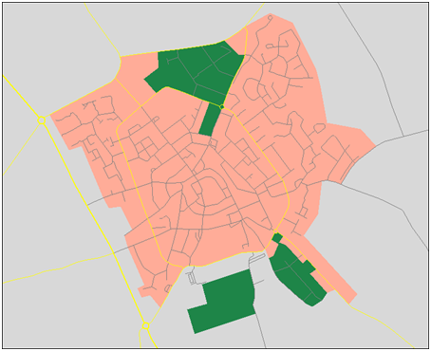
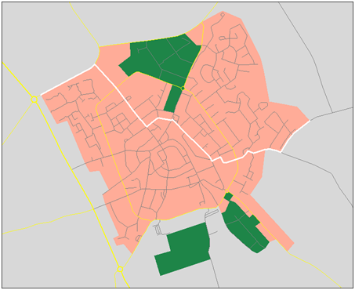
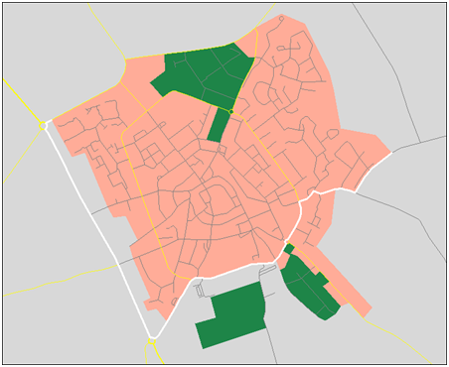
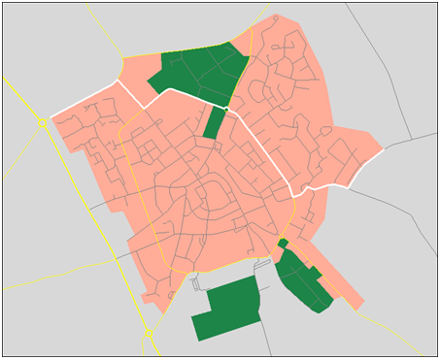
a
b
d
c

Figure 5.1 - Map of mall town of Den Burg in The Netherlands, without route (1a), and with routes calculated with respectively equal FC cost for each FC (1b), a factor 2 higher FC cost for each next higher FC level (1c), and a factor 3 higher FC cost for each next higher FC level (1d). Only three FC levels are present, grey lines represent FC5, thin yellow lines FC 4 and wider yellow lines FC 3.

A | node | f | g | h | N | parent | diste | distc | edge | cd
1 | 543096236 | 1827 | 0 | 1827 |  | 0 | 0 | 0 | 0 | 1
4 | 543096232 | 4548 | 2575 | 1973 | 1 | 543096236 | 161 | 2575 | 585197323 | 1
2 | 543096235 | 4178 | 2457 | 1720 | 1 | 543096236 | 154 | 2457 | 585197328 | 1
3 | 838228634 | 4418 | 2710 | 1709 | 2 | 543096235 | 16 | 253 | 763725241 | 1
8 | 543095806 | 6372 | 4705 | 1666 | 2 | 543096235 | 141 | 2248 | 585197322 | 1
6 | 727268964 | 5530 | 3873 | 1657 | 3 | 838228634 | 73 | 1163 | 763725242 | 1
5 | 838228635 | 5152 | 3413 | 1738 | 3 | 838228634 | 44 | 703 | 763725243 | 1
9 | 838228636 | 6396 | 4738 | 1658 | 3 | 838228634 | 127 | 2028 | 763725244 | 1
 | 543096203 | 21172 | 19486 | 1686 | 4 | 543096232 | 1057 | 16911 | 61302045 | 1
14 | 543096160 | 8146 | 5970 | 2176 | 4 | 543096232 | 212 | 3395 | 61302046 | 1
7 | 727268963 | 6278 | 4599 | 1680 | 6 | 727268964 | 45 | 726 | 585197329 | 1
11 | 727268969 | 7109 | 5520 | 1589 | 6 | 727268964 | 103 | 1647 | 585197332 | 1
10 | 727268968 | 6638 | 5013 | 1626 | 6 | 727268964 | 71 | 1140 | 585197327 | 1
12 | 543095810 | 7517 | 5926 | 1590 | 8 | 543095806 | 76 | 1221 | 585197324 | 1
 | 543096136 | 18369 | 16077 | 2292 | 8 | 543095806 | 711 | 11372 | 61302039 | 1
11 | 727268969 | 10179 | 8590 | 1589 | 10 | 727268968 | 224 | 3577 | 585197331 | 1
12 | 543095810 | 8583 | 6993 | 1590 | 10 | 727268968 | 124 | 1980 | 585197326 | 1
13 | 543095809 | 7980 | 6419 | 1561 | 12 | 543095810 | 31 | 493 | 585197325 | 1
15 | 543093991 | 9362 | 7879 | 1482 | 13 | 543095809 | 91 | 1460 | 61301610 | 1
 | 543095913 | 25632 | 22554 | 3079 | 14 | 543096160 | 1036 | 16584 | 61302044 | 0
20 | 543096148 | 11116 | 8862 | 2254 | 14 | 543096160 | 181 | 2892 | 61302027 | 1
16 | 543093992 | 9871 | 8422 | 1449 | 15 | 543093991 | 34 | 543 | 61300682 | 1
22 | 543093982 | 11443 | 9945 | 1498 | 15 | 543093991 | 129 | 2066 | 61300687 | 1
17 | 543093949 | 10230 | 8775 | 1455 | 16 | 543093992 | 22 | 353 | 61300712 | 1
18 | 543093948 | 10499 | 9063 | 1437 | 16 | 543093992 | 40 | 641 | 61300654 | 1
19 | 543094006 | 10889 | 9420 | 1469 | 17 | 543093949 | 40 | 645 | 61300688 | 1
18 | 543093948 | 11596 | 10160 | 1437 | 17 | 543093949 | 87 | 1385 | 61300656 | 1
21 | 63384834 | 11417 | 10025 | 1392 | 18 | 543093948 | 60 | 962 | 61300705 | 1
27 | 543095483 | 12394 | 10908 | 1486 | 19 | 543094006 | 93 | 1488 | 61301517 | 1
34 | 543095527 | 13107 | 11680 | 1427 | 19 | 543094006 | 141 | 2260 | 61301518 | 1
 | 543096147 | 16468 | 13924 | 2544 | 20 | 543096148 | 316 | 5062 | 61302026 | 1
 | 543096179 | 17489 | 14953 | 2536 | 20 | 543096148 | 381 | 6091 | 61302031 | 1
23 | 543093778 | 11937 | 10585 | 1352 | 21 | 63384834 | 70 | 560 | 61300660 | 1
 | 543093969 | 225131 | 223846 | 1285 | 21 | 63384834 | 134 | 213821 | 80092748 | 1
28 | 63384832 | 12625 | 11204 | 1422 | 21 | 63384834 | 147 | 1179 | 61300659 | 1

Table 5.1 - Illustration of the search process with a simple A* algorithm. The table shows the first part of the search for route 1c of Figure 5.1. Figure 5.2 provide a detailed look at the part of the route and the node-IDs that is covered in this table. Colum node give the node-IDs of the node that have successively been found, column f gives the sum of g (total link cost up to this node) and h (heuristic cost from this node), parent is the ID of the previous node, diste is the rel distance (in m) of the edge between previous and newly found node, distc the calculated cost of the link using the cost multiplier, edge the link-ID, and cd is the column closed.
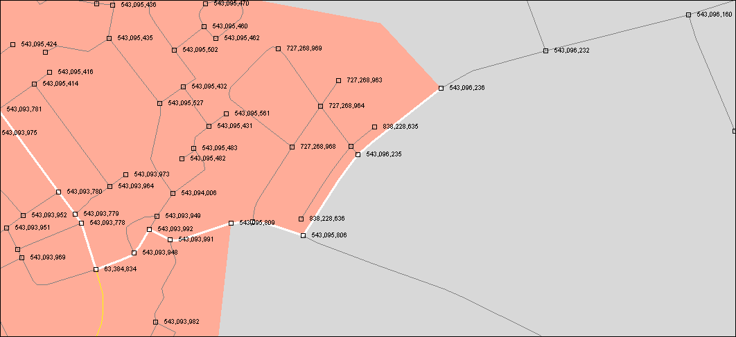

Figure 5.2 - First part of the route 1c of Figure 5.1, as described in 1, with node-IDs.

Bidirectional search
An approach to further improve the efficiency of a route search algorithm is to apply bidirectional search. This strategy reduces the search space. It implies that the algorithm searches from the start node to the end node, but also, and in parallel with this search, from the end node backwards to the start, until optimal paths from both directions have reached the same node. The algorithms need to maintain two lists, one for each direction (a forward and a backward list). Assuming that the algorithm runs on one single-core processor, the algorithm needs to switch between both directions, and the number of successive iterations in each direction between switches needs to be set. Also, the algorithm needs a statement to check if an optimal path from the other direction has been reached. This can be done by checking for each new active node if it already appears as a closed node in the list for the other direction.

Restrictions
The route calculation algorithm also needs to take into account restrictions. Examples of restrictions are turn restrictions at intersections (e.g. a left turn may when coming from a particular direction may be prohibited), one-way links for which travel in one of the directions of the link is prohibited). The first restriction is modelled in the map database as a relationship between two links, the second one by a the attribute Direction of Traffic Flow. Restrictions need to be taken into account by the algorithm. Restrictions can be general (generally applicable) or conditional (dependent on, for instance, vehicle type, time of the day or day of the week).

Dynamic information: traffic
The route calculation can also take into account dynamic information. The best known and most valuable type of dynamic information is traffic information. The oldest digital traffic information channel is RDS-TMC (Radio Data System - Traffic Message Channel). It is a combination of a protocol, a location referencing method and pre-defined event codes. Development of RDS-TMC started in 1984 [10], and the system became first operational in 1998 in Germany. A TMC message contains a location reference, which relates to a part of the road network, and traffic information related to that location, e.g. e reduced speed due to a traffic jam or a road work. TMC uses pre-coded locations stored in location tables to reference part of the road network. Due to the limited size of a location table, and the effort to pre-code locations and maintain locations tables, TMC coding is limited to major roads for through traffic.
The TMC location codes are also stored in the digital map database, which enables translation of the location reference to a set of link-IDs, and thereby interpretation of the message by a navigation system equipped with an RDS-TMC receiver. It can create a look-aside table of affected links in the area of interest, indicating the reduced speed values and the source of the problem. These values can be used, in principle, by a routing algorithm. The algorithm could take the values into account when evaluating link travel time during the route calculation process. A statement needs to be added to the algorithm to check for a particular link in the look aside table, if for the link in question a dynamic speed reduction exists. The information is also used by the system, when on route, to suggest calculating an alternative route to circumvent the traffic problem, and in general the information concerning traffic jams and road works can be presented to the driver on the displayed map, and by oral warnings.

RDS-TMC is relatively old technology, but it is available across Europe (from local service providers or radio stations; in many places still for free,), and in several other parts of the world, mature and rather stable, and therefore still widely in use. It has two major drawbacks. The pre-coded locations and the need for location tables limit the addressability of the network, and the system of TMC location codes is rather coarse. TMC can also be used on other bearers than RDS (with higher bandwidth), and other, map-based methods for location referencing have been developed, which provide a highly improved functionality.
TPEG is a new protocol for transmission of traffic and traveller information, designed for wide-band communication bearers, offering a wide range of possibilities for all kinds of services. The protocol was developed since end of 1997 by the EBU (European Broadcasting Union) supported Transport Protocol Experts Group. Gradually TPEG is coming into operation.
Pan-European traffic services are offered by the map providers. As an example, NAVTEQ Traffic is provided as a dynamic content feed that consists of continuously updated information about traffic conditions. It provides flow and incident data aggregated and tested from multiple sources including GPS probes, roadway sensors and event-based data from government sources. It features traffic flow conditions with speed values, unplanned incidents such as accidents and stalled vehicles, and planned incidents such as road construction and closures. In Europe it is available both in a NAVTEQ proprietary format and in the standard TMC format via RDS broadcast traffic services. As NAVTEQ Traffic Pro it is available via an (connected) XML feed. TPEG feeds are in active development and available for testing. Coverage in Europe concerns the countries Austria, Belgium, Denmark, Finland, Germany, Italy, Luxembourg, The Netherlands, Norway, Russia, Sweden, Switzerland, United Kingdom, while the XML feed is available in these countries, and in addition in France, Poland and Spain. Source: [11].

Historic traffic information
In addition to actual traffic information, a navigation system may also use historic traffic information, especially concerning traffic flow. Such data can be derived from large sets of probe data, and provide e.g. for every link of the major roads in the network an average speed value (or a travel time) for every day of the week for certain time intervals. Like for actual dynamic information, these values can be used in the route calculation process, when the algorithm is evaluating the travel time of a link.

NAVTEQ Traffic Patterns
NAVTEQ Traffic Patterns (a registered trade mark of NAVTEQ Corporation) is a database of typical average traffic speeds (or traffic flow velocities) on roads. For Europe, the coverage is 100% FC 1-5 for all countries in western and central Europe . The product is derived from billions of multiple-year, vehicle speed observations, including probe data records. It is available as a relational look-aside file in csv format, which is referenced to the map database. [12]
Two types of referencing are provided: to TMC location codes as coded as attribute in the map database, and to link-IDs. Referencing to TMC location codes provides a limited set, as TMC location codes are only available for the major parts of the road network. A TMC location code in the map database, and thereby a NAVTEQ Traffic Patterns values pointing to this TMC code, may cover 1-n map database links, dependent on the local situation. Coding to link-IDs comprises one set of Traffic Pattern values for each link. [13]
Traffic Patterns provides speed values in two units of measure, km/h and mph, with granularity of 1 km/h and 1 mph, for each day of the week (and combinations), and in two levels of time granularity, intervals of 15 minutes and 1 hour. [13]

Predictive traffic
Predictive traffic information uses both traffic patterns based on statistical historic information, and real-time traffic information. This requires sophisticated modelling and complex algorithms for integration of different types of traffic information data from various sources. Traffic patterns provide a good basis, but random events like accidents, vehicle breakdown and severe weather conditions may significantly interfere with these regular patterns. Traffic, like the weather, is a complex system with non-linear behaviour, which poses limits to its predictability. The integration of different kinds of traffic information into effective predictive traffic information for route calculation is an inticate process, which is currently only in the early stages of development. [14]

Link transition cost
Minimal distance routing based on the lengths of links in the map database is pretty accurate. Minimal time routing requires use of link distance together with an estimated average speed over the link, and thereby is less accurate. Traffic patterns, as described above, may help to improve this estimate by making it more accurate and reliable. Another important item to take into account, to improve accuracy, is link transition cost. As a simple example, it may make a considerable difference if one traverses an intersection with a right turn, a straight ahead or a left turn. Estimates for such delays cannot directly be derived from the map database, but some heuristics may help, based for instance on the type of turn, the presence of right-of-way signs, stop signs and traffic lights and presence of pedestrian and bicycle crossings. Also traffic information may help to provide insight into such delays.

Vehicle fuel consumption
A variant of least distance routing and least time routing is least fuel routing. For this, the cost function focuses on the expected amount of fuel to be used for a route from origin to destination. For this, for a general understanding, it is useful to have a look at vehicle fuel consumption.
Oguchi et al. [15,16] provide an illustrative model for instantaneous total energy use (or power requirement) of the vehicle, in terms of fuel consumption:
$f_{t}= f_{t\left(idle\right)}+ δ\left[\left(μ+\sin{θ}\right)mgv+κv^{3}+\left(m+m^{'}\right)αv\right]{\left(εηH\right)}^{-1}$ (1)
with the following definition of the parameters:

$$f_{t}$$ | instantaneous fuel consumption per unit of time [L/s]
$$f_{t\left(idle\right)}$$ | instantaneous fuel consumption in idling condition
$$δ$$ | coefficient, value $δ$ = 1 if the term between square brackets > 0, otherwise $δ$ = 0
$$v$$ | vehicle speed [m/s]
$$μ$$ | coefficient of rolling friction resistance
$$θ$$ | road gradient (uphill positive, downhill negative)
$$m$$ | mass of the vehicle (kg)
$$g$$ | gravitational acceleration (9.8 [m/s²])
$$κ$$ | aerodynamic drag coefficient [kg/s²]
$$m^{'}$$ | equivalent mass of rotational inertia [kg]
$$α$$ | vehicle acceleration [m/s²]
$$ε$$ | brake thermal efficiency of the engine
$$η$$ | overall transmission efficiency
$$H$$ | volumetric energy density of gasoline or diesel [MJ/L]

To apply this model to experimental data, the following integral variant of the equation is used, with division into a series of time intervals:
$Q=ƒ_{\left(idle\right)}T+δ\sum_{j=1}^{J}{\left[\left(μ+\sin{θ}\right)mg\int_{t_{js}}^{t_{je}}{vdt}+κ\int_{t_{js}}^{t_{je}}{v^{3}dt}+\frac{1}{2}\left(m+m^{'}\right)\left(v_{je}^{2}-v_{js}^{2}\right)\right]}{\left(εηH\right)}^{-1}$ (2)
The additional parameters are listed below. This model has been used in some recent studies, see [17,18].

$$Q$$ | total fuel consumption during trip [L]
$$T$$ | total travel time of trip [s]
$$J$$ | total number of intervals j
$$j_{s},j_{e}$$ | start and end of interval j

The first term represents the basic energy use in idling condition. The four terms between the square brackets relate the energy needed to overcome rolling friction resistance, to change altitude, to overcome air drag resistance, and for acceleration. The term on the right side is not counted when it is negative (due to driving downhill or braking).
The left term represents the basic energy use when the engine is in an idle operating condition. This relates to the inertial friction of the engine, and the energy use by the electric generator, and various electric and electronic appliances, like air conditioning, headlights, and engine cooling fan cooling-water pump.
The term on the far right side, which applies to each of the four terms within the square brackets, represents the thermodynamic efficiency (or brake thermal efficiency) of the engine $(ε)$, the overall transmission efficiency $(η)$, and the energy content of the fuel $(H)$. The brake thermal efficiency of the engine is the efficiency measured at the shaft of the engine (based on brake horsepower, "the available power of an engine, assessed by measuring the force needed to brake it" [19]).
The four terms between the square brackets represent the different contributions to the total energy use of the vehicle, which are related to its movement (or speed). These are, from left to right:
- energy use to overcome rolling friction resistance;
- energy use for positive change of altitude (uphill) or release by negative change of altitude (downhill);
- energy use to overcome the air drag resistance;
- energy use for positive change of speed (acceleration) or release by negative change of speed (deceleration, braking).
Note that the formula does not take into account some additional external effects, like e.g. wind and rain.
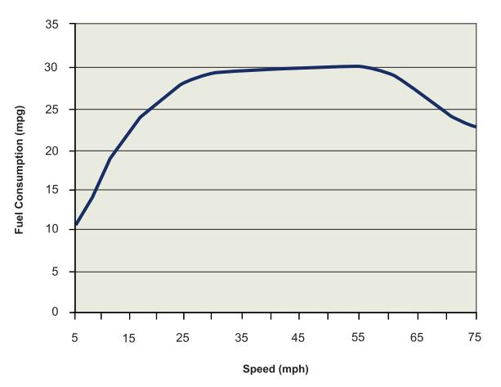
Figure 5.3 - Fuel consumption versus vehicle speed. Source: [20], based on information of the US Department of Energy (see e.g. [21] for a similar diagram), based on [22].

As can be easily seen from the above formula, in terms of fuel efficiency (amount of fuel used per distance, expressed as [mpg] of [km/L]), the energy use for overcoming rolling resistance is roughly independent of speed, while the energy use to overcome air drag resistance is proportional to the square of the speed. A typical curve for fuel use per distance versus speed is given in 5. 3. Assuming that the graph depicts values at constant driving speed (no acceleration and deceleration) on a horizontal road (no up- or downhill), it indicates optimal and rather constant efficiency at mid-range speeds, while at speeds above 100 km/h the efficiency is rapidly decreasing, which is especially due to the air drag resistance with its quadratic relation to speed.
Figure 5.4 provides an example of typical energy flows for a passenger car for two different driving scenarios.
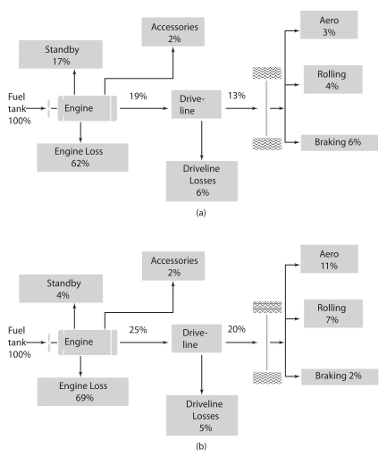

Figure 5.4 - Example of typical energy flows for a recent model (as of 2006) passenger car for two different driving scenarios (urban and highway). Source: [23].

The information presented in this section is in the first place related to passenger cars. However, mutatis mutandis (i.e., with the necessary modifications), it is also applicable for heavy goods vehicles.

Energy-efficient routing

Eco-driving and eco-routing
It is important to distinguish between eco-driving and eco-routing. Both terms have become quite popular in recent years. Eco-driving points to the driving behaviour of the vehicle user to reduce fuel consumption (smooth driving), and some measure the driver can take to make the car as fuel-efficient as possible.
The following components of eco-driving can be distinguished (non-exhaustive list): moderate acceleration, efficient deceleration, moderate speed and use of the highest possible gear for moderate engine speed (these together enable smooth driving); proper car maintenance, proper tyre pressure (these are car related measures the driver can take and is responsible for).
Eco-routing is about optimising route choice in terms of fuel efficiency. It is not necessarily always the same as minimal fuel routing. Like the shortest route or the fastest route are not always the optimal route, the least fuel route may not always be optimal (in terms of driver requirements), which means that distance and time may play their role as well in defining the eventual optimal eco-route.

Minimal fuel routing
Similar to minimal distance and minimal time routing, also for minimal fuel routing a link cost and a link transition cost are calculated. The cost function is the estimated fuel consumption for travelling the link and for making the preceding link transition. It can be expressed as link fuel cost (LFC).
While link distance cost is pretty accurate, as the map database is an accurate and quite detailed representation of reality, link and link transition time costs are already less accurate. They need estimates of the speed on the link, and of the waiting time during the link transaction. Modelling fuel consumption of a route is considerably more complex and "a daunting task" [24], which may also be clear from the fuel consumption model presented in the previous section. It involves many variables, and complex and partly unknown relationships with fuel use. The approach proposed in [24] is to focus on the big items for which model relationships with fuel consumption are well known, and to construct in this way a reasonable model, by which reasonable estimates can be made. In this way one may expect that the model will be rather consistent in ranking different route alternatives in a consistent way, even if the estimates are only approximate. For modelling link fuel costs, three components of fuel cost are distinguished in [24], which we will indicate as base fuel cost (at zero slope and constant speed), slope fuel cost and braking fuel cost (due to acceleration and deceleration, stop and go). As we will see, these component nicely match the various parts of equation (1). The next three sections are, mutatis mutandis, for a substantial part based on [24].
Table 5.2 lists map and dynamic attributes that are relevant for minimal fuel routing (in addition to the usual attributes that are relevant for minimal distance or minimal time routing).
road curvature | road surface type | railway crossing location
road slope | road coefficient of friction | speed bump location
road surface type | speed advice signs | narrowing road sign location
intersecting road type | dynamic speed limits | slippery road sign location
right-of-way sign location | predicted speed of travel | school zone location
stop sign location | weather information
traffic light location | pedestrian crossing location

Table 5.2 - Map attributes, other static attributes and dynamic attributes that are relevant for minimal fuel routing. Source: [24], adapted.

Base fuel cost component
In view of the big picture, and looking back at equation (1), it may be clear that the parameter expected average speed along a link is an important parameter, which in fact embodies several of the link attributes that influence fuel consumption. The speed is used to calculate the base fuel cost for the link, at zero slope and constant speed (no acceleration and deceleration). Base fuel cost then corresponds to three terms in equation (1), the left most term (fuel use in idle operating condition), and the first and third term (from left) between the brackets (fuel use to overcome rolling friction resistance and air drag resistance).
To establish a value for this parameter for the time the vehicle will arrive at the link according to the calculated route scheme, information from a traffic patterns database may be used, complemented, when relevant (short-term), with real-time traffic information. This is possible for those roads for which traffic patterns information is available (this is today most roads, see section 3.9). For roads for which this information is not available, more conventional map attributes can be used. The predicted information for a link may include the time needed to arrive at this link from a previous link, the link transition cost. This may comprise different values for different originating links, dependent on the type of transition manoeuvre (right turn, straight ahead, left turn). For the link one average speed value is given, which includes the time needed for the manoeuvre to arrive at the link from the previous one, and also speed variations along the link. By using a look-up table of fuel per distance versus speed for the vehicle type (brand and make), similar to the information contained in the graph in Figure 5.3, the speed fuel cost for the link in question can be calculated. The relationships are expressed in the following two formulas.
$link speed=f(link,prevlink,time)$ (3)
$link FC (base)=g(link speed,vehicle type,link length)$ (4)
Tables for fuel per distance versus vehicle speed (at zero slope and constant speed ) seem to exist at car manufacturers, but could not be identified in the public domain.

Gradient fuel cost component
Road slope or gradient is another important factor contributing to the link fuel cost. The gradient fuel cost (GFC) corresponds to the second term between the square brackets (from left) in equation (1). Like a look-up table for fuel per distance versus vehicle speed at zero slope and constant speed, for slope a look-up table may be used that describes the impact on fuel per distance due to slope versus speed, for different slope values. This could be a table in which the slope impact is singled out (i.e. the table only contains the fuel consumption due to the slope), but more likely this is a table that includes a line for zero slope, like the example table in Table 5.3. As the impact of slope on fuel consumption also relates to vehicle speed and vehicle type, we can extend formula (4) to include slope, for use with a table as in Table 5.3, leading to the following formula:
$link FC (base,slope)=g(link speed,slope, vehicle type,link length)$ (5)

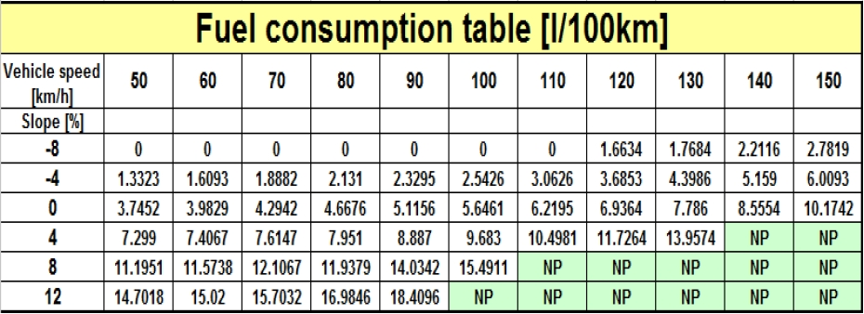

Table 5.3 - Example of table for fuel per distance versus vehicle speed for different slope values (including zero). Source: [25].

Such look-up tables for fuel per distance versus vehicle speed for different slope values (including zero) seem to exist at car manufacturers, but could not be identified in the public domain.
Some other road characteristics may influence the fuel consumption as expressed in formula (5). The most prominent one is the road coefficient of friction (related to the road surface type). Its influence is difficult to model, but could be expressed by applying a road friction multiplier for each link dependent of the road type, leading to equation (6).
$link FC (base,slope)=g(link speed,slope, vehicle type,link length,road type)$ (6)
Driving characteristics may also have quite some influence, as may the vehicle condition (maintenance, tyre pressure), which may deviate from the ideal situation for which the related look-up tables is designed. However, these influences may well be ignored, as they are not likely to substantially influence the relative ranking of routes.

Fuel cost component related to variations in speed (braking fuel cost)
The third important factor that contributes to fuel consumption and link fuel cost is variation in speed, due to frequent deceleration and acceleration. This relates to the fourth term (from left) between the square brackets in equation (1). In deceleration kinetic energy is lost, which must be re-supplied by the engine during acceleration. The average speed used in the previous equations is the average including speed variations. Causes for deceleration are intersections in general, right-of-way signs, stop signs, traffic lights and traffic congestions. Different speed variation patterns have different impacts, and the larger the deviations, the larger the impact on fuel consumption. Modelling the impact of these deviations is not an easy task. In [24] it is proposed to use some type of penalty multiplier to be applied to formula (6) to add the estimated effect of the variations in speed on a link to the fuel consumption.
One approach is to evaluate the difference between the legal speed limit of the link and the average speed for the link from traffic values (patterns and/or actual) , in such a way that the penalty increases more than linearly with the increase in speed difference. The proposed formula is (mutatis mutandis):
$multiplier=1+{(\left(speed limit-speed\right)/speed limit)}^{2}$ (7)
One weakness of this approach (also mentioned in [24]) is that it assumes considerable speed variations due deceleration and acceleration when the speed difference is large, while actually the traffic might be smoothly flowing, but just at a low speed. Another mentioned weakness is that the model is not based on tests. In addition, it does not seem to have a theoretical underpinning.
Another approach is to use a pre-calculated multiplier that is based on historic data, just like traffic patterns, and stored in look-aside tables. It seems that vehicle mass is also a relevant variable for this (see formula (1). This leads to the following expression for the multiplier, named SVM (speed variation multiplier) in this text:
$SVM=h($link,time,vehicle mass) (8)
This multiplier is then applied to formula (6), leading to formula (9), which expresses the total estimated link fuel consumption:

$link FC =SVM*g(link speed,slope, vehicle type,link length,road type )$ (9)

Discussion
The tables with pre-calculated speed variation multipliers, based on historic observations, do not yet exist, so this is something for the (near) future.
One weak point in the above approach is possibly the inclusion of speed variations due to intersections in general, right-of-way signs, stop signs and traffic lights, in general at link transitions. On one side these are somehow included in the average speed used to calculate the link transition cost that is included in the base component, which is especially based on traffic patterns. They are also sources of speed variations, which may be expressed by the multipler of equation (8). On the other hand, these intersection related speed variations may have their own characteristics, different from the characteristics of speed variations due to congested traffic on links. And they may even exist and be relevant if there is mainly free flow on the links.

The EcoMove project

Description and goals of the EcoMove project
EcoMove is an EU-funded R&D project of the type Large-scale integrating project (IP). The project started 1 April 2010, and has a planned duration of 36 months. The consortium consists of 33 partners, is lead by ERTICO, and includes research departments of car manufacturers BMW, CRF and Ford, truck manufacturer DAF, system vendors Bosch, Continental and Marelli, and map providers NAVTEQ and Tele Atlas. As one of the topics is eco-routing, it is relevant to include a short description in this report. The full title of the project is "Cooperative Mobility Systems and Services for Energy Efficiency".
The project intends to "create an integrated solution for road transport energy efficiency by developing systems and tools to help drivers sustainably eliminate unnecessary fuel consumption (and thus CO₂ emissions), and to help road operators manage traffic in the most energy-efficient way. By applying this combination of cooperative systems using vehicle-infrastructure communication, the project aims to reduce fuel consumption by 20% overall." [26] It is thought that this target can be achieved by optimising routes, driver behaviour and network management. The idea is that in principle the perfect eco-driver travelling through the perfectly eco-managed road network, using a combination of cooperative applications for eco-driving and eco-traffic management would make it possible to come near to the theoretical least possible fuel consumption, leading to the mentioned 20% reduction in fuel consumption. The EcoMove concept is depicted in Figure 5.5. The focus is on both cars and heavy goods vehicles.

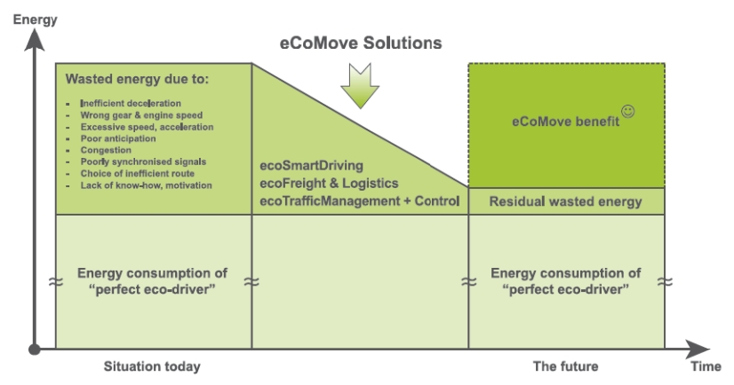

Figure 5.5 - EcoMove vision and approach. Source: [27]

The project, being an IP, is structured into sub-projects (SPs). The technology part of the project consists of one horizontal technology SP, SP2 - Core technology Intregration, and three vertical applications SPs, SP3 - ecoSmart Driving, SP4 - ecoFreight and Logistics, and SP5 - ecoTraffic Management Control.
The core technologies will consist of the EcoMove fully integrated platform for V2V and V2I communcation, based on technology developed in the CVIS and SAFESPOT EU-funded projects; (2) EcoMove messages, especially eco FVD (floating vehicle data) and ecoTSD (traffic situation data) messages; (3) the ecoMAP, an map database enhanced with attributes needed for eco-driving support, such as slope, historical speed profiles and energy consumption data; and (4) a situational operational model for eco-driving support and transport strategy analysis, taking account real area-wide energy use and specific energy "hot-spots".

EcoMove components
The EcoMove concept is a mix of various components, on both the vehicle side and the infrastructure side. See table 5.x for an overview. On the vehicle side green routing, an eco-smart driving assistant, and …
vehicle side: eco-driving support (cars and goods vehicles)
green routing | - optimum route from static and dynamic factors  - map learns from experience
eco-smart driving assistant | - adoption of the most efficient driving strategy  - dynamic driving advice via the HMI
post-trip driving analysis | - feedback on driving behaviour  - long-term coaching strategy
freight specific measures | - eco logistics planning  - training and eco-bonus scheme
infrastructure side: eco traffic management and control
adaptive balancing and control | - eco green wave  - balanced priority control  - eco route distribution
eco motorway management | - prioritised ramp metering  - eco merging assistant  - speed and headway control
eco traveller support | - fuel consumption and emission prediction  - eco strategy model Freight-specific measures

Table 5.4 - Overview of the main components of the EcoMove approach. Source: [27], adapted.

Ecomove research questions

The project has formulated the following research questions [26]:
- To what extent can eCoMove solutions decrease the fuel consumption and therefore also CO2 emissions of a vehicle/fleet/network with cooperative technologies?
- How can eCoMove sustainably change the behaviour of private and professional drivers into a more eco-friendly driving style?
- What impact have eCoMove solutions in a cooperative environment for the traffic system of a city/region/network (smoothing of speeds, congestion avoidance, changes in travel distances and travel times)?

Discussion on the 20 % reduction goal
It is not clearly stated with respect to which benchmark situation the 20% reduction of fuel consumption relates. Although there is some reference to literature, it is not crystal clear where this figure, which plays an important role in the EcoMove marketing, originates from. Note that the EcoMove research questions are more careful in this respect, and just indicate the goal to investigate how much fuel can be saved. Looking at Figure 5.4, it can be seen that some 80-87 % of vehicle fuel energy is considered to be used for inefficiencies, accessories and standby (idle operating conditions). Certainly, especially in city use some gain concerning standby could be obtained from improved traffic management (like green waves). Also in the logistics field gains can be achieved by efficiency improvements. And gains are already achieved today by use of navigation systems. But despite these items, it is difficult to see how 20% could be saved on total energy use if only some 13-20 % of the energy is used for the actual driving (overcoming rolling resistance and air drag resistance, and braking).

Elements of EcoMove particularly relevant for GRO:NT
Most relevant for the GRONT project is the component green routing. In the EcoMove deliverable D2.2, "High Level Architecture", section 4.1.1.1, the following description is given of the component eco-navigation, as part of eco-smart-driving:
The ecoNavigation application has two core functionalities: calculating a fuel efficient route and guiding the driver. For the first functionality, it takes all available information that might influence fuel usage and computes the most fuel efficient route (i.e. the one with the lowest absolute fuel consumption from departure to arrival) to a given destination. For the second <functionality>, <it> gives turn-by-turn instructions to the driver, using the calculated route. The application provides calculate route service as it is used by ecoTripPlanning. [28]
Note that the sub-component fuel-efficient route calculation is also used in the component eco-trip-planning (discussed in section 4.1.1.1). Section 4.1.2.1 of the same document decribes eco-truck-navigation:
The Truck ecoNavigation application is an extension on the ecoSmart Driving (SP3) ecoNavigation. Hence, it also has two core functionalities: calculating a fuel efficient route and guiding the driver. Given the inputs from the SP3 ecoNavigation application, it also uses SP4 related data inputs to provide navigation tailored to SP4 requirements and business models. [28]
Interesting for this report is also section 4.1.2.1 in the document, describing eco-tour-planning:
The Truck ecoTourPlanning has four core engine processes. The ecoTour Creation engine takes available and relevant information that influence infrastructure state and availability and calculates the most efficient tour station sequence for given transport orders and fulfilling given restrictions. The Mission Authorization engine receives an authorisation request from the tour creator and checks its conformance to the Local Authority policy requirements set through the "Defining Policy" functionality of the City Logistics system. Then, the ecoTour Realisation engine strives to execute the authorised route profile and inform the tour creator about events while mission execution and changes "and deviations" affecting the initial planned tour. Finally, the Carbon footprint calculation engine provides an initial carbon footprint estimate based on the initially available and relevant information that is used to find the most efficient route to destination. [28]
Section 4.1.4.4 of this deliverable describes the eco-map:
The ecoMap component is a facility for the eCoMove applications, providing the applications with the means to store, retrieve and exchange map-related data in a single ITS station. It will consist of a digital map database enhanced with extra attributes needed to support eCoMove driver assistance applications for energy efficiency. [28]
Section 4.17 of Deliverable 5.2 [29] describes a component named eco-network prediction, with sub-components eco-map services, energy map calculator and rout distribution calculator. This clearly has to do with traffic management component of efficient routing, which is not so much different from a similar approach to traffic management to achieve a better distribution of traffic over a network from the perspective to avoid or reduce congestion (for which the Germans have a nice term: "Netzausgleich", network balancing).
Figure 5.6 provides the fucntional description of eco-navigation, as presented in Deliverable D3.1 [30], with the following description:
Functional description of ecoNavigation. For the ecoRouting it holds for both the ecoTripPlanning as well as the dynamic ecoNavigation and ecoGuidance. The aim is to improve the eco balance by planning a route with lowest fuel consumption and guiding the user on that route while travelling. Dynamic changes of eco relevant parameters are taken into account by continuous check for updated information from the traffic centre, from other vehicles, and from the ecoCooperativeHorizon. [30]

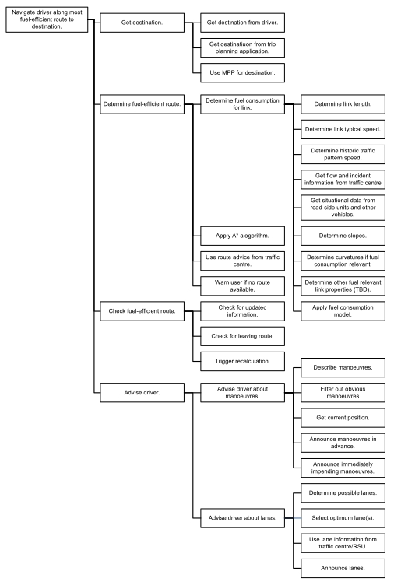

Figure 5.6 - Functional description of eco-navigation, EcoMove project. Source: [30]. The part in the red box concerns the routing component.

System Availability

Introduction
This chapter reports on the study conducted to identify applications that are available today and are related to the scope of the GRO:NT project, and more specifically to the subject of this report: route calculation and optimisation.
Applications offering green route optimisation specifically for trucks have not been identified in this study. Only applications offering truck routing and applications offering eco-routing in general have been identified. These are described in sections 7.2 and 7.3 respectively. Section 7.4. presents one other relevant application that have been identified during this analysis.

Truck routing applications
See Annex 1 (Chapter 10) for relevant details from marketing communications.
A total of eleven providers of truck navigation applications have been identified. In alphabetical order these are: ALk, Becker, Falk, Garmin, Masternaut, Navigon, Navgear, PTV, Rand McNally, Snooper and TomTom.
Details of the different models of each brand can be found in Annex 1. Apart from differences like design, map coverage and device characteristics, they all offer the same kind of solution for truck drivers: a map database enhanced with specific attributes for truck navigation (like restrictions on weight, and dangerous goods) combined with the option to enter the vehicle characteristics (weight, height, length, load) to enable the system to calculate and propose a route that is adapted to the specific characteristics of the vehicle in question.
Obviously, the solutions for navigation optimised in terms of HGV restrictions proposed by each of these systems can already significantly contribute to reducing fuel consumption, by avoiding mistakes that truck drivers can easily make without having this information. However, none of these systems offers the most energy efficient route for trucks. This would require additional attributes beyond mere truck restrictions, as well as additional vehicle parameters and a different algorithm to take all this into account.

Eco-routing applications
See Annex 2 (Chapter 11) for relevant details from marketing communications.
The following brands offer an eco-application in some of their models: Bosh, Fiat, Garmin, Hyundai and TomTom. Details can be found in Annex 1. Some of the solutions proposed fall in the area of eco-driving (section 4.1.), e.g. Garmin Ecoroute and Bosch ECO navigation, and are outside the scope of the topic of route calculation and optimisation as discussed in this report.
One solution, that has been announced to be launched in the summer of 2011, which attracted special attention, is the Hyundai application proposing
ADAS attributes such as slopes, height and curvature enable the routing calculations to take into account more precise road geometry and the nature of the terrain. And the NAVTEQ Traffic Patterns product enables to indicate where and when traffic jams are likely to happen based on historical statistics information. In this way, drivers can be guided via alternative routes where traffic is expected to flow more smoothly. Together these attributes enable the navigation system to find routes, which minimize fuel consumption.
Even though the details of the implementation of this Hyundai system are not in the public domain, it shows that eco-routing applications for cars start to become available on the market that are using some of the elements identified in this report as relevant for energy efficient optimisation (like slope and historical traffic information).

Eco-predictive cruise control for trucks
See Annex 3 (Chapter 12) for relevant details from marketing communication.
One other application, not offering routing, is worth mentioning in this analysis This concerns the RunSmart Predictive Cruise application from Freightliner Trucks (see Annex 1 for details). This system uses specific map attributes (and especially the slope of the road ahead) and the concept of the Electronic or ADAS Horizon to adjust the actual speed of the truck dependent on the terrain characteristics for maximum fuel efficiency. The system is implemented as akind of eco-predictive cruise control. In this way it takes the driver (and efficiencies of his driving behaviour) partly out of the loop. Without being an eco-routing solution this system demonstrates that applications are available today that uses map attributes to reduce energy consumption.

Conclusion
On the one hand, applications are available today for truck drivers to help them find a route that is best tailored to the characteristics of the truck they are driving with the help of specific map attributes (for instance the NAVTEQ Transport product). On the other hand, applications are available, tailored to car drivers, to help provide assistance in reducing fuel consumption. Most of these applications are in the area of eco-driving (e.g. improve driving habits based on driving statistics collected over time by the application), while some first applications for calculating and navigating the most energy-efficient route are making are appearing on the market. Given this picture, there seems to be room for the development of applications proposing at the same time truck and eco-routing. In addition, there is certainly room for innovation and improvement of what is available today, especially in the eco-routing segment.

Evaluation, discussion and general conclusion

Topics of study revisited
- Approaches for route optimisation and navigation algorithms, and for link costing: general, HV specific, fuel efficiency specific, preferred routes specific; functionality, classification and attributes used; current, and trends and requirements for the near- and mid-term future
This topic has been extensively dealt with, in a general sense. HV specifics enter into the formula's via parameters like vehicle type and vehicle mass, and via vehicle specific fuel consumption tables. Preferred routes for trucks are not generally covered by the map providers (apart from some preference provisions for very specific situations), but are derived from the core map in combination with additional attributes like concerning speed category, speed limits, stop signs, traffic signals and specific truck restrictions, as well as historic traffic information from traffic patterns. The description of the way eco-routing specific link costing can be implemented indicates both the current status and the near-future trend. Also the extensive description of the goals and approach of the EcoMove project indicate in which direction developments are heading.
- The need for and specification of a special functional road classification for HV routing
Like the preferred routes for trucks are not generally covered by hard-coding such routes in the map database, there is also no need for a special functional road classification for HV routing. Current map databases and map database products are sufficiently rich to enable optimal HV routing without having such classification.
- Relevance and use of dynamic and semi-dynamic data such as traffic information, traffic patterns and weather related information
Use of traffic information as part of the eco-routing link costing formula's has been discussed. Inclusion of weather information in the formula's has not been explicitly discussed.
- Relevance of road use charging, both for route optimisation and as an incentive for taking the optimal route
This topic has not been elaborated. It is not seen as particularly relevant at this moment, also given the status of developments of road use charging across Europe.
- Remaining other aspects: relevance and methods to take into account driver characteristics; status and future of a general vehicle platform; learning map concept, and self-learning from previous routes; on-board versus off-board; development status of platooning
These topics have not been elaborated, and are considered to be outside the (limited) scope of the current study. With one exception: on-board versus off-board is discussed in the parallel GRO:NT sub-report on architecture.

General conclusion and further work
The report clearly indicates in which direction route calculation and optimisation with a focus on eco-routing is going, and provides specifics concerning algorithmic implementation. The given approach includes options for truck-specific eco-routing.
An interesting topic for some further study has been identified. The hypothesis for this further study is that current least time routing is already rather efficient in terms of eco-routing, and that the improvement form specific eco-routing may be marginal. This hypothesis could be tested by taking an OD (origin-destination) matrix and calculating for each OD combination the least time route and the optimal eco-route, and calculating for both routes the theoretical fuel consumption.

References
- CEN TC 278, Geographic Data Files (GDF 3.0), draft European Standard (ENV), 12 October 1995, European Committee for Standardization (CEN), Brussels.
- ISO, Intelligent Transportation Systems - Geographic Data Files - Overall Data Specification (GDF 4.0), ISO 14825:2004, 2004, International Organization for Standardization (ISO), Geneva.
- NAVTEQ Corporation, NAVTEQ’s GDF 3.0 Reference Manual v39.0, 1 July 2011 (Proprietary and Confidential), Chicago, USA.
- Zhao, Y., Vehicle Location and Navigation Systems, 1997, Artech House.
- Flinsenberg, I.C.M., Route Planning Algorithms for Car Navigation, PhD thesis, 2004, Technical University Eindhoven.
- Jenkins, M., Introduction to Route Calculation, 2007, NAVTEQ Network for Developers (NN4D).
- Dijkstra, E. W., A note on two problems in connexion with graphs, Numerische Mathematik 1, 1959, pp 269–271.
- Hart, P. E., Nilsson, N. J., Raphael, B., A Formal Basis for the Heuristic Determination of Minimum Cost Paths, IEEE Transactions on Systems Science and Cybernetics, Vol. 4, Issue 2, July 1968.
- NAVTEQ Corporation, Attribute Overview and Usage, version 2011 Q1, 1 January 2011 (this document is Proprietary and Confidential, and meant for internal use by NAVTEQ and current database licensees).
- Marks, B., and Kopitz, D., RDS: The Radio Data System, Artech House, 1998.
- NAVTEQ Corporation, NAVTEQ Traffic, presentation, May 2010.
- NAVTEQ Corporation, NAVTEQ Traffic Patterns, one-pager, version of 20 July 2011, Chicago, USA.
- NAVTEQ Corporation, NAVTEQ Traffic Patterns Global Specifications v1.1, proprietary and confidential, December 2010, Chicago, USA.
- NAVTEQ Corporation, Real-Time Traffic Services - The Next Frontier, EU Traffic White Paper, 2010, Chicago, USA, version of 6 April 2011.
- T. Oguchi, M. Katakura and M. Taniguchi, Available Concepts of Energy Reduction Measures against Road Vehicular Traffic, Proceedings, 3rd World Congress on Intelligent Transport Systems, Orlando, 14-18 October 1996.
- T. Oguchi, M. Katakura, New conceptual evaluation method of amount of exhaust emission gas on vehicular road traffic, in: L.J. Sucharov and C.A. Brebbia (editors), "Urban Transport VI", WIT Press, Wessex Institute of Technology, Southampton, UK, 2000.
- T. Kono, T. Fushiki, A. Katsuya, K. Nakano, Fuel consumption analysis and prediction model for "eco" route search, Proceedings, 15th World Congress on Intelligent Transport Systems, New York, 16-20 November 2008, paper TS29-10110.
- A. Corréïa, S. Amaya, S. Meyer, M. Kumagai and M. Okude, Eco routing for European market, 17th ITS World Congress, Busan, 25-29 October 2010, paper TP100-2.
- Oxford University Press, Oxford Dictionaries Online, internet portal.
- Kansas Energy Council, Kansas Energy Chart Book 2008, January 2008, Topeka, Kansas, USA.
- US Department of Energy, Fuel Economy Guide - Model Year 2011, report DOE/EE-0333, undated.
- B.H. West, R.N. McGill and S. Sluder, Development and Validation of Light-Duty Vehicle Modal Emissions and Fuel Consumption Values for Traffic Models, US Departmemt of Transportation, Federal Highway Administration, publication FHWA-RD-99-098, March 1999, McLean, Virginia, USA.
- Committee for the National Tire Efficiency Study, Tires and Passenger Vehicle Fuel Economy, Transportation Research Board (TRB) Special Report 286, Washington, 2006.
- A. Calkins, Green Routing, internal paper, NAVTEQ Corporation, August 2008, Chicago, USA.
- S. Durekovic, Green Routing, A perspective, internal presentation, NAVTEQ Corporation, undated, Sulzbach, Germany.
- EcoMove Consortium, Annex I - Description of Work, EcoMove Consortium, Brussels, 13-11-2009.
- J. Castermans, A. Brusselsmans and J.C. Pandazis, Project presentation and fact sheet, deliverable D1.2, EcoMove Consortium, Brussels, 14-07-2010.
- T. Smits, High Level Architecture, Deliverable D2.2, EcoMove Consortium, Brussels, 09-05-2011.
- P. Mathias, J. Vreeswijk and P. van Koningsbruggen, Architecture and System Specification, Deliverable D5.2, EcoMove Consortium, Brussels, 18-03-2010.
- N. Eikelenberg, J. Subbian, R. Blanco, D. Sanchez, L. Andreone, S. Damiani, E. Balocco, E.-P. Neukirchner, Lutz Bersiner, SP3 ecoSmartDriving Use Cases & System Requirements, Deliverable D3.1, EcoMove Consortium, Brussels, 31-10-2010.

System Architecture

Objectives
The objective of subgroup system architecture is to identify the state-of-the-art of the system architecture of navigation systems for large goods vehicles. The objective is also to give recommendations concerning the system architecture and interfaces for future navigation system for large goods vehicles. These questions are a summation of the more detailed questions (see below) that the subgroup system architecture will investigate:How does the system architecture of different navigation systems (for large goods vehicles) available today, look like?
- What is the evolution of the data, from source to presentation of the final route to the user?
- What kind of interaction between fleet optimization and navigation systems could be relevant in the future?
- What kind of interaction between vehicle systems and navigation systems could be relevant in the future?
- Which are the limitation of the System Architecture of different navigation systems (for large goods vehicles) available today?
- Should a system for efficient HV navigation be onboard, off board or a mix?
- Which requirements does a system architecture need to fulfill in order to facilitate the involvement of dynamic data, road charging data, open source/free data, etcetera

Surrounding systems and current initiatives

Systems optimizing transport operations
There is a large number of systems aiming at optimization of transport operations in different ways. These systems could also be categorizes in different ways using different terms. Below the three terms “Transport Management Systems”, “Navigation systems” and “Fleet Management Systems” are introduced. For each term there is a brief description of the meaning of the term in this report and the current situation within this field. This chapter will also introduce the EcoMove-project which aims at developing a system considering aspect of all the above terms.

Transport management systems
Transport Management Systems (TMS) supports the business process of optimizing the utilization of vehicles according to a number of given parameters in order to fulfill transport assignments. TMS often also support administrative operations regarding transportation such as tracing of the transport as well as the subsequent billing.
The optimization can be done on different levels:
- Strategic level (localize where to place a new warehouse/HUB/terminal or dimensioning the resources (vehicles and driver etc.))
- Tactic level (establishing line structure, chose from available resourses, set up time tables for line based traffic etc)
- Operative level (daily planning with allocation of orders to vehicles, load planning etc.)
- Real time level (continuous route planning with new orders allocated to routes etc.. Which in parts imply an overlap between “Transport Management Systems” and “Navigation Systems”, see below)
These systems are often set to optimize “the business of the transporting company”. Time is often set as the most significant parameter and also the number of needed vehicles and drivers for fulfilling the assignments. Distance is also often taken into account. Systems where a higher level of detail (such as for example slope, variation in speed along a road segment, stop and goes, adjustments for different kinds of vehicles etc.) have not been found. This means that the behavior of a truck under certain conditions and the most fuel-efficient way of driving is not considered explicitly. Some systems does generalize to an extent where they use the linear distance between different pick-up and delivery locations instead of the actual distance on drivable roads when calculating an “optimal” route. This could result in a route recommendation not nearly optimal, especially for example in areas with few roads. This approach however is often held as sufficient in areas where there are a lot of roads available and no water etc. between the destinations. The optimization aiming for the most economical route could result in recommendation which will lead to a total driven distance longer than the route calculated manually, but maybe with fewer vehicles and drivers. Of course this is a matter of the importance each parameter is given in the optimization. But even if so, the TMS doesn’t seem to go further in the optimization for energy efficiency than just locking at the driven distance. This means that there are much that could be done in order to improve the accuracy of the optimization in this sense.

Navigation systems
Navigation systems aims to find the optimal route (in respect to given parameters) between two destinations and then guide the driver along the way. Conventional navigation systems normally optimizes for time or distance, trying to find the route that will result in a minimal distance or time spent between origin and destination. In these solutions there is no need for external information to be communicated to the vehicle (even if some solutions take into account traffic information).
Navigation systems claiming to offer truck specific routing considering the attributes of the vehicle (e.g. length, height, weight) and uses this information in order to avoid certain road segments. Still these systems most often optimizes for time and distance and not energy efficiency, as they exclude many of the factors significantly influencing the energy consumption of a truck (for example slope, stop and go etc.). Many of these parameters are static data that could be based on measurements or historic data.
Lately however more and more systems are also considering dynamic data about for example traffic conditions estimating the expected speed and variation in speed along a way when optimizing the route [tex Honda, Ecomove]. This development puts new requirement on the possibility to transfer data to the vehicle and also results in a more extensive optimization algorithm to find the best route.

Fleet Management Systems
Fleet Management Systems mainly focusing on the control and follow up of drivers and vehicles. For example follow up of the fuel consumption or need for maintenance and repair of each vehicle etc. Also follow up of the driving behavior of each driver is often included.

Driver assistant systems
Look ahead
Platooning

The EcoMove project
EcoMove is a project aiming at reduce the inefficiency within transportation in three different aspects:
- Drivers’ behaviour
- Route choice
- Traffic management
In the sub-project of EcoMove called “ecoFreight & Logistics” is focused on companies that are transporting goods on the road by means of heavy commercial vehicles. This sub-project address issues regarding the transport planner in the back-office of the transport company as well as the driver of the truck. Inefficiencies caused at the moment by these users will be addressed by the following applications:
- ecoTour Planning – addressing roughly the issues described in “Transport management systems” above
- Truck ecoNavigation – calculates the most fuel-efficient route to the next destination and guides the driver there.
- ecoDriver Coaching System –supports the driver to follow the calculated route in the most fuel-efficient way.

The functional architecture in fig x, illustrates the different applications, their interfaces with each other and also the link to the sub-project SP5, which is “Traffic Management and Control “ The following data is required from there:
- Traffic state predictions that describe the traffic situation on a short (next 15min) (optional) / mid (day level) / long-term (next days)
- Traffic status that reports the actual situation (e.g. traffic jams)
- Network optimal routes that allow SP5 to overrule in-vehicle Truck ecoNavigation and distribute traffic equally
- Traffic signal states (e.g. traffic light status) and local advices (e.g. lane choice, speed) that are incorporated by the ecoDriver Coach

In summary the EcoMove-system is considering a wide range of aspects relevant to accomplish an energy efficient transport.
The Truck ecoNavigation is the application most relevant for energy efficient navigation (which is the scope of the GRONT-project).
The ecoNavigation application is intended to give classic route advice for all types of commercial transport. Thereby it considers specific order or time constraint in or under which locations must be visited. Furthermore it enables the choice between primarily optimizing for time and optimizing for CO2 emissions. The overall functionality is illustrated by the Functional analysis I fig x below:
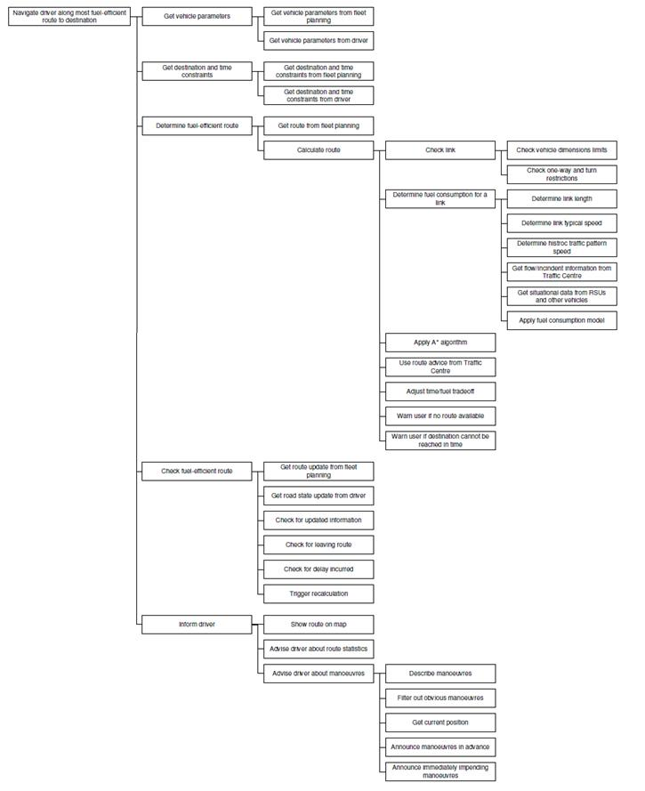
Figure 6.1: Functional analysis for Truck ecoNavigation

Communication channels
An increasing number of vehicles are equipped with devices that enables them to communicate with infrastructure and other vehicles. This trend is expected to continue opening up possibilities for new functionality based on wireless communication. Navigation and other applications aiming at energy efficiency are examples of this. Communication between vehicles is referred to as V2V-communication (vehicle to vehicle), while V2I-communication (vehicle to infrastructure) means communication between vehicle and infrastructure. V2X-communication is a more general term for vehicles communication.
On a high level the applications that could benefit from V2X information are generally categorized in:
- Safety critical applications
- Supportive applications
- Infotainment applications
These different categories implies different requirement on the communication channel. The safety crucial applications are most often also time critical meaning the latency of the communication needs to be low, while the infotainment applications are not as time critical but instead requiring a high data rate
Most functionality related to navigation have to be considered as supportive in its character. The criticality in time is most often not very high and therefore not demanding a very low latency time.
Mahmod et.al. presents an overview of the performance of different wireless technologies that could be relevant for V2X-communication [fig x]. The technologies mentioned are mobile communication represented by 2G/3G, WLAN (the “open” IEEE 802.11a/b/g standards and the standard 802.11p dedicated for V2X communication), DSRC, IR and the respective CALM standard for these technologies. CALM is an ISO-standard for Intelligent Transport Systems (ITS) for different communication carriers.
Latency: VS: >.1 s, S: 0.1-1 s, M: 1-60 s L: < 60 s
Range: S: <1000m, m : 2 km l: > 2 km

Not mentioned in fig (x) is the 4G communication technology which is currently being gradually installed at first hand in urban areas.4G is expected to offer 100 Mbit/s for mobile users.
Some navigation systems today also use the radio channel of audial radio to receive traffic information according to the TMC-standard. However the TPEG –standard specifies a language independent traffic messages protocol that could be transferred over most digital carriers.
Mahmod et.al. have also done a matching between applications of the CVIS-project and the recommended communication carrier (fig x), based on the requirements of each application and the performance of each carrier.

Communication and computing platforms
In this section the SPITS and Navteq MPE communication and computing platforms and their respective functionality is described.

SPITS - Strategic Plattform for Intelligent Traffic Systems
[Source: Congress Proceedings International Automotive Congress on Future Powertrains & Smart mobility 2011.
+ www.spitz-project.com]
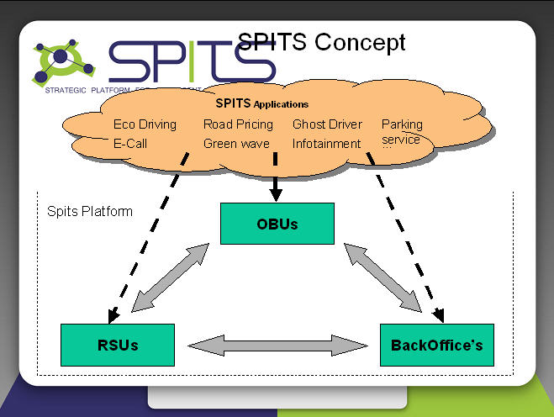
Fig 6.n: Overview of SPITS architecture
The SPITS platform is an Open platform for ITS-applications developed within the SPITS-project. The project is joint effort of a large number of partners. The complete SPITS system consists of a SPITS platform and applications. The functionality will be divided between applications and the SPITS platform, based on the reusability or other considerations.
The SPITS platform is both a software and a hardware platform.
The software platform
The software platform brings a well known application framework (Android) on top of a Linux kernel. The Android Software Development Kit can be obtained free of charge and documentation is readily available. To this TomTom (as member of the SPITS-project) added to this platform a flexible HMI framework supporting standard 3rd party Anroid widgets as well as TomTom’s navigation engine with API’s.
The hardware platform
The SPITS on-board unit uses off the shelf computing modules based an ARM processors (CortexA8, Dual core CortexA9 expected soon) and a USB based interconnect that allows external modules to be added (via a regular USB connection) or internal modules in the form of standard mini PCI-Express cards (USB variant). This allows both main processor and peripherals to be replaced and/or upgraded. A large set of peripherals are connected to the SPITS OBU, including displays, speakers, microphones but also car interfaces towards (CAN & OBD interface) and interfaces towards other vehicles, road side units or back office (DSRC communication based on 802.11p standard). The OBU also include a SIM-card holder to enable mobile communication.
The SPITS-platform have been and is currently used within the European projects CVIS, Safespot and FREILOT.

Navteq Map and Positioning Engine (MPE)

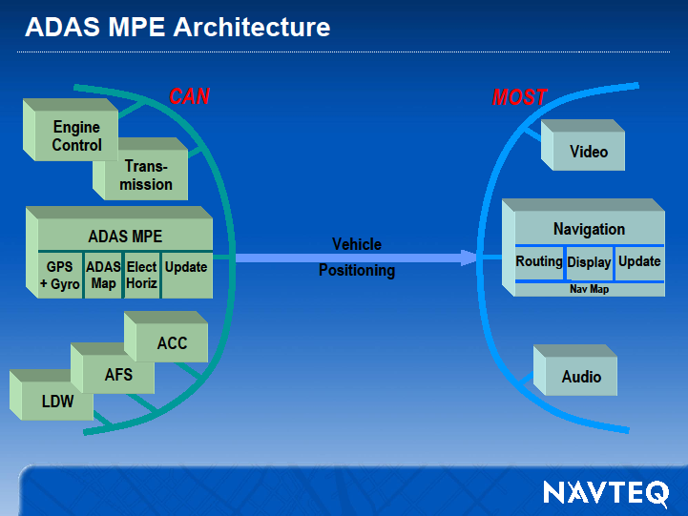

Recommendation/Comments
Important standpoints regarding System architecture
- On-board vs off-board route calculation
- Transport Management Systems
- Interaction with vehicle systems (ADAS etc.)
- Sensors and communication channels (hardware)
- Wireless communications and computing platforms

On-board vs off-board route calculation
Historically most navigation systems have been autonomous in the sense that all data and software needed have been available in the vehicle. These systems require no connections to outside information or process sources. The last decade more and more navigation systems take dynamical factors (e.g. traffic) into account when calculating the route and therefore require a communication channel to transfer this information. The use of dynamic data is likely to increase not only because of the advances within wireless communication, but also because of the significant influence dynamic data has on energy efficiency.
The GRONT system described in the break down structure above figure is one example of a system taking into account an extensive set of external data.
Except for the current traffic pattern, which is strongly influencing the energy efficiency as well as the travel time of a certain route, the concept of platooning which has shown promising effects on fuel consumptions could also lead to a need for information on available platoons to join along a route.
Extended use of dynamic and external data makes it relevant to consider the alternative where the route calculation is made on a server, in contrast to systems where the route optimization is made on the embedded system in the vehicle.
In this report two different architectural solutions realizing the GRONT functionality described above are evaluated.
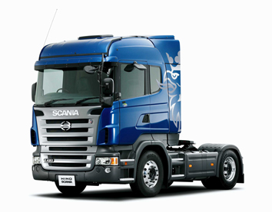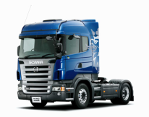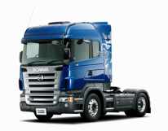

Uppdate map/part of map
on-board solution
Dynamic traffic data,- TMC
Dynamic traffic, TPEG

Estimated acceleration profile
Positions and time slots på delivery and pickup locations
Currently available platoons
Available parking
Rutt
Estimated Time(s) of arrival(s)

Driving and
resting times
Server
Vehicle
Position
Currently
available
platoons
Dynamic
Traffic data
(e.g. TPEG)
Floating
Car Data
Estimated
acceleration
profiles
”Information
server”
Transport
assignments

Dynamic
traffic data
Alternative 1
Road user
charges
Weather
information
Vehicle
model
Driver-
model
Road user charges
Weather information
Alternative 2
Figure 6.2: On-board architectural solution alternative
In the ”On-board solution” route calculation is made on-board on an embedded platform. Input data necessary for calculation of the energy efficient route is sent to the vehicle..

Route
Off-board solution
Estimated Time(s) of arrival(s)
Driving and resting times
Position
Server
Vehicle
Vehicle ID
Vehicle weight etc.
Currently
available
plattons
Dynamic
Traffic data
(e.g. TPEG)
Floating
Car Data
Uppdate map/part of map
Estimated
acceleration
profiles
”Navigation
server”
Transport
assignments
Road user
charges
Weather
information
Vehicle
model
Driver
model
Driver categorization
Third party
navigation
service provider

Figure 6.3: Off-board architectural solution alternative
In the “Off-board solution” route calculation is made off-board on a server. Input data is collected from different sources to the server in order to calculate the energy efficient route, which then is sent to the vehicle where it is shown to the driver.

Important aspects to consider
Choosing an On-board navigation solution or a Off-board navigation solution will have major implications in a number of aspects. For each aspects the implications of a on-board and an Off-board solution will be discussed. This section is based on the assumption that the GRONT- system will realize the functionality presented in the introduction.

System cost
With the increasing amount of input data used for route calculation the required processing and storage capacity will increase significantly. The GRONT-system will require more processing and storage capacity than most current navigation systems. The cost for processing och storage capacity in embedded systems continuously decrease but is still higher than on a server. On the server both storage and processing capacity could be balanced between users as well, decreasing the total capacity needed.
The cost for wireless communication is still a major barrier for extensive use of real time data. Especially when crossing borders and roaming charges are added to the bill. The cost of data traffic within a country as well as the cost of roaming are expected to continue to decrease. In “A digital agenda for Europe” the EU-commission sets an objective that the difference in tariffs between roaming and home-country mobile-phone calls should approach zero by 2015. The GRONT-system will require an extensive use of real time (or near real time data) for the full indented functionality (The need for maintained functionality when not connected is addressed below). In the on-board solution much of this data needs to be transferred to the vehicle where the route optimization is made [see figure xxx]. In the off-board solution the real time data is used as input on the server side during route calculation but no real time input data have to be send to the vehicle. Even though some additional data (such as pickup and delivery times,...) needs to be send to and from the vehicle, the off-board solution will probably require less data to transferred and also less bandwidth between server and vehicle.
The GRONT-system will add complexity compared to conventional navigation systems. The increase in complexity is expected to be similar in the on-board as in the off-board solution.

Data security
What implication would a on-board or a off-board solution have on data security?

Support for third party solutions
The user requirements of different users of the GRONT-system are very divers and the need for integration with other systems is extensive. This makes the interfaces to the GRONT-system, and to what extent the system offers third parties to contribute to the value proposition, is held as a very important aspects in the evaluation of different solution alternatives. One way of supporting third party service providers is to offer on-board hardware and user interfaces. In order for a third party provider to utilize this the system need well defined data interfaces. Figure X and figure Y, illustrating the on-board and off-board solutions, gives an overview of the interface between the server and vehicle. Choosing a on-board solution would make it more complex to supply all required data to different third party navigation systems. This will also lead to expenses in order to administrate the interface that should be offered each third party and their respective customers. The off-board solution would offer a less complex interface for third parties, mainly consisting of the calculated route. This interface is also more likely to be more lasting than an interface containing a large number of different data. With this interface a third party suppliers (as well as the truck manufacturer) could also more easily update their service as the need for making changes on the vehicle (in terms of data accessibility) would be less frequent.

Maintained functionality when not connected
The GRONT-system will be dependent on external data in order to deliver full functionality. This is valid for both the on-board and off-board solution. Both will require to be “connected” to access to real time data. However even when the vehicle has no connectivity the system still needs to offer a energy efficient routing based on static information available in the vehicle. This implies that some kind of route calculation must be possible on-board. In the on-board solution all route calculation is already being done on-board in the embedded system. In the off-board solution on the other hand this adds additional requirements on hardware and software in the vehicle. Their will for example mean that map data and historical data needs to be saved in the vehicle also in the off-board solution.

Required time for route calculation
Depending on the use of the system the time for route calculation will by more or less crucial. The scenarios where the time for route calculation is most important is when the driver initiate an route calculation just before he is about to leave, and when the route needs to be recalculated due a deviation from the route. Less important is the time needed for route calculation for example if the route calculation is initiated by a transport planner in advance, or when recalculating the route during the trip (to check for changed conditions affecting the route) when the vehicle is travelling according to the original route.
To keep the time for calculating the optimal route for taking a lot of real time data (or near real time data) in to account will be challenging. It will be possible to perform the actual optimization quicker on the server, with more processing power available. Additional to the time for optimization the time for communicating real time data or the route to the vehicle needs to be considered (even is the time for the optimization is expected to be the major part). As discussed above the on-board solution is expected to lead to more data traffic, however part of this data transfer might not have to be carried out in direct connection to the route optimization, but could be communicated regularly. The data will then be available for route calculation on-board.

Relation to Transport Management Systems
- Often there is a lot to be gained concerning energy efficiency by optimizing the allocation of several assignments to several different vehicles even if the optimization is made regarding time or distance. Of this reason the possibility to transfer a route generated from the TMS on-board unit should be considered in an energy efficient navigation system.
- There is a need for a standard for route calculated off-board to be send to on-board units regardless of the source of the calculated route. This need is identified by both navigation service provider as well as TMS providers.

Interaction with vehicle systems (ADAS etc.)
- Important to chose a navigational map that also offers a ADASIS-extractor in order to be able to use the map data for ADASIS functions.
- Platooning will have implications on the need for using external data for route optimization as the location af platoons will be interesting in order to be able create platoons and save fuel.
- The Navteq MPE …
- ADAS MPE Architecture

Communication channels
- The only communication carrier with sufficient coverage is mobile communication via 2G/3G. The cost for data transfer would however be high.
- WLAN 802.11p could probably be used in an prototype however this communication channel might in a later stage be limited concerning data traffic as other ADAS functions requires bandwidth.
- An issue regarding WLAN especially for a final solution is the need for new infrastructure in terms of road side units equipped with WLAN. These would have to be located approximately 1km apart along the way in order to offer continuous connectivity. Which is not likely in the near future. Even in a prototype solution this is not very convenient. The WLAN could however be used in order to communicate large amount of data att certain point along the way where WLAN is available.

Wireless communications and computing platforms

The SPITS-platform seems to be a promising alterative…

References
Xxx, X. (200x). ""
[Mahmod et. al] 2008,M. M. Mahmod, I. Kahlim, E. Uhlemann, N, Nygren, ”Wireless Strategies for Future and Emerging ITS Applications”

Business Models

The Nature of Business Models
Noted management consultant Peter Drucker described a business model as the answer to the questions: Who is your customer; what does the customer value; and, how do you deliver value at an appropriate cost? Clayton Christensen, Harvard Business School professor, researcher and author of a number of books and articles on ‘disruptive technology’, says that a business model should consist of four elements: a customer value proposition; a profit formula; key resources; and, key processes. Ramon Casadesus-Masanell, also of HBS, and Joan E. Ricart of the IESE Business School in Barcelona, have performed extensive research on the subject of business models and have offered a refinement of previous formulations: a business model consists of a set of managerial choices and the consequences of those choices.
Every choice that management makes has a consequence. A policy choice, such as choosing the location of a company’s office (center city or suburban office park) has consequences for the types of staff the company can attract. An asset choice, such as whether to build an internal workforce or outsource production, has consequences in transportation costs, quality control and vulnerability to political upheavals. A governance choice, such as whether to own or lease the equipment and facilities used by the company, has consequences in the eventual value of the company.
The term business model has been used interchangeably with both strategy and tactics. A business model is based on a selected strategy. Tactics are the choices that can be made once the business model is chosen. As an example, a newspaper company that chooses to offer a free newspaper (its strategy) cannot use lower price as a tactic to combat rivals, while a rival who charges a price at the newsstand can lower its price or offer reduced subscription rates.
When TomTom introduced its portable navigation device in 2004, the company’s strategy was clear: Make navigation a mass market product. Up to that point, navigation had been an expensive option on expensive automobiles. All of the existing navigation system suppliers (e.g., Bosch, VDO, Denso, Melco, etc.) had the identical strategy, to deliver navigation systems to automotive OEMs. In order to achieve their aim, TomTom built a business model that aligned with its goal. It made policy, asset and governance choices that were self-reinforcing and stood the test of time. Mass market required low cost and low price. These two features of the model required a high degree of standardisation of the products and no tailoring. To get the large volumes necessary to achieve economies of scale, the product had to be sold at retail in as many channels as possible.
TomTom Business Model

- TomTom was able to disrupt the in-vehicle navigation business by implementing a business model that consisted of virtuous cycles.
- The strategy was to make navigation systems a mass market item, rather than an expensive option on expensive autos.
Economies
of Scale
Low
Cost

Large
Volume

Low Price
Limited
product
selection
No tailoring

Sell at retail

In 2008, TomTom completed the purchase of Tele Atlas. It had acquired Applied Generics in 2006, which gave it capabilities in delivering traffic information using cellular floating vehicle data (CFVD). Comined with an agreement forged with Vodafone Netherlands to use Vodafone’s mobile phone data for producing real-time traffic, TomTom completed a major change to its strategy when Tele Atlas became part of the company. In addition to being a supplier of mass market navigation systems, it is now both a content provider and a software integrator, delivering its content to the ultra low-cost systems it has created thus far for Renault, Fiat and Mazda. The company has once again disrupted the business model of competitors by moving into the integrated device market.
TomTom Business Model: Version Two

- TomTom has created a second, complementary business model that builds on its PDNs.
- It is able to offer low-cost navigation to automotive OEMs
Economies
of Scale
Low
Cost

Low Price
Limited
product
selection
No tailoring

Sell at retail

Lower Price
Offer Services

Invest in
content

Limited
tailoring
Large
Volume

Moderate
Volume

PNDs
Ultra Low Cost Navigation

Offer Services

We need to investigate whether there are any companies that have a strategy to deliver route optimisation and guidance for heavy trucks, whether they have defined a business model for executing their strategy, and if so, what the business model looks like, and what tactics they are using.

Roles

Navigation Systems and Services Eco-System
There is a major difference between an eco-system and a value chain or supply chain. The term ‘value chain’ is often used to describe how different companies work in a symbiotic way to deliver a service offering to a customer. This is a misuse of the term which was first used by Michael Porter to describe internal company business practices as shown in the diagram below. The idea is that at every stage in the production of a product or the delivery of a service, each department or business unit increases the value of what it has received so that the final product or services delivered to the customer is able to return a profit.
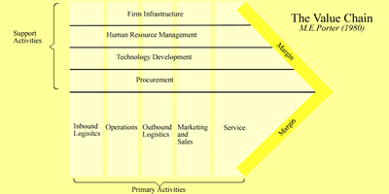
6
Securitas Workshop Michael L. Sena Consulting AB
Adding Value - What is a Value Chain¹
1. The value chain was described and popularized by Michael Porter in his 1985 best-seller, Competitive Advantage: Creating and Sustaining Superior Performance, New York, NY The Free Press
A Value Chain is a sequential set of primary and support activities that an enterprise performs to turn inputs into value-added outputs for its external customers.
The idea is to add value at each stage and end up with margin.
The Value Chain
M.E. Porter (1980)
Support Services
Service

Inbound
Logistics
Operations
Outbound
Logistics
Marketing
And
Sales
Support
Services
Firm Infrastructure
Human Resource Management
Technology Development
Procurement

Margin
Margin
According to the Council of Supply Chain Management Professionals, a supply chain is “the material and informational interchanges in the logistical process stretching from acquisition of raw materials to delivery of finished products to the end user. All vendors, service providers and customers are links in the supply chain.” Manufacturing cars requires a supply chain. Manufacturing navigation systems requires a supply chain. Delivering a particular navigation solution with a particular set of services in a particular place for a particular set of customers will require a supply chain, and the companies in the supply chain will be selected from an eco-system that has formed around the that particular segment of the market.
An eco-system consists of many companies, each attempting to generate margin from its own contribution to an offering. The companies group together in different constellations depending on the market in which they are operating and on the way in which the offering system is sold and serviced. In the case of navigation solutions, autonomous systems, connected systems and off-board systems all have different eco-system structures even though they may have overlapping members. For example, Navteq and Tele Atlas deliver navigable map data to all three., but Appello, an off-board navigation system supplier, and de Carta, Appello’s map server software supplier, do not engage in either the PND or autonomous navigation sytem eco-system.
The eco-system for OEM navigation has been relatively fixed since the mid-1990s when navigation systems were first introduced.
- Map Data Sources – Navteq (now owned by Nokia) and Tele Atlas (now owned by TomTom) collect data as primary sources using field operations teams and specially-equipped vehicles, but the principal sources of data are the national land surveys (e.g., British Ordnance Survey and Swedish Lantmäterieverket), county and local road and planning authorities.
- Map Data Aggregators – Navteq and Tele Atlas are principally data aggregators. They collect data from various sources and combine this data
- Tier Two Navigation Data Suppliers – Zenrin is a Tier Two supplier. It processes map data from Navteq and Tele Atlas, combines it with data that it sources, and converts the result to a format called KIWI that it readily readable by the Japanese Tier One Navigation System Suppliers.
- Tier One Navigation System Suppliers – Companies that make and deliver the navigation systems, such as Denso, Melco and Bosch, who make integrated systems for sale to the automotive OEMs.
- Automotive OEMs – The car and truck companies that purchase navigation solutions from the Tier One Navigation System Suppliers. The diagram below shows a picture of the suppliers to the automotive OEMs at a particular point in time.
Figure 7.1: The OEM Navigation System Eco-System
Automotive OEMs
Map Data Sources
Tier One Navigation System Suppliers
Tier Two Navigation Data Suppliers
Map Data Aggregators
End User
The eco-system s for Personal Navigation Devices, like those from market leaders TomTom, Garmin and Navigon, and for off-board systems, such as those from Appello and Telmap, are more streamlined. Garmin has always had its own cartographic operation which sourced map data and combined it with Navteq data to create its own proprietary format. TomTom, following its acquisition of Tele Atlas, is now as much as a map data supplier as a systems supplier. These companies supply their sytems directly to users.
PND and Off-board Navigation System Eco-System
Map Data Sources
Tier One Navigation System Suppliers
End User
The eco-system for Connected Navigation Systems solutions is getting smaller, with End Users delivering updates to the combined Map Data Sources/Navigation System Suppliers, like Google, Nokia and and TomTom.
Connected Navigation System Eco-System
Map Data Sources/Navigation System Suppliers
End User

Data Providers
The navigation data provider industry has traditionally been divided into public and private suppliers. For many years, from the start of navigation in the early 1990s until 2005, Navteq and Tele Atlas were the dominant and practically the only private suppliers. AND International entered the competition following a contract it completed for Microsoft in which it created digital map data for the countries where neither Navteq nore Tele Atlas had coverage, such as Turkey, Eastern Europe and the Middle East. This data was not intended by Microsoft to be used in in-vehicle routing devices. Its purpose was for Internet map display and route planning. Nevertheless, AND attempted to sell this data into the navigation system market—without success due to the lack of full attribution and the lower level of geometric accuracy of the data.
In 2007, when Nokia and TomTom announced their planned acquisitions of respectively Navteq and TomTom, Microsoft and Google and any of the navigation system suppliers or car companies had an opportunity to raise the bids for one or the other company and gain control of the private data market. Garmin put in a bid for Tele Atlas, but TomTom increased their offer and Garmin backed out. The sales were closed in mid-2008, and since then there have been two interesting developments in the navigation data market:
- Google has introduced its own database of North America which it claims is navigable; and,
- Open Street Map has gained in popularity and is in wider use for a number of applications.
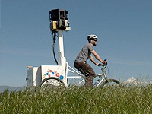 | Google claims to have collected its own data using its own sourcing methods developed as part of its StreetView product. Google records video images of many of the streets in the world in StreetView. Launched in May 2007, StreetView provides users with 360° horizontal and 290° vertical panoramic street level views within Google Maps. Google collects these images using special cameras and equipment that capture and match images to a specific location using GPS devices.
“Most recently we've added a new vehicle to our fleet that we call the "Trike". We basically took the same technology in our Street View cars and towed them behind a 3-wheeled tricycle in a device reminiscent of an ice cream cart. The Trike lets us reach areas not accessible by car, such as hiking trails, biking trails and college campuses, just to name a few.”
Open Street Map is as much a part of the social network movement as the street map data industry. It is advertised as a “free, editable map of the whole world, made by people like you and me”. The web interface allows a registered user to view, edit and use the data. The movement was founded in July 2004 by Steve Coast (that’s really his name). In April 2006 a foundation was established with the aim of “encouraging the growth, development and distribution of free geospatial data and providing geospatial data for anybody to use. Shortly afterward, the founder announced that he had received €2.4 million venture capital funding from CloudMade, a commercial company that will use OpenStreetMap in its products.
The actual data is compiled in various ways. Some data is delivered by registered users from GPS points collected while driving, cycling or walking. However, the vast majority of the data in OpenStreetMap consists of data obtained from public agencies, like the US Census data, or data donated by private companies, such as AND. Two of its early sponsors were Google and Yahoo!
Today, it may be more appropriate to discuss map data in the same way we discuss computing platforms, as proprietary, industry standard, common source and free open source. Common Source platforms include Microsoft, Apple and Android. Someone owns them, they can be used for a price, and there is a large body of developers who are constantly improving them. With Free Open Source platforms, like Linux, no one owns | 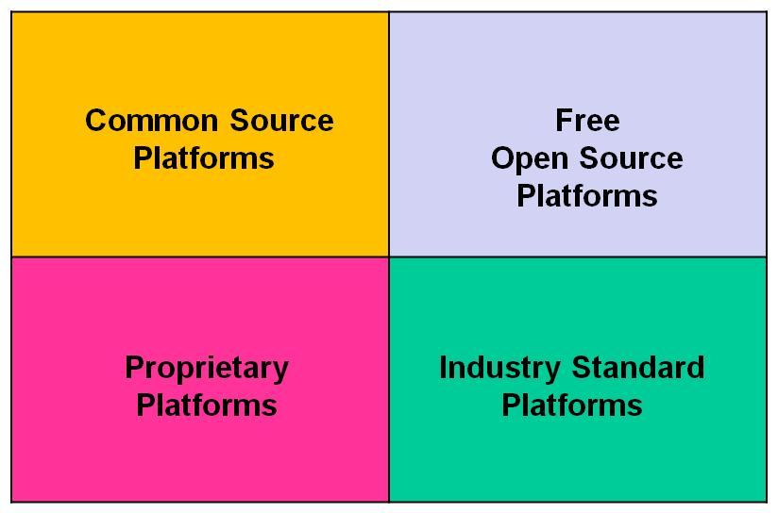
them, everyone can use them and anyone (who is properly registered) anyone (who is properly registered) can improve them. Communities of producers use general public licenses to guarantee users the right to share and modifty created works provided that the modifications are shared. Industry Standard platforms are owned by an industry group, and only the industry group members may use them. RDS-TMC, TPEG, OSGi, Genivi and Autosar are examples. Proprietary platforms are owned by a company who takes full responsibility for maintenance and updating, and the platform can only be used if the full solution is taken.
- Industry Standard Platforms: OSGi; GDF; Arcinfo Shape
- Free Open Source Platforms: OpenStreetMap; US Census; USGS
- Proprietary Platforms: Google; Bing; MapQuest
- Common Source Platforms: Navteq; Tele Atlas
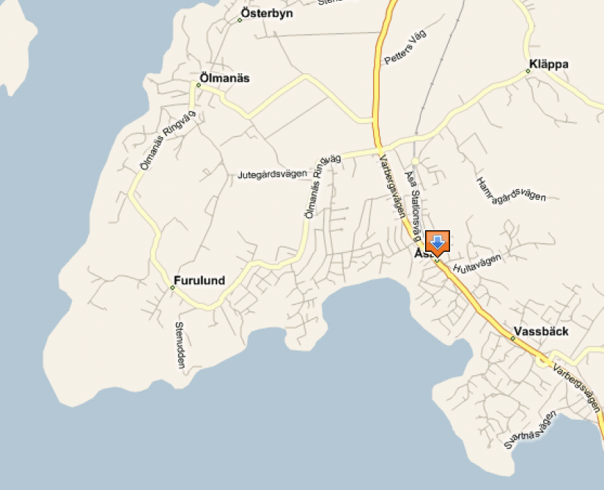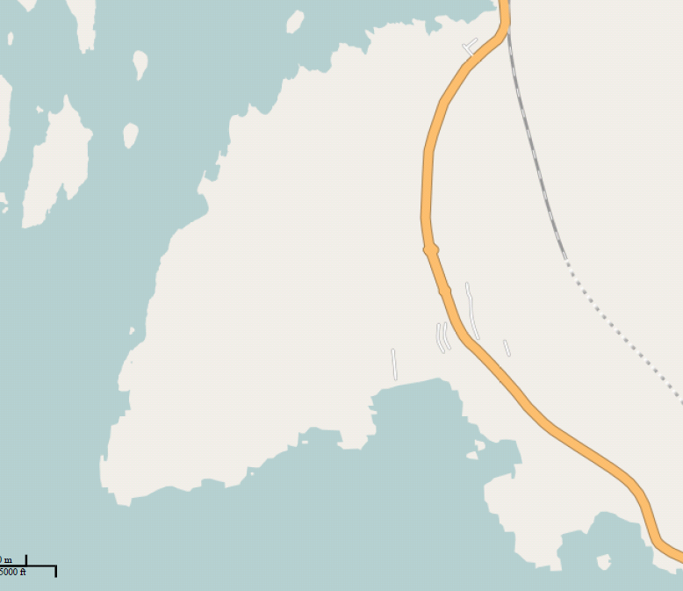
Navteq in Microsoft Mappoint
OpenStreetMap
At least somebody got the railroad track in the right location
…but we have not gotten around to much else
Figure 7.2: Comparison between Navteq and OpenStreetMap

The same geographic area, the well-known community of Åsa along the western coast of Sweden, south of Gothenburg, is shown on the left in a Microsoft Mappoint (Bing Maps) web application, and on the right in OpenStreetMap. The alignment of the railroad tracks in the Navteq map is more than three years out of date, while it is correct in the OpenStreetMap data. However, the incompleteness of the road network renders the OpenStreetMap data unusable.

Navigation Map Engine Suppliers
When navigation systems were first developed in the late 1980s and early 1990s, the developers of those systems viewed the navigation engine with the necessary route planning algorithms and map display routines as the core intellectual property. The systems competed on the basis of speed of route calculaton, ease of address input, voice quality and timing of turn-by-turn route instructions. A company that wanted to deliver on-board navigation solution by combining all of the pieces had few suppliers to choose among. Microsoft had developed an early verion of its operating system specifically for vehicles, called Windows Automotive, but it had few adherents. Those that did adopt it, like Mitsubishi Electric Company, simply ported their own solutions to the platform.
Disaggregation of the navigation system components began for two reasons: vehicle OEMs pressed prices for complete navigation systems to unsustainably low levels, and at the same time the OEMs forced consolidation of tier one manufacturers to reduce their total number of suppliers. This caused some companies to move into the business of providing complete information (i.e. navigation) and entertainment (i.e. radio, CD/DVD and, in some countries, TV) solutions, and the term ‘infotainment’ was coined. Siemens VDO, now part of several companies, including Continental and TomTom, was a prime example of this. It also opened the door for companies to provide specialized pieces of the solution, such as just the display or only the navigation software.
Elektrobit, a Finnish technology company, was one of the first to explore and exploit the changes occurring in the automotive software and hardware space.  EB street director is an industry leading navigation software solution for the automotive and consumer electronics market. It is modularly designed and supports many different operating systems. EB street director can be used in devices that range from built-in systems in vehicles and PNDs to mobile phones and MIDs. The stable and well-documented interfaces of EB street director's architecture allow customers to integrate their own applications and services (e.g. online search) as well as those of third-party manufacturers. | 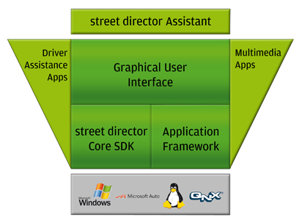
TomTom and Garmin are now competing in the automotive navigation software arena as intensely as they competed in the briefly expansive PND market. They have an advantage over the embedded system suppliers, such as Denso, Bosch and Melco because their original PND business was very similar, piecing together their software with low-cost, off-the-shelf components.
A point that is often missed is that in-vehicle navigation systems came to the market at exactly the same time as the first web-based routing systems from MapQuest, which eventually began to include street level mapping and routing, gaining competitors in the form of Microsoft, YaHoo!, Rand McNally and eventually, ten years later, Google. The Internet alternatives were the precursors to server-based off-board navigation from companies like Webraska in France, Telmap in Israel and Wayfinder in Sweden. These companies also developed proprietary routing engines and competed on similar criteria as the on-board suppliers.
In the early 2000s, a company that wanted to integrate the pieces of an off-board system had few choices to choose among. At the time there was one company, Telcontar (which subsequently re-named itself deCarta), that saw an opportunity to provide hosting services for routing and map display to companies that had other business interests but who needed a map display and routing offering. Telcontar also licensed their software to companies that wished to host their own solution, license their own map data and integrate other services that were not part of the deCarta suite.
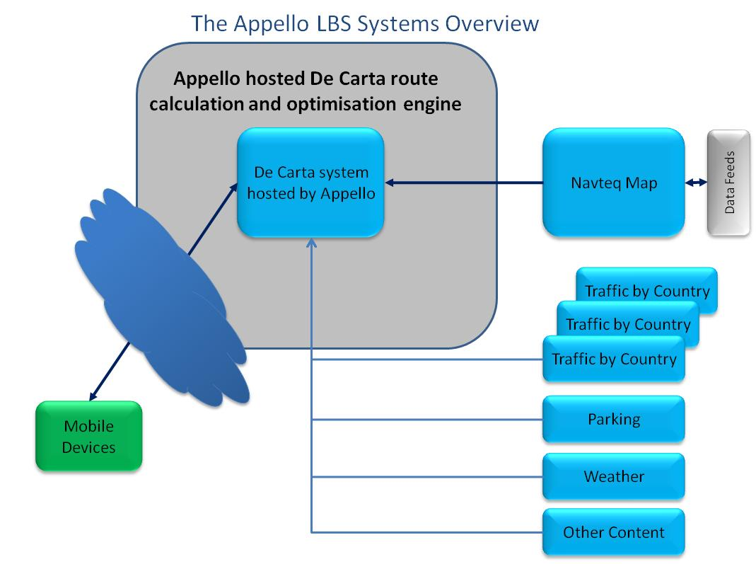 | One of these companies is Networks in Motion (now TCS) in the US, which is the largest supplier of off-board routing solutions. Another is Appello, which has been using deCarta software since 2000. Appello is delivering off-board route planning services to a number of mobile network operators in Europe and other parts of the world. It aggregates map data from Navteq, traffic information from various country sources, and other location-based data. This data is assembled in the deCarta server hosted by Appello and delivered as routes to mobile devices.
Several companies tried to replicate what MapQuest and deCarta had developed in the US for the European market. Two of these were Maporama in France and Map24 in Germany. Most of these countries have either gone out of business or have been acquired. Map24 was bought by Navteq and is now incorporated into its map services offering as MapTP. Navteq is now competing with its customers by offering its MapTP software and services directly to the market. A company can choose to host the software at its own site, as Hughes Telematics does in the US, or it can contract with Navteq for hosting services, as Daimler-Benz does in Europe for its Fleetboard product.
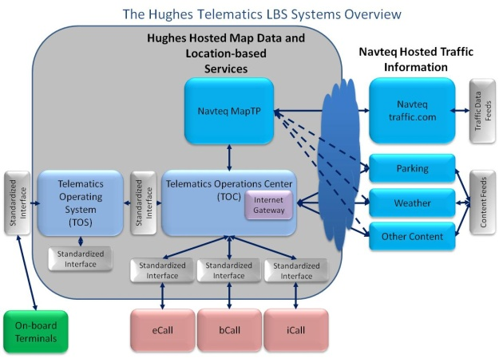 | 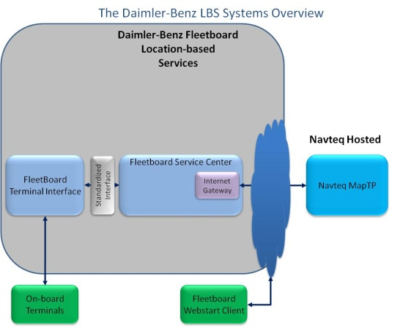

An increasingly popular model for companies is to use Google Maps or Bing Maps (Microsoft) as the full service supplier using web services. WirelessCar has applied this model since its start when PTV was the map service supplier. Google and Bing have captured the majority of this business from companies like PTV, first by offering free services for internal use and then competitive license fees, high quality map display and operations, and flexible business models. | 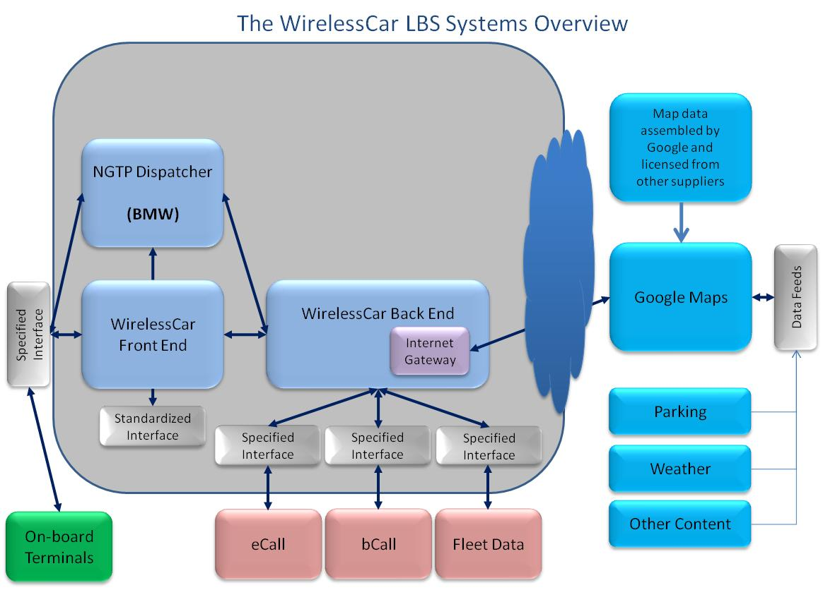

End Users
The role of the end user of systems is shifting from consumer to prosumer. Prosumers is a combination of two words, Producers and Consumers. End users are participating in the production of goods and services which they also use. The model is similar to the co-creation of software. Another example is the online encyclopedia, like Wikipedia. An older version of the same concept is Zagat Guide Books which is a printed and on-line assembly of reviews and ratings by visitors to restaurants, hotels and other sites.
The evolution of the passive consumer to active prosumer means that the payment relationship between the end user and the system supplier is changing, with the prosumer expecting to have a reduced (or no) cost as a result of his or her increased contribution to the product. It also means that the system supplier becomes reliant on the prosumer as part of the service delivery eco-system.

User generated content
Customers expect to share data with other users and gain benefits from network effects. TomTom has successfully introduced its MapShare program in which its customers report faults directly. A new company called Waze goes one step further with a completely new strategy for delivering services to the vehicle environment. Their stated strategy is “to work in cooperation with drivers worldwide to create the world's first live driving map, providing users with the real-time road intelligence they need for better everyday driving.” The services include constantly-updated road maps, alerts on traffic and accidents, and data providing users with the fastest route to get to wherever they need to go. Most of this is already available from navigation systems and smart phones equipped with traffic information services, but Waze goes two steps further.
Because all the base map data and updates are collected and updated by the drivers using the service, it is free. When a driver agrees to activate the Waze service on his or her mobile phone, the data collected is automatically collected, processed and delivered to users. Drivers can also use the application to report accident alerts, police traps, weather hazards or cheap gas offers. Waze also encourages developers to build additional applications for drivers using our live maps. They provide access to the map and the map data itself as well as their real time API.
After three years of operation financed by venture capital, Waze is preparing for monetizing its product. The funding has been used to build up its operational infrastructure to process and deliver data worldwide and to expand its corporate and marketing capabilities. It is moving its headquarters from Tel Aviv to Palo Alto. Waze will make money by licensing its crowd-sourced data to public and private parties who will use it instead of paying Navteq, TomTom or Inrix for their data, presumably because it is less expensive or more accurate. It will also move into the location-based advertising business by both cooperating and competing with the likes of Google.
 | Waze claims that it is building a new approach to location-based advertising, moving from a so-called ‘location-targeted’ to ‘location aware’ and then to ‘location-guided’ model. This means that the company has incorporated brands into its crowd-sourced geographic data processing platform which it believes will create both differentiation and engagement by both advertisers and producer/consumers (prosumers). One example of this is the addition of parking garages and available data to Waze’s database. Parking garage owners have apparently shown significant interest in paying Waze to advertise open spaces in real time. It does not take too much imagination to combine this idea with other social networking businesses like Groupon, which auctions coupons for products and services.

Demand for information
Vehicle manufacturers have begun to understand that data obtained from their vehicles can offer opportunities to reduce warranty costs by highlighting problem areas in new models before manufacturing has produced a large number of the cars. Many problems, like a power leak on the multi-media bus, can be fixed with a simple software upgrade. Several car manufacturers, including BMW, General Motors and Toyota, have already included a feature in their telematics systems to deliver fault code and other data from their vehicles to their data processing centers. GM’s OnStar delivers a report to the customer, a vehicle health report, in return for the customer agreeing to open its system to GM, and it has publicly stated that the cost savings realized from this program in reduced warranty costs are significant.

Updates
The one area in which prosumers will play the most important role is in the delivery of up-to-date data. The traditional view of map updating as practiced by Navtet and Tele Atlas is to rely on its own employees and trusted agents, such as navigation system companies that use the map data in their systems. Input from actual users of the data was given a very low priority because it could not be trusted. | 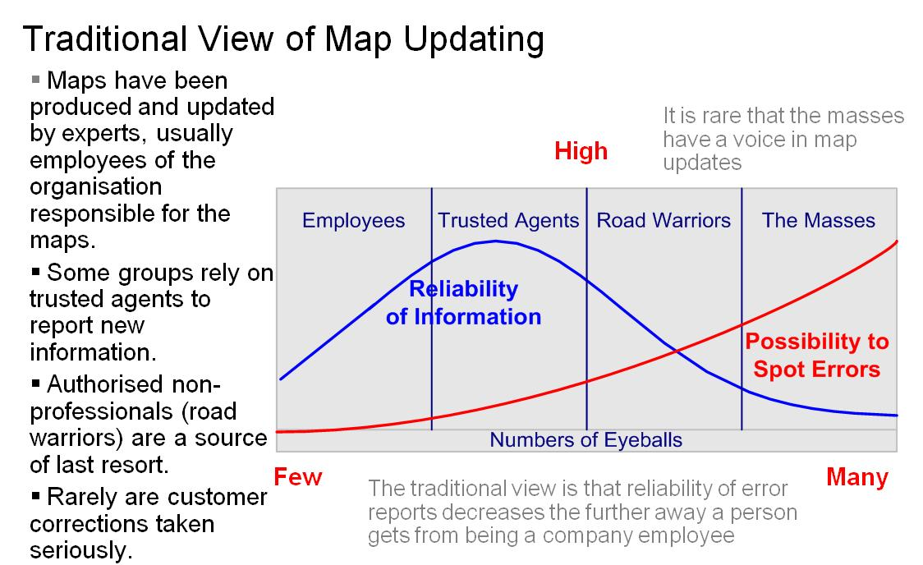
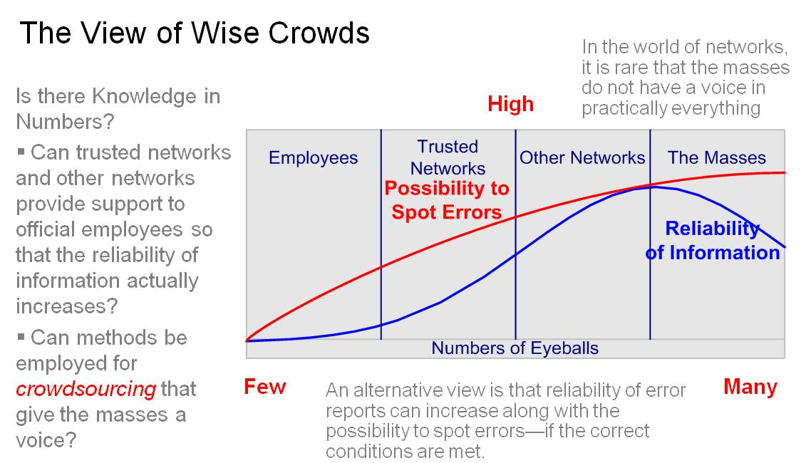 |  | Prosumers are changing this paradigm, but not because they have become better trained in spotting errors. It is the systems that have been developed by the hardware suppliers that have provided the tools for users to deliver accurate information about errors in the map data. Even mobile phones now equipped with GPS devices that can provide accurate location information, and the reports can be supplemented with photos taken with the built-in cameras and voice files with complete descriptions of the problem.

Payment Models

Who Pays Whom
Money Flow Diagrams provide a clear picture of the eco-system and the relationships among the participants in this eco-system. They identify the key player or players, the ones who control the payment stream. These are the companies that have the most leverage for defining the nature of the offering, but they are also the ones who bear the largest burden for investing in system and service improvements.

Original Equipment – Embedded Navigation
The predominant model for navigation was Embedded from the time of its introduction until around 2005 when PNDs began to be sold in volume. This model still exists among most vehicle OEMs. Embedded means that the system and all necessary hardware and software components are integrated in the vehicle and installed at the time the vehicle is manufactured. The map data delivered on one or more CD/DVDs is part of the price of the original equipment purchase and is either pre-loaded at the factory, the port of entry or at the dealer, or is loaded by the customer. Subsequent updates of map data are sold through the OEM dealer network or directly to customers from the map data suppliers via phone or web pages. Either the OEM or the hardware supplier pays for the map data. Traffic data in the Embedded model is usually paid for by the OEM national sales company.
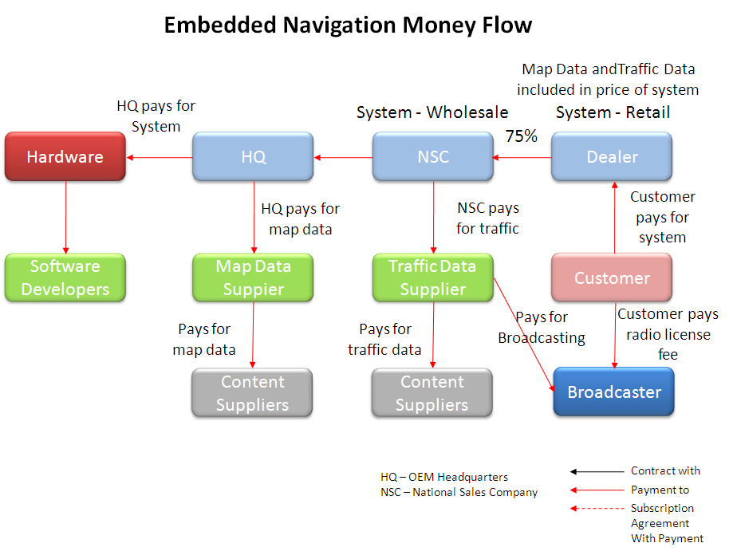
Figure 7.3: Embedded Navigation Money Flow
The dealer is the point of sale for the system and makes a commission on all systems sold as options (i.e., not included as standard), either stand-alone or as part of an options package. Money flows back to the headquarters via the national sales company (NSC). It is the NSCs that usually pay for traffic data in their respective countries, which is then delivered for free to the customers. The OEM headquarters (HQ) pays for both the system hardware and the map data. Each of the tier one suppliers to the HQ and NSC organizations pay their respective suppliers.

Aftermarket Navigation – Personal Navigation Devices
Aftermarket navigation eliminates a few layers of administration and, therefore, cost. The hardware supplier (e.g., Garmin, TomTom, ALK, Rand McNally) has the direct relationships with electronics dealers in each country and with the map data, traffic and other content providers. This model moved navigation from an expensive in-vehicle option to a mass market consumer device that could be used both in and out of the vehicle. With its built-in positioning and relatively long battery life, the device could serve as a moving map outside the vehicle as well, and it could be moved from one vehicle to another, taken on trips and plugged in on hired cars. The main advantages that PNDs has over the embedded systems, low cost and portability, are reinforced by the ability to take the device to a PC with an Internet connection and use the PC as a way of downloading updated maps and other content.
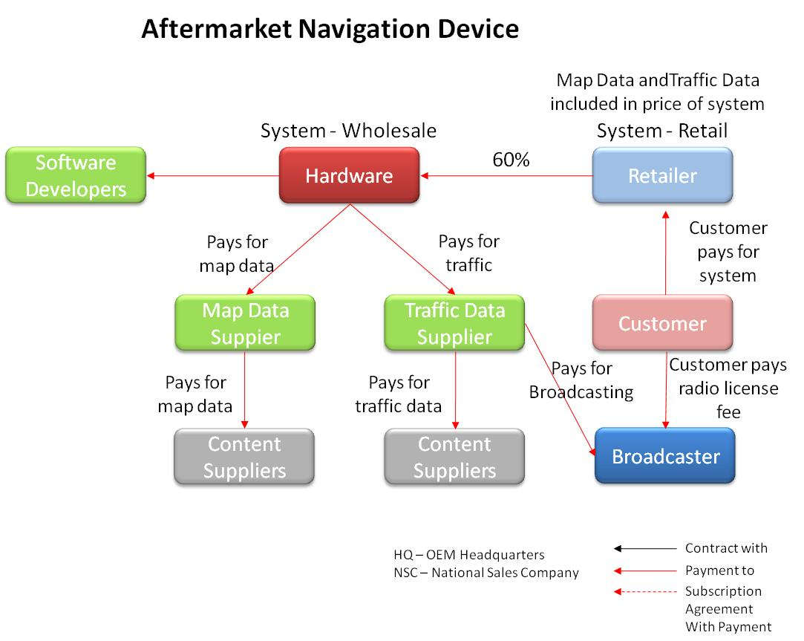
Figure 7.4: Aftermarket Navigation Money Flow

Off-board Navigation
The advantages of PNDs are now also available in Smartphones, like the Apple iPhone, Nokia N8, and the various Android-based models. The relatively large touch screens make them look like PNDs. Add the fact that they have built-in Internet connectivity, cost about the same as a PND if purchased without a subscription, and are often free when bought with a subscription, come loaded with maps (Ovi maps from Nokia and Google maps in the US on Android), and they become irrestible as an alternative to buying a one-trick horse, even if the horse performs that one trick very, very well. With the advent of the iPad and all of its clones, navigation has moved to the big screen. Every PND supplier is now offering its solution on both the smartphones and the pads. See the following site for how this works.
(http://www.youtube.com/watch?v=5SkltRqOF5k&feature=player_embedded#at=251Off-board Navigation)
The Navigation Service Provider (NSP) is the spider in the web for off-board navigation. The NSP assembles and pays for all static and dynamic data. The NSP builds and maintains its own server, as is the case with Telmap and ALK, or licenses a server from a sever supplier, as Appello does. Mobile network operators are the principal clients for the NSPs. The MNOs have the relationships with customers, retail outlets and the handset manufacturers. Google’s offering of free smart phone routing has changed the model slightly, since the customer is not paying for usage, but money still has to flow back back to the NSP, otherwise the NSP is out of business.
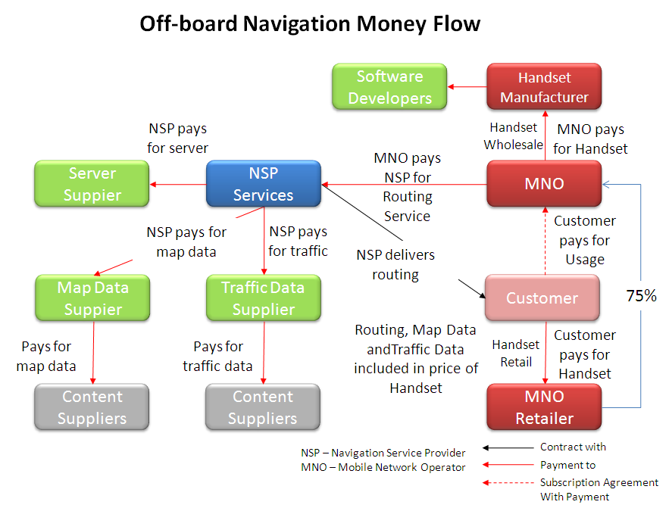
Figure 7.5: Off-board Navigation Money Flow

Embedded Telematics – Distributed Model
 | Telematics systems, such as General Motors’ OnStar and Volvo’s Volvo On Call (pictured), provided connectivity services in the vehicle via a location-enabled, wireless communications device. The OEM integrates the device in the vehicle and sells the device to the customer or includes the device as part of a package or as a standard. In some cases, the navigation system is connected to the telematics system with the telematics system providing wireless connectivity for information download. Points of interest or destinations that have been selected off-board can be downloaded to the navigation system via the telematics interface. This is how the BMW Connected Drive system functions. In other cases, the telematics service provider offers a navigation service. OnStar has a navigation service that it offers its customers.

In the Distributed Telematics model, services are included in the price of the system. The dealer takes a commission on the total price of the system and services. The NSC pays the country service providers for emergency and information services, pays the Telematics Service Provider (TSP) for connectivity services and passes back money to headquarters. HQ pays for the hardware and optionally pays for the SIM-card and network services. The TSP pays for all hosting services and for the content used to deliver the location-enabled services.
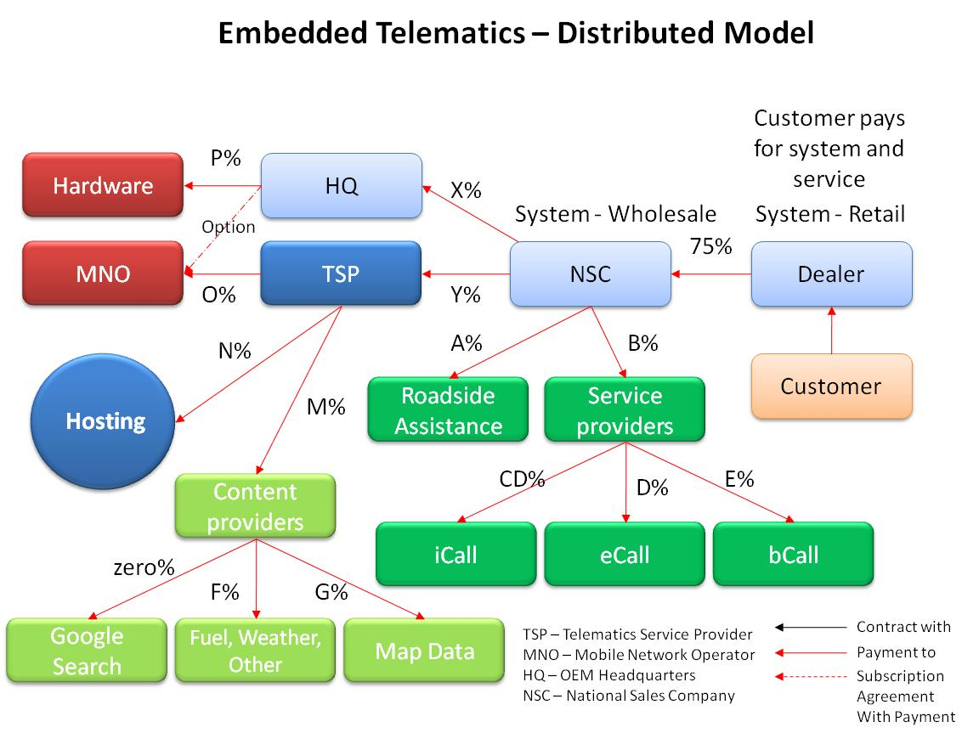
Figure 7.6: Embedded Telematics Money Flow

Embedded Telematics – Subscription Model
In the subscription model, which is applied by GM in OnStar, Mercedes-Benz in the US with its mbrace system, among others, the TSP collects money from the customer and distributes it back to all of the participants in the eco-system. In the case of OnStar, the hardware is included in the car as a standard. In the case of mbrace, the customer pays for the hardware separately.
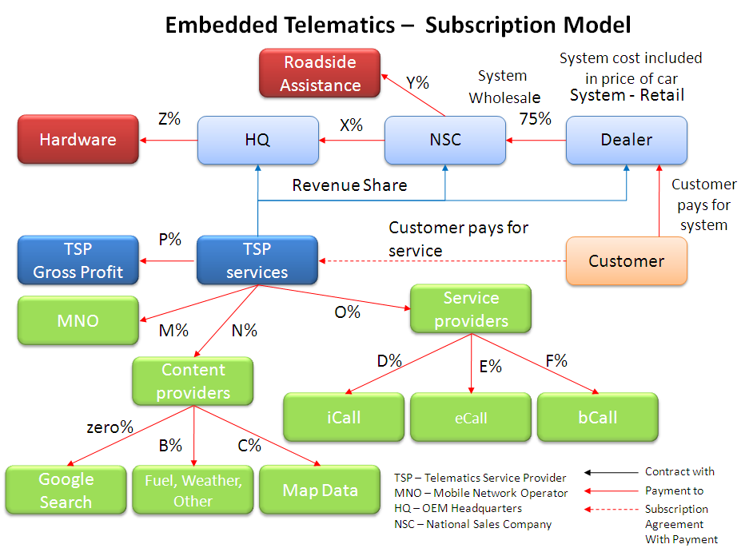
Figure 7.7: Embedded Telematics Subscription Money Flow

Fleet Accessory – Subscription Model
A number of Truck OEMs offer a fleet management system and associated services to their customers. In some cases, as with Daimler-Benz FleetBoard, the system and service is provided to owners on other truck brands.
Installation of the FleetBoard hardware can be made in any commercial vehicle.

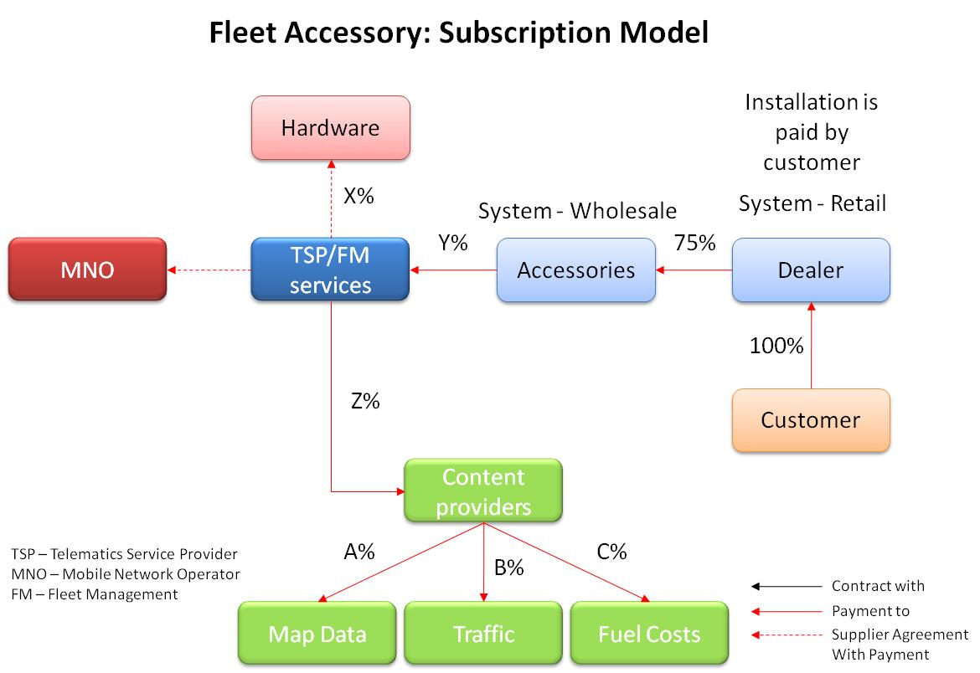
Figure 7.8: Fleet Accessory Subscription Money Flow

Market Size

Vehicle Sales
European Fleet Vehicle Sales by Country - 2009
Country | LGVs* | LCVs** | Private Cars
Austria | 3 926 | 25 582 | 319 403
Belgium | 6 202 | 53 620 | 476 194
Czech Republic | 3 117 | 13 007 | 167 708
Denmark | 2 676 | 15 220 | 112 199
Finland | 2 178 | 8 693 | 88 344
France | 28 578 | 372 590 | 2 302 398
Germany | 40 322 | 170 067 | 3 807 175
Italy | 12 370 | 175 405 | 2 159 459
Luxembourg | 790 | 3 063 | 47 265
Netherlands | 9 963 | 51 281 | 387 155
Norway | 2 822 | 23 504 | 98 675
Poland | 6 235 | 40 232 | 320 206
Portugal | 2 365 | 38 905 | 161 013
Spain | 8 200 | 106 527 | 952 772
Sweden | 4 783 | 27 432 | 213 408
Switzerland | 3 292 | 23 110 | 266 049
UK | 19 326 | 185 317 | 1 994 999
TOTAL EU27+EFTA | 163 082 | 1 409 170 | 14 524 579
* Large Goods Vehicles
**Light Commercial Vehicles
Large Goods Vehicles represent slightly more than 1% of the annual vehicle sales in the twenty-seven European Union member countries and the three EFTA countries. Therefore, it should be no surprise that special-purpose navigation systems with truck-specific attributes for Large Goods Vehicles have been slow in coming to market. Before it was sold in part to TomTom and in part to Continental, Siemens VDO was the only one of the traditional OEM navigation system suppliers to introduce a truck navigation system, and it was short-lived.
Products on the market today that are offered as truck navigation systems are coming from the PND suppliers, including TomTom, Garmin, and from smartphone software supplier ALK. ALK has a long history of highway truck routing in the US, where they had built their own truck-attribute database for the major roads in North America as early as 1995. In the US, Rand McNally,formerly known mostly for being one of the world’s largest paper map publishers, has transformed its relatively small truck management system into a full-scale routing and logistics offering. Called InteleRoute, it is sold as a truck routing system currently only in the US.

Navigation System Sales
Estimates of navigation system sales are made by many market analysts, but since all navigation sytems are sold with either a Tele Atlas (TomTom) or Navteq database, I believe that these two companies are in the best position to deliver the most accurate reports on the number of systems sold. In a mid-2010 corporate presentation, TomTom reported stated that in 2009, approximately 25% of all cars on the roads in Europe and North America had some form of navigation system, and that this would grow to over 40% in 2012.
Navteq indicated at its Navteq Directions gathering in the Autumn of 2010 that the growth of embedded navigation systems, as opposed to PND- or smartphone-based systems, was ready for a dramatic increase because of low-cost navigation solutions now being developed by the car companies. TomTom has been the leader here, and Garmin has followed. Their competition ensures that prices for the software components will be low and there will be a constant striving for having the most innovative features.
Additional information presented at the 2010 Navteq Directions suggested that 2010 would be the year for phone-based navigation to experience explose growth due to a new business model, so-called ‘perpetual solutions’. In this model, the phone manufacturer or the mobile network operator delivers the phone and/or the subscription with a mapping and routing application that is either on the phone from the start, or are downloaded. These applications are generally free and standard (i.e., the customer does not have to actively choose to them).
More widespread use of phone navigation will most likely mean that more LGV drivers will be using these applications. Lower cost embedded navigation could mean that truck companies will consider including navigation systems as an option or even as standard offerings. What this can potentially mean is a larger market for the data that is necessary to drive true truck routing.

The growth of ultra low cost integrated navigation is evident when looking at the increase in market share gained by TomTom between 2008 and 2009, from zero to 10%. TomTom’s share is growing at the expense of established players like Continental, Blaupunkt, Magneti Marelli and Pioneer.

Truck Navigation
The IntelliRoute TND700, like the IntelliRouteTND500 unit launched in 2009, was developed for professional truck drivers and tested extensively by professional drivers on the road. Many of the new and improved features in the IntelliRouteTND700 were developed as a direct result of driver feedback.  The 700 series unit includes more than 363,000 data updates derived from users of the IntelliRouteTND500 Tell Rand feedback feature as well as proprietary research from Rand McNally. Overall, IntelliRouteTNDdevices provide 35% more truck routing information than other GPS units.  "Accurate, truck-specific road data and restrictions help avoid accidents and substantial fines, improve asset utilization and arrival times, and keeps insurance costs down for drivers," said Danny Sack, Senior Product Manager of Rand McNally. | 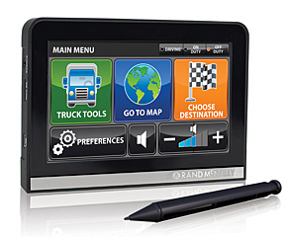

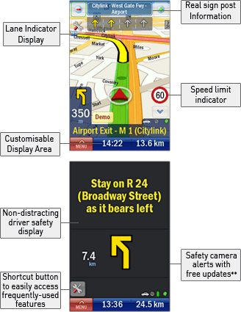 | ALK, another US-based company, offers a truck routing product called CoPilot Live Truck. It calculates optimal routes for commercial vehicles based on vehicle size and load type. It automatically avoids truck-restricted roads, taking into account low bridges. Height, weight and width restrictions, steep inclines and environmental and hazardous materials (HAZMAT) restrictions are used (when this data is available). ALK has developed its own database for major roads in the US, and has collected truck attributes for these roads. In Europe, ALK relies on data from Navteq, for which some truck attributes are available in some countries.

Fleet Management
Gauging the size of the fleet management market is difficult because there are many definitions of what constitutes a fleet management system (FMS). For many years, fleet management was synonymous with vehicle tracking and following the vehicle’s course as it made its deliveries (known as tracing). The field was known as Track and Trace. According to Frost & Sullivan, almost 50% of the installed based of commercial vehicle telematics was for Track and Trace and the remainder was FMS. Fleet Management is more than knowing where the vehicle is and sending messages to it, which are the principal functions of Track and Trace. FMS need to provide complete integration between the vehicle, the back office of the shipper and the customer.
The benefits of effective FMS deployment include both cost savings and cost avoidance for the customer and the shipper, new revenue opportunities for both, improved customer service, better regulatory compliance and higher employee satisfaction. Route guidance and route optimization are now being recognized as an important, if not yet necessarily vital, component of an FMS. This is indicated by the appearance of navigation software vendors among the leading suppliers of fleet management systems.
It is not only in integrated navigation where the low-cost PND suppliers have made significant inroads. TomTom, with its relatively low-cost Tomtom Work product, has quickly become one of the top fleet management systems in the aftermarket segment, which is illustrated in the chart to the right. Fleetboard includes the ALK truck routing system as one of its functions. In April, 2011, Cybit and Masternaut, two of the largest Track and Trace companies, merged. They will retain the brand Masternaut.

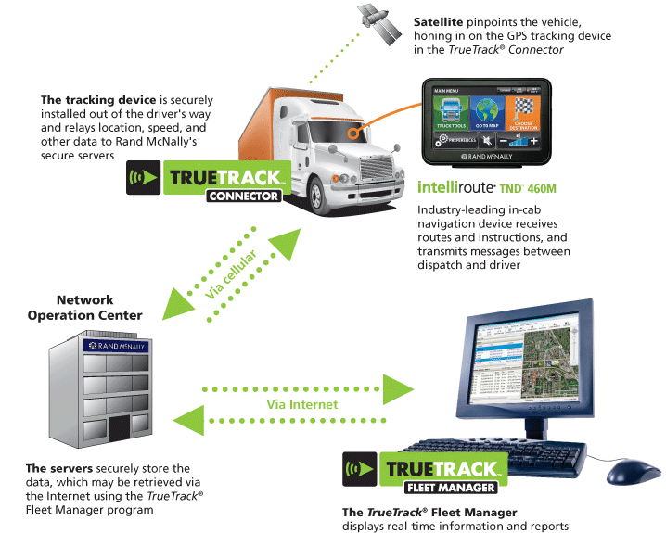

Results from fuel optimization compared with usual fastest route optimization

Objective of the comparison
To know if energy efficient navigation for heavy vehicles really differs from usual car and truck navigation we have to do some simulations in order to find the answer. Three different optimization methods have been used to find routes between chosen addresses:
- Optimizing for fastest route for a usual car.
- Optimizing for fastest route for a 4.2 m high 60 tons truck taking the relevant traffic restrictions into account.
- Optimization for least fuel consumption for a 4.2 m high 60 tons truck taking the relevant traffic restrictions into account.

Description of the simulation

Test environment
Existing software called Triona Routing Framework (TRF) has been used. The fuel optimization model is an add-on to TRF.
Road network and attributes come from NVDB. All available attributes as traffic restrictions describing where it is allowed to drive etc. are used. For a 60 ton truck, only BK1 roads are allowed and as the height of the truck is set to 4.2 meters, height restrictions below that mean a blocked road.
Travel time is essentially calculated by using functional road class and speed limits. For trucks maximum speed limit is set to 80 km/h except n motorways where it is set to 90 km/h.
Two hierarchies are used when finding best route. FRC 0-6 are in one level and FRC 7-8 are in another level.

Model for fuel optimization
The Artemis/HBEFA-model is used. Fuel consumption in g/km is used for a new 50-60 ton truck driving in free flow traffic in Sweden. The fuel consumption depends on:
- Rural or urban area
- Speed limit
- Road class (Artemis classes are mapped into FRC used in NVDB, see below)
- Gradient <-5, -5 -- -3, -3 -- -1, -1 – 1, 1 – 3, 3 – 5, >5
Artemis classes mapped to FRC in NVDB:
- MW => Motorway (independent of FRC)
- Semi_MW => Motortrafikled (independent of FRC)
- Trunk => FRC = 0-2
- Distr => FRC = 3-4
- Local => FRC = 5-6
- Access => FRC = 7-8
Height values from NVDB are used in the model. It is very important to exclude strange height values and to interpolate where height values are missing.

Chosen routes
22 addresses in cities spread out in Sweden have been chosen. 14 of them are Schenker terminals where trucks usually load and unload. Routing between all of them has been simulated using the three optimization methods described in chapter 1 above. This means 231 single routes and 462 routes when using both directions. The route choice can be different in different directions so we have used both directions in the evaluation.

Results

Statistics

Fuel optimization for trucks vs fastest route for trucks
Statistics regarding route length/route choice:
- 422 of 462 routes differ in length indicating different route choices
- 45 routes differ more than 3% in length
- 11 routes differ more than 5% in length
The diagram below shows that optimizing for fuel usually means an extra travel time between 0 and 2 %. A few times will a route be chosen that results in much longer travel time.

Fuel optimization for trucks vs fastest route for cars (car navigator)
Statistics regarding route length/route choice:
- 425 of 462 routes differ in length/route choice indicating different route choices
- 120 routes differ more than 3% in length
- 69 routes differ more than 5% in length
The diagram below shows that the travel time for a truck when optimizing for least fuel is much longer than for a usual car. Even when optimizing for fastest route for a truck the travel time is much longer than for a car due to the fact that trucks are not allowed to drive faster than 80 km/h (90 km/h on motorways).

Examples

Linköping-Växjö
Orange is usual car routing fastest route (253 km, 3h 2 min), purple is truck routing fastest route (223 km, 3 h 23 min) green is fuel optimization for trucks (219 km, 3h 31 min).
The different routes for car routing and truck routing with fastest route is due to the fact that a truck has a limited speed to 90 km/h on the E4-motorway where the speed limit for cars is 120 km/h.
The western route (orange) is definitely most hilly and therefore not optimal when optimizing for least fuel. The height profile on the purple route shows a long climb and a descent down to Växjö. The height profile on the green route shows a long flat part before a steep climb and a descent down to Växjö. The differences in height profiles might be the reason why the green route is chosen as most fuel efficient, but we currently do not have all facts available to easily do a deeper analysis of it.
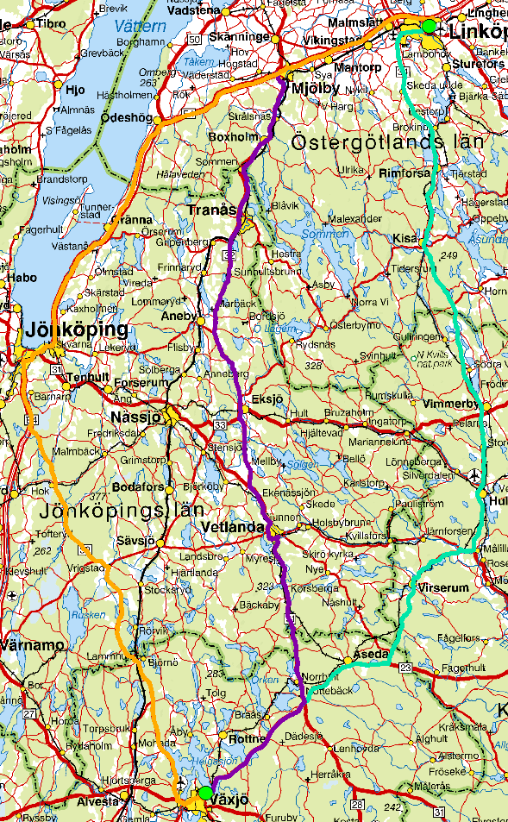
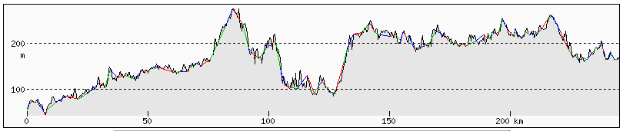
Height profile fastest route with a car Linköping-Växjö, orange route in the map

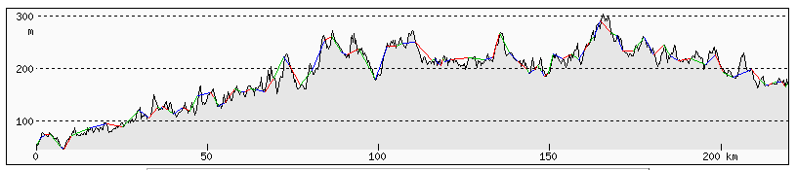
Height profile fastest route with a truck Linköping-Växjö, purple route in the map
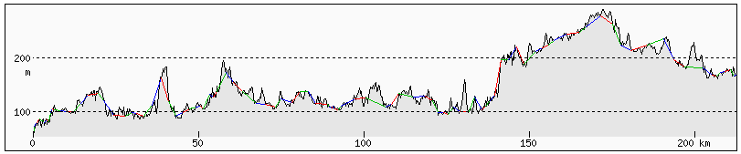
Height profile most fuel optimization for a truck Linköping-Växjö, green route in the map
The height profiles are not based on NVDB-data. They are based on the service http://www.heywhatsthat.com/profiler-0904.html and the elevation data source is NASA SRTM (Shuttle Radar Topography Mission).

Incorrect height values
Incorrect height values results in some strange route choices for fuel optimization routes. One example is shown below where the ramp is used instead of routing straight on the motorway.
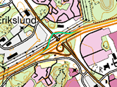

Borlänge-Karlstad
Orange is usual car routing (218 km), green is fuel optimization for trucks (also 218 km!)
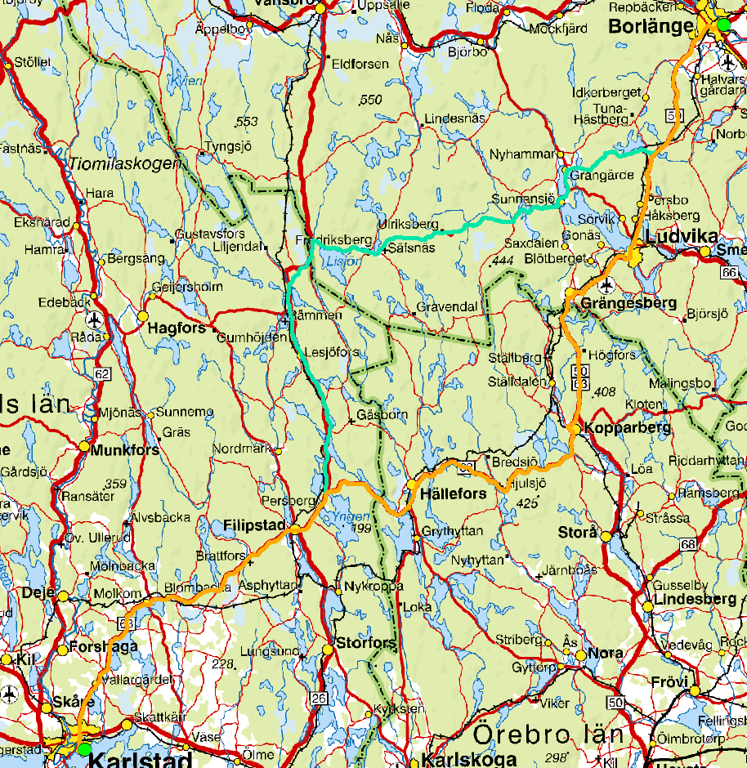
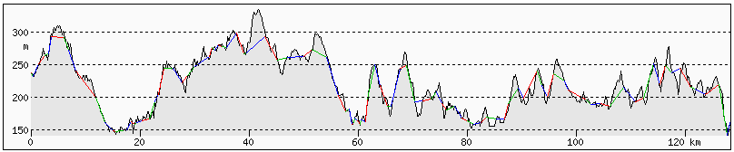Height profile fastest route for cars (orange route). The part that differs from the green 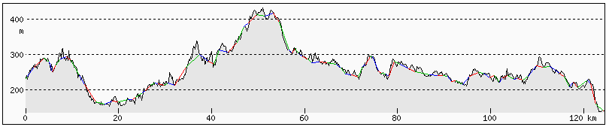route.
Height profile fuel optimization route for trucks (green route). The part that differs from the orange route.

Karlstad-Malmö
Very different routes when choosing fastest route for cars (orange) vs fuel optimization route for trucks (green)!
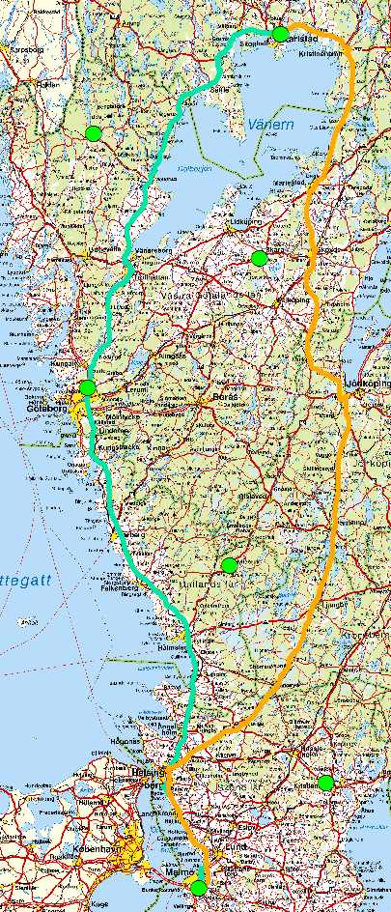

Passing Helsingborg
Using a 4.2 m high truck results in some strange route choices depending on current height restrictions. There is a height restriction on 3.8 m on E4 close to Helsingborg, which results in the following detour for a large truck (green route).
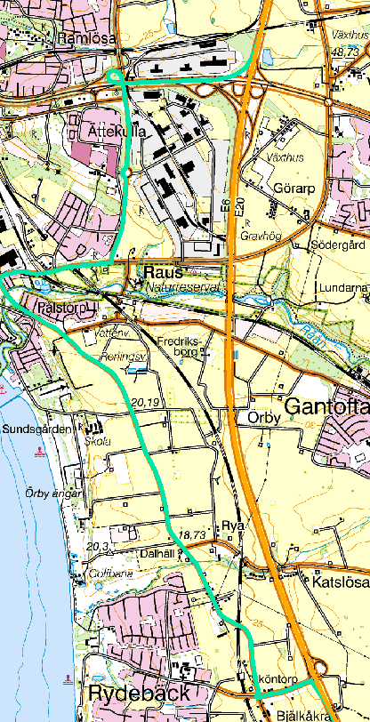
The bridge resulting in the height restriction is visible in Google street view.
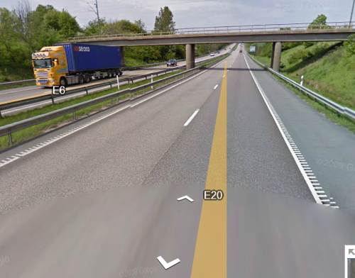

Conclusions
The used pure fuel optimization model really means different route choices compared to optimization for fastest route, regardless if it is the fastest route for cars or the fastest route for trucks.
Fuel optimization tends to choose smaller roads and shorter distances than fastest route optimization. Using the model as it is done now, means that driving a shorter distance in 60-70 km/h on small roads often results in less fuel consumption than driving a longer distance in 70-80 km/h on larger roads. For a more realistic fuel optimization model there is a need to take more parameters into account:
- Transitions between speed limits means extra fuel consumption
- Turning and crossing roads and streets (equal or larger in size than the one driving on) means extra fuel consumption.
The quality of the height-values might affect the route choice as smaller roads usually have less accurate height values or no height values at all resulting in less fuel consumption in the model.
As speed limits for trucks are maximized to 80 km/h (90 km/h on motorways) both fastest route optimization and least fuel optimization for trucks means the use of smaller roads than usual fastest route for a car. This might not be the desired result (especially not from the authorities’ point of view) and this indicates the need for more parameters to optimize for.
The results show that optimization for fuel definitely is possible, but for a commercial product, a model is needed which combines optimization for:
- Lowest amount of fuel usage
- Fastest route
- The use of major roads
How to weight these factors against each other will be a task for each navigation provider or an even more flexible solution will be to allow the user to do the weighting as shown in the HMI example below.

Conclusions and Recommendations

Requirements
- There is not a significant body of research completed in gathering and quantifying the technical or commercial requirements for energy-efficient navigation for heavy vehicles.
- Project work completed to-date, such as HeavyRoute and SOLVI, and research in progress, such as eCoMove, provide good information about parts of the problem which look at the specific problem of energy-efficient navigation and route optimization for Large Goods Vehicles.

Data
- Most of the attributes, relevant for energy efficient heavy vehicle navigation, are specified and available. The obstacles are coverage and up-to-dateness.
- Functional road class, speed limits, restrictions, real time travel times and as historical travel time profiles are used for heavy vehicle navigation today.
- Slope data are of large value for energy efficient navigation. Slope data are available for major roads, but the use is still minimal.
- Traffic lights, junctions, stop signs, acceleration profiles, historical fuel consumptions affect smooth driving, but are not used today.

Route optimization
- There is very little research available on route optimization and navigation for Large Goods Vehicles.
- There are only a few companies who are providing navigation and route optimization products to the LGV market today.
- There do not seem to be any examples where route optimization is combined with advanced driver assistance systems (ADAS).
- By using already available data describing slopes, junctions, stop signs, curvature, etc. route optimization for LGV could be improved today.

System Architecture
- The question of whether the route planning software and road database are on-board or off-board is one of the principal issues that must be addressed, and there are at present no definite indications that one or the other is best.
- Real-time information about delays on the route is essential, but not all available sources provide reliable data.
- Integration of route optimization with transport management systems and with on-board vehicle systems and sensors needs to be considered, but there is not a wide body of experience on these topics.

Business models
- There are no companies supplying navigation and route optimization products that have a clearly stated strategy to deliver energy-efficient products to the LGV market.
- Companies selling truck navigation products today have combined them with off-the-shelf fleet management, and navigation is offered as one of the features.
- The major inhibiting factors to building an effective business model based on such a strategy are the relatively small number of LGVs compared to cars and light commercial vehicles, the incremental cost of the data compared to what has been sufficient for cars, and the price sensitivity of the majority of the freight carriers.
- Business models for LGV navigation will need to be built around non-market dynamics since market forces do now appear to be strong enough to support the cost of their development and continued maintenance.

Appendices

Annex 1 - Truck routing applications on the market

ALK
CoPilot Live v8 Truck
Provides dock-to-dock, voice-guided GPS navigation with industry-standard PC*MILER truck-specific routing to help professional drivers reduce fuel costs and out-of-route mileage, increase efficiency and avoid costly fines and vehicle damage.
Running conveniently on a wide range of mobile devices, including smartphones, laptops and rugged devices, it takes into account truck-restricted and prohibited roads to provide safe and reliable routes on truck-legal roads.
With CoPilot Live Truck, optimal routes are calculated based on vehicle size and load type to avoid commercial truck restrictions.
With over 30 years of experience delivering commercial truck mileages, routes and mapping solutions to the North America Transportation & Logistics industry and developing navigation solutions for leading truck manufacturers such as Scania, we have unrivaled expertise and understanding of truck navigation requirements.
Weblinks
http://www.copilotlive.com/uk/truck/
http://www.alk.com/email/CoPilotTruck/doc/CoPilot%20Livev8TruckOverview.pdf

BECKER
Becker Traffic Assist Pro Z302
With the new Becker Traffic Assist Pro Z302, Becker presents the first mobile truck navigation system, which the driver can use to define profiles that are tailored specifically to his vehicle and payload. Individual details on height, width, length, axle number, weight and payload can be saved which are then analysed in order to calculate the route.
Impassable roads, tunnels and bridges are excluded depending on the profile data and possible, alternative routes are offered for selection in a map view so that the driver can choose the best route for him. For the first time, the scope of delivery also includes a 360° radio remote control that can be installed as required and used to control almost all of the PND’s functions, offering the best possible operating convenience and optimum safety.
A little extra, from us to you: The new Becker Traffic Assist Pro Z302 is supplied with Becker BestMaps included and thus guarantees the most up-to-date NAVTEQ maps for Europe for a period of 24 months – free of charge.
Naturally, the Becker Traffic Assist Pro Z302 can also be used for other vehicles or by pedestrians and cyclists – simply select the correct profile and off you go.
Weblink:
http://mobilenavigation.mybecker.com/en/products/becker-traffic-assist/detail/product/
BECKER-TRAFFIC-ASSIST-PRO-Z302-3/action/detail/controller/Product/

Falk
Note that a lot of information about Falk is in German.
The Navi manufacturer Falk and the IT-Sales GmbH from Nuremberg present together a new truck-navigation software which can be installed easily on the devices F8, F10 and F12: the software is supplied on a warehouse ticket SD which is inserted in the Steckplatz of the Navis. Then one can decide whether the device should start the normal Falk software or the Gamba truck Navisoftware. The memory card with maps of Europe considers truck parameter like length, height, width, axle load as well as the load.
Weblinks:
http://www.falk-navigation.de
http://www.mygamba.de

Garmin
Dēzl 560LT Truck-friendly navigation
Truck specific routing with preloaded street maps for Europe, Lane Assist with PhotoReal Junction View, premium lifetime traffic, nuRoute technology, Bluetooth hands-free calling, speaks street names, Where am I?, photo navigation
Nüvi 465T Truck-friendly navigation
Truck specific routing for Europe, Lane Assist, Traffic Alerts, Hands-free calls with Bluetooth wireless technology and more.
Nüvi 465TF Truck-friendly navigation
No more narrow country lanes or difficult manoeuvres with the nüvi 465TF - our first sat nav designed for trucking professionals. It has a UK truck attribute database, European mapping and specialised routing options and is supplied with a Fleet Integration cable.
Weblink:
https://buy.garmin.com/shop/shop.do?cID=275

Masternaut
Information only available in French.
Weblink:
http://www.masternaut.com

NAVIGON
NAVIGON Truck Navigation (NAVIGON 8410, NAVIGON 70 Premium, NAVIGON 6310, NAVIGON 40 Premium)
Let yourself be shown your optimal lorry route! Simply enter the height, width, length, weight and axle load for your vehicle type (HGV, delivery van, caravan) and your NAVIGON will show you the appropriate route for you, thanks to the new Truck Navigation system. You can therefore safely avoid roads on which lorries or caravans are not permitted, narrow roads, bridges and tunnels with low height clearances. In addition, this service will also navigate the way to over 16,000 additional points of interest, such as filling stations, shops that are open around the clock or HGV washes.
Truck Navigation features:
- Special route profile for HGVs, delivery vans and caravans
- Profile configuration based on length, height, width, weight, max. axle load and whether you are carrying hazardous goods
- Consideration of legal restrictions, e.g. roads where lorries or caravans are not permitted
- Time-related restrictions
- Display of special points of interest
It is not currently possible to use Truck Navigation in addition to the Live Services.
Weblink:
http://www.navigon.com/portal/int/karten_services/funktionen/navigationsprofile/truck_navigation.html

NavGear (distributed by Pearl)
NavGear 5 StreetMate RS-50-3D LKW-Edition Europa
Information available in German
Welcome in the luxury class for truck driver: the exclusive 5 "-Trucker-Edition combines top technology with best functionality and special maps for Europe. So your new Navi knows not only bridge heights and close passages, but also the profile of your truck or delivery vehicle. In addition, you can consider while planning a route even different dangers profiles.

A Premium POI package especially for long-distance truck driver serves your new driving comfort: this contains, e.g., supplementary bridge heights, the most adapted gas stations (also with fuel card.
It is the most comfortable and most economic StreetMate of all times as well as a big plus in security. The additional Bluetooth-free speaker lets you relaxing travel.
Weblink:
http://www.pearl.de/a-PX4545-5483.shtml

PTV
Truck Navigator
"Truck navigation: Save time and money"
Take the best routes for trucks and get to your customers safely and on time: Professional navigation is now available especially for trucks. It can do everything that navigation solutions are expected to do – and it even takes trucks' extra requirements into account: Bridge heights and capacities, vehicle clearance heights and truck restrictions. A route created especially for trucks saves time and money right from the start, because it is specifically calculated for trucks and local detours can be avoided.
Weblink:
http://www.ptvag.com/index.php?id=2882

Rand McNally (only US and Canada)
Truck GPS (Intelliroute TND 500, 510, 700, 710)
"Truck navigation you can trust"
Rand McNally's flagship GPS device, the IntelliRoute TND 500 uniquely meets the needs of the over-the-road trucker by providing detailed routes for trucks and turn-by-turn spoken directions. This original 5" GPS device provides the unique trucker business tools that will eliminate manual calculations of mileages, provide an efficient manner to calculate arrival time to your destination and more!

The IntelliRoute TND 500 has been recognized by the Consumer Electronics Association (CEA) for excellence in design and technology with a 2010 CES Innovations Award as well as the "Best of Innovations" honor for In-Vehicle Navigation. The IntelliRoute TND 500 is Rand McNally's first trucking navigation device designed to guide professional drivers on the safest, most efficient route for trucks.
Built from the ground up for professional drivers, the IntelliRoute TND 500 incorporates input and hours of testing by real truckers. The device was built to help truckers in each phase of their work day from planning to driving to reporting. With 35% more truck routing information than other GPS units, the device leverages Rand McNally's proprietary truck data derived from more than 70 years in the commercial transportation industry.
Features include:

- Full U.S. and Canada Maps
- Trucker Business Tools
- Access to updates and upgrades via the TND Dock
- Searchable truck stop information from the Trucker's Friend National Truck Stop Directory
Weblink:
http://trucking.randmcnally.com/ctonline/products/intelliroute_tnd/intelliroutetnd_details.jsp

Snooper
Truckmate S900, S200, S6000, S7000, AVN S700
Truckmate is the first dedicated portable Truck satellite navigation system. Snooper Truckmate uses satellite navigation technology to calculate width, height and weight limits to create truck and HGV friendly routes. Truckmate satellite navigation software avoids low bridges and weight restricted roads based on the size and load of your truck or commercial vehicle.

Snooper's truck satellite navigation system can be effectively utilised by all commercial vehicles from trucks and HGVs to coaches and buses. The benefits to truck satellite navigation software go beyond saving time there is also the environmental and cost effectiveness of a truck satellite navigation system with improved fuel consumption and improved cost effectiveness. Truck satellite navigation software from Snooper is compatible with both the s2000 Syrius and s600 Syrius.
Weblink:
http://www.snooperuk.com/snooper_products/gps_truck_navigation/index.html

TeleType
WorldNav
Not available in Europe.
The new WorldNav 7400 Truck GPS model is the latest and most versatile commercial trucker GPS offered by TeleType. In addition to all the standard WorldNav Truck GPS features found in the other WorldNav Truck GPS models, this model features a serial expansion port which then allows special accesssories to be added. Optional accessories include Traffic Antenna for unlimited use of traffic incident and congestion report. Special adapters can be added to allow you to monitor the tire pressure of your vehicle. An economical live tracking option tailored to small fleets or independents can be added as desired.
The WorldNav 7400 Truck GPS offers a high resolution touch screen equipped with Bluetooth and more. This WorldNav model supports Truck Routing for professional commercial drivers, bus drivers, and RV'ers. Insures that routes will follow roads that are suitable for truck travel, and yet the commercial driver can rely on the routing as it takes into account commercial truck restrictions such as bridge heights and clearances, load limits, one-way road designations, and allowances. Easily configure the software to any size and weight vehicle for appropriate routing. Including semi-trucks, construction vehicles, and oversized vehicles. Easily change the specifications to suit your truck including oversized and overweight vehicles.
The WorldNav's "Know Before You Go" technology checks the entire route before you start your trip. If you need to make a change, WorldNav automatically checks the route again to insure that you avoid truck restricted areas and low bridges.
Weblink:
http://www.teletype.com/p/740060.html

TomTom
Pro 7100 Truck, Pro 7150 Truck
Smart routes for your trucks
Diversions, rerouting and size restrictions: every day your drivers face a bewildering number of challenges to get the goods through. The PRO 7100 TRUCK uses smarter navigation to plan better routes for your drivers. They are less likely to get stuck, delayed or drive unnecessary distances - meaning efficient journeys and accurate scheduling.
Your trucks are large, now your satnav is too. The new TomTom PRO 7150 TRUCK has a 5"/13cm screen that makes navigating your trucks even easier, giving clear visual instructions to guide your drivers around restrictions. With the TomTom PRO 7150 TRUCK your vehicles are less likely to get stuck, delayed or drive unnecessary distances - meaning efficient journeys and accurate scheduling. And your drivers are more relaxed using an extremely easy to operate navigation device with large screen.
Truck specific routing throughout Europe (45):
Avoid small streets, sharp turns & U-turns
Favors major over small roads
Uses truck specific average speed assumptions

Access restrictions1 in 15 European countries (for major and interconnecting roads):
Routes around known dimensional and weight restrictions in: AT, BE, CH, DK, DE, ES, FR, HU, IE, IT, NL, LUX, SE, PT, UK
Restriction and dead end warners:
Avoid unnecessary maneuvers in dead-end streets
Make your own map correction with TomTom MapShare
Block streets for trucks based on height, length, width, weight, weight per axle or load restriction
Connect to the office (requires a subscription to WEBFLEET):
The PRO 7100 TRUCK can be part of TomTom WORKsmart solutions - for effortless fleet management. Inform your customers of the arrival times, use the digital tachograph information to reschedule your plans in real-time or manage working hours effortlessly with a single click.
Weblink:
http://www.tomtom-navigation.co.uk/index.php

Annex 2 - Eco-routing applications on the market

Bosch
ECO Navigation
Saves fuel and is kind to the environment.
Thanks to ECO navigation, you’ll find the route that gives you the best-possible energy balance. In contrast to previous navigation system generations, ECO navigation takes all the decisive factors into consideration in route calculation.
These include such route features as the elevation profile or the number of villages and towns you pass through and the intersections along the way – as well as the typical vehicle consumption values and the driver profile. To make this possible, Bosch has calculated the optimum average values on the basis of all the vehicle and driver information available.
As a result, you avoid not only unnecessary toxic emissions, you also reduce your fuel consumption.
Weblink:
http://iphone.bosch.com/navigation/en/econavigation.html

Fiat
EcoDrive
EcoDrive is a free software codeveloped by Microsoft and Fiat Automobiles. It was unveiled at the 2008 Paris Motor Show and its aim is to allow drivers to reduce their fuel consumption and pollution emissions. It is now available for Fiat 500 and Fiat Grande Punto and in 2009 it will be available throughout the whole FIAT range equipped with Blue&Me.
When the car is being driven, ecoDrive collects all the data about CO2 emission and fuel consumption, by saving them to a USB key linked to the Blue&Me device. Afterwards, users can analyse and improve their results by connecting the USB key to a domestic computer. Moreover, ecoDrive allows users to receive driving tips on how to achieve a lower environmental impact and share experiences throughout an on-line community called ecoVille.
Weblink:
http://www.fiat.co.uk/ecodrive/#ecodrive/intro

Garmin
Eco-Route
Monitor Real-time Engine Performance Data on Your nüvi
Get customizable gauges to monitor RPM, air/fuel mixture, oil pressure, oil temp, coolant temp, air flow, fuel flow, air pressure, and more
Reads Diagnostic Trouble Codes (DTC)— allows you to view over 4000 trouble codes, their meaning, and reset the check engine light
Accurate fuel consumption data can actually help you improve MPG
Simple installation takes an average of only five minutes
Get Real-Time Diagnostics
This easy-to-install device plugs into your vehicles OBD II port to tap into your vehicle's diagnostic system. Using Bluetooth wireless technology it delivers real-time engine performance diagnostic data directly to your compatible nüvi. It can even help troubleshoot engine and performance problems.
Check Your Gauges
Now you can have a complete gauge cluster in one convenient location. The information displayed on the gauges page is collected directly from your vehicle. You can select the gauges you want to monitor most and customize screens with various gauge packages. The number and type of gauges displayed may vary by vehicle.
Save a Trip to the Mechanic
After completing a simple setup, you can use your nüvi to run diagnostic testing on vehicle systems. Determines why your check engine light is on without paying a mechanic. It reads diagnostic trouble codes; tells you what they mean, and even allows you to reset your check engine light. It also monitors other engine data, including temperatures, emissions, battery charge, and drive train.
Learn How to Increase MPG
You can use the data from ecoRoute HD to actually help you improve your driving habits and get more miles to the tank full using timely fuel and mileage reports featuring accurate fuel consumption/conservation data. Calculate your fuel efficiency, carbon footprint, and more all through your compatible nüvi.
Mechanics and dealers can charge you as much as $100 to run the same diagnostic tests ecoRoute HD performs just to find out why your check engine light is on. Add on its ability to help you save on fuel and ecoRoute HD can more than pay for itself!
Easy Installation
Simply plug the ecoRoute HD module into the vehicle’s standardized onboard diagnostics port (OBD II) then complete the easy one-time pairing with your compatible nüvi. Just like that, you’re ready to start receiving the vital data from your vehicle and run diagnostic checks through the intuitive interface of a compatible nüvi.
Weblink:
http://www.garmin.com/us/extras/services/ecoroute

Hyundai
NAVTEQ has been chosen by Hyundai to provide advanced content for its new navigation platform which features a green routing option as well as the traditional ’shortest’ or ‘fastest’ routes.
Hyundai developed the new software using NAVTEQ’s digital map data with additional ADAS attributes such as slopes, height and curvature which enable the routing calculations to take into account more precise road geometry and the nature of the terrain.

This has been coupled with NAVTEQ Traffic Patterns which predicts where and when traffic jams will happen based on when they typically occur - so drivers can be guided via alternative routes where traffic flows more smoothly.
Together these attributes enable the navigation system to find routes which minimize fuel consumption.
Tests comparing ‘fastest route’ and ‘greenest route’ calculations in several city and urban scenarios ranging from Paris to Frankfurt, New York and Chicago showed that when using the ‘greenest route’, there was at least a 6% fuel saving per trip and often more.
In additional NAVTEQ research, green routing – with the navigation system determining the most fuel-efficient route – proved the eco friendly feature with the highest level of interest, followed by green driving (which advises the driver on the optimum speed and gear for the terrain) and then predictive cruise control.
Most of those surveyed would anticipate using green features on a weekly basis.
Hyundai is also working with NAVTEQ to improve the navigation take rate even further through effective dealer and customer communications which illustrate how navigation adds value and potentially helps reduce running costs.
NAVTEQ has been encouraging for many years consumer adoption of navigation through a variety of innovative marketing programs facilitating easy and convenient dealer ordering processes by creating on-line stores for map updates, offering "map bundles" to keep navigation systems at an optimum performance with up-to-date maps or sending out dealer communications via email and direct mail when an update becomes available.
The new navigation software will be used on the company’s map updates from spring this year - making the advanced ‘green routing’ feature available to drivers with the recently launched Veloster.
Weblink:
http://press.navteq.com/index.php?s=4260&item=26705

TomTom
WORKsmart-Eco
You determine how green your business is and how much money you will save. WORKsmart-Eco is fully flexible in the choice of hardware. If you're serious in your ambitions to become green you would want to measure your performance, that's why TomTom ecoPLUS is an essential part of the solution. It provides fuel efficiency and carbon footprint straight from the vehicle for WEBFLEET to report on. You can see the impact of your smart dispatching and other efforts made to reduce costs and carbon in your organization.
You can read more on how your business can turn green in 3 steps in our WORKsmart-Eco brochure. Or simply leave your details and we'll tell you why we think you can save at least 8% of your fuel cost.
Weblink:
http://business.tomtom.com/en_gb/solutions/environmental-responsibility/

Annex 3 - Eco-predictive cruise control for trucks on the market

Freightliner Trucks
Freightliner Trucks Launches RunSmart Predictive Cruise for Cascadia (3/19/2009)
Freightliner Trucks today launched its new, proprietary RunSmart Predictive Cruise system. This innovative technology evaluates the upcoming road profile more than one mile in advance and determines the most fuel efficient vehicle speed. The system is now available as an option for a Detroit Diesel DD15-equipped Freightliner Cascadia with a 72-inch raised roof.
Developed by Freightliner’s parent company, Daimler Trucks North America, working together with NAVTEQ – a leading global provider of digital map data for location-based solutions and vehicle navigation – RunSmart Predictive Cruise can increase fuel economy when operating on rolling terrain.
"At Daimler Trucks, we understand that meaningful gains in fuel efficiency call for innovative solutions," said Elmar Boeckenhoff, vice president of engineering for Daimler Trucks North America. "RunSmart Predictive Cruise demonstrates how we leverage cutting edge technologies to benefit our customers and reaffirm our commitment to society as a whole."
RunSmart Predictive Cruise: How it Works
Unlike standard cruise control, where the truck tries to maintain a set speed regardless of the terrain ahead, RunSmart Predictive Cruise looks up to one mile ahead of the truck’s location and anticipates road grades by using GPS and 3D digital map technology. The system adjusts the actual speed of the truck for maximum fuel efficiency based on the terrain while staying within 6 percent of the set speed.
Using advanced digital map slope data from NAVTEQ, RunSmart Predictive Cruise combines high precision GPS road coordinates with road grade data of more than 200,000 miles of the most widely used truck routes in the continental United States.

"The NAVTEQ map provides the depth and accuracy required for fuel efficiency applications," said Bob Denaro, vice president of ADAS, NAVTEQ. "Daimler’s use of map attributes for an on-board application independent of a navigation system is a significant industry accomplishment demonstrating major innovation."
"This is part of our long term vision to improve truck efficiency using GPS and 3D digital map technology," said Derek Rotz, manager of advanced engineering for Daimler Trucks North America. "RunSmart Predictive Cruise shows what can be achieved through dedication and collaboration to break new ground. We’re proud to be first in this industry to bring predictive technologies to the market."
For more information, call or visit your nearby Freightliner Trucks dealership or go to www.FreightlinerTrucks.com.
Weblinks:
http://www.freightlinertrucks.com/inside-freightliner/news/news-detail.aspx?id=813
http://www.youtube.com/watch?
References
- Zhao, Y., Vehicle Location and Navigation Systems, 1997, Artech House.
- Flinsenberg, I.C.M., Route Planning Algorithms for Car Navigation, PhD thesis, 2004, Technical University Eindhoven.
- Jenkins, M., Introduction to Route Calculation, 2007, NAVTEQ Network for Developers (NN4D).
- Dijkstra, E. W., A note on two problems in connexion with graphs, Numerische Mathematik 1, 1959, pp 269–271.
- Hart, P. E., Nilsson, N. J., Raphael, B., A Formal Basis for the Heuristic Determination of Minimum Cost Paths, IEEE Transactions on Systems Science and Cybernetics, Vol. 4, Issue 2, July 1968.
- NAVTEQ Corporation, Attribute Overview and Usage, version 2011 Q1, 1 January 2011 (this document is Proprietary and Confidential, and meant for internal use by NAVTEQ and current database licensees).
- NAVTEQ Corporation, NAVTEQ’s GDF 3.0 Reference Manual v39.0, 1 July 2011 (Proprietary and Confidential), Chicago, USA.
- Marks, B., and Kopitz, D., RDS: The Radio Data System, Artech House, 1998.
- T. Oguchi, M. Katakura and M. Taniguchi, Available Concepts of Energy Reduction Measures against Road Vehicular Traffic, Proceedings, 3rd World Congress on Intelligent Transport Systems, Orlando, 14-18 October 1996.
- T. Oguchi, M. Katakura, New conceptual evaluation method of amount of exhaust emission gas on vehicular road traffic, in: L.J. Sucharov and C.A. Brebbia (editors), "Urban Transport VI", WIT Press, Wessex Institute of Technology, Southampton, UK, 2000.
- T. Kono, T. Fushiki, A. Katsuya, K. Nakano, Fuel consumption analysis and prediction model for "eco" route search, Proceedings, 15th World Congress on Intelligent Transport Systems, New York, 16-20 November 2008, paper TS29-10110.
  - Corréïa, S. Amaya, S. Meyer, M. Kumagai and M. Okude, Eco routing for European market, 17th ITS World Congress, Busan, 25-29 October 2010, paper TP100-2.
- Oxford University Press, Oxford Dictionaries Online, internet portal.
- Committee for the National Tire Efficiency Study, Tires and Passenger Vehicle Fuel Economy, Transportation Research Board (TRB) Special Report 286, Washington, 2006.
- Kansas Energy Council, Kansas Energy Chart Book 2008, January 2008, Topeka, Kansas, USA.
- US Department of Energy, Fuel Economy Guide - Model Year 2011, report DOE/EE-0333, undated.
- B.H. West, R.N. McGill and S. Sluder, Development and Validation of Light-Duty Vehicle Modal Emissions and Fuel Consumption Values for Traffic Models, US Departmemt of Transportation, Federal Highway Administration, publication FHWA-RD-99-098, March 1999, McLean, Virginia, USA.
  - Calkins, Green Routing, internal paper, NAVTEQ Corporation, August 2008, Chicago, USA.
- CEN TC 278, Geographic Data Files (GDF 3.0), draft European Standard (ENV), 12 October 1995, European Committee for Standardization (CEN), Brussels.
- ISO, Intelligent Transportation Systems - Geographic Data Files - Overall Data Specification (GDF 4.0), ISO 14825:2004, 2004, International Organization for Standardization (ISO), Geneva.
- NAVTEQ Corporation, NAVTEQ Traffic Patterns, one-pager, version of 20 July 2011, Chicago, USA.
- NAVTEQ Corporation, NAVTEQ Traffic Patterns Global Specifications v1.1, proprietary and confidential, December 2010, Chicago, USA.
- NAVTEQ Corporation, Real-Time Traffic Services - The Next Frontier, EU Traffic White Paper, 2010, Chicago, USA, version of 6 April 2011.
- S. Durekovic, Green Routing, A perspective, internal presentation, NAVTEQ Corporation, undated, Sulzbach, Germany.
- EcoMove Consortium, Annex I - Description of Work, EcoMove Consortium, Brussels, 13-11-2009.
- J. Castermans, A. Brusselsmans and J.C. Pandazis, Project presentation and fact sheet, deliverable D1.2, EcoMove Consortium, Brussels, 14-07-2010.
- T. Smits, High Level Architecture, Deliverable D2.2, EcoMove Consortium, Brussels, 09-05-2011.
- G. Vernet, J. Stille, F. Krietsch, N. El Ghouti, F. Gatti and P. Themann, Functional Architecture and System Specification, Deliverable D4.2, EcoMove Consortium, Brussels, 15-03-2011.
- P. Mathias, J. Vreeswijk and P. van Koningsbruggen, Architecture and System Specification, Deliverable D5.2, EcoMove Consortium, Brussels, 18-03-2010.
- N. Eikelenberg, J. Subbian, R. Blanco, D.Sanchez, L. Andreone, S. Damiani, E. Balocco, E.-P. Neukirchner, Lutz Bersiner, SP3 ecoSmartDriving Use Cases & System Requirements, Deliverable D3.1, EcoMove Consortium, Brussels, 31-10-2010.
- 2008,M. M. Mahmod, I. Kahlim, E. Uhlemann, N, Nygren, ”Wireless Strategies for Future and Emerging ITS Applications”

- www.tomtom-navigation.co.uk/site/TomTom_Go_7000_Truck.php
- NVDB Specifikation av innehåll v5.5, Trafikverket 2010
- NAVTEQ Attribute overview
- eCoMove 101102-DEL-D4.1-System-description-Use-cases-and-System-requirements-v08
- Navigation tung trafik; Peo Svensk, Mats Lindqvist, 2010, report for TRV Sweden
- http://www.isotc211.org
- http://www.iso.org/iso/iso_technical_committee?commid=54706
- Transportation Research Part D: Improving computerized routing and scheduling and vehicle telematics: A qualitative survey, Michael Baumgartner, Jacques Léonardi, Oliver Krusch; Max Planck Institute for Meteorology
- Science Direct: 3D-mapping optimization of embodied energy of transportation; Joshua M. Pearce, Sara J. Johnson, Gabriel B. Grant

Officially in the EU called LGV for Large Goods Vehicles. LGVs are classified by the European Union as motor vehicles (i.e. trucks/lorries) with a maximum allowed mass (MAM) or gross combination mass (GCM) of over 3,5 tonnes. There are two sub-categories: N2 – vehicles up to and including 12 tonnes; and, N3 – vehicles over 12 tonnes.
SOLVI – Safe Operation for Large Vehicles Initiative; IVSS-funded project; completed September 2009.
In the UK, this type of vehicle is called an ”estate car”.
In the summer of 2006, Wal-Mart sold its eighty-five stores in Germany and left the market, taking a one billion charge against its earnings. The reason: its local competitors, especially Metro, were better at the Wal-Marting game than Wal-Mart.
2008 figures.
Some stores have evolved into warehouse shopping facilities with a minimum of frills and no service, and with goods piled up on pallets for picking by the customers. High shelves in the same space where he customer is shopping are packed with goods that would normally be in a storage facility out of the customers sight.
Arkansas ranks 49th out of 50 in Median Household Income: 1999-2001; 1st in Persons Below Poverty Line: 2000-2002; and 46th in Average Annual Pay: 2002. U.S. Census Bureau, Statistical Abstract of the United States (2004).
Carbon monoxide emissions for trucks (105 grams per ton of transport per kilometer) are three times greater than for rail (35 g/tkm), and over five times greater than for shipping (18 g/tkm).
Raheel Shabih and Kara M. Kockelman, Effect of Vehicle Type on the Capacity of Signalized Intersections: The Case of Light-Duty Trucks, University of Texas at Austin, 1999).
Global Logistics Network, Inc.
In this chapter, in general sense, references [4], [5] and [6] have been used.
In first prototypes of the Carin navigation system, when GPS was not yet integrated, the user had to enter an intersection close to the current position, and to push a button when the intersection was passed.
The official notation of the name of the project is "eCoMove". We use the more convenient notation "EcoMove" in this report.
The Annex still needs to be compiled, and will be included in the next version of this document.
TomTom, NXP, Logica, TNO, GreenCat, NSPYRE, PEEK traffic solutions, CATENA, Fourtress, Eindoven technical university.Twente technical university and Leiden technical university
I was working in a consulting role to division of a Swedish company called framfab in 2000, and had the responsibility to deliver a location-based solution. I chose Telcontar as the map engine supplier. Framfab folded, but the division survived and now exists as Appello.

